1

Psychology Internal Assessment

IBDP 2021

Can Preference for Background Music Mediate the Irrelevant Sound Effect?

Candidate number

CONTENTS

1 Introduction ------------------------------------------------------ 2

2 Exploration -------------------------------------------------------- 3

- Design --------------------------------------------------------

- Participants -------------------------------------------------

- Materials ----------------------------------------------------

- Procedure ---------------------------------------------------

3 Analysis ------------------------------------------------------------ 4

● Descriptive --------------------------------------------------

● Inferential ---------------------------------------------------- 5

4 Evaluation ---------------------------------------------------------- 6

5 Bibliography ------------------------------------------------------- 7

6 Appendices -------------------------------------------------------- 8

2

INTRODUCTION

Learning relies to a large extent on memory, and cognitive research into memory-improving techniques is an important aspect of education. Recent research shows that there are instances in which the ability to recall leads to improved memory performance, a phenomenon called the Irrelevant Sound Effect (ISE), which refers to the situation when the task-relevant background sound disrupts the pattern of serial recall.

The original experiment on which this one was based was conducted by ​Perham and Vizard (2010), involving the investigation of the impact of background music on serial recall tasks, and if it mediated irrelevant sound effect.

Perham and Vizard investigated this idea by using a sample population aged between 18 to 30 years old university undergraduates. They investigated if the preference of music had any impact on the performance of serial recalling task. Researchers asked participants to memorise consonants that were displayed on powerpoints and asked participants to recall them in serial orders while either their favourite music, disliked music, unstable state speech and stable state speech was played as background sounds. Participants were asked to rank those sounds in order of their preference. The study revealed that there was no significant difference in performance between liked and disliked music conditions. Most of them rated quiet condition as relatively favourable condition, results indicated that performance was the best under quiet condition.

Aim: The study aims to determine the influence of music on the performances in adults, in which they would be memorizing a list of words while listening to music at the same time. The aim has bigger implications in terms of the students learning power with the increased influence of music in their everyday lives. Different types of music has been a part of our everyday life.

Research hypothesis: The ability to recall words from a given list decreases as participants are exposed to a musical environment

One talked Hypothesis: There would be a significant increase or decrease in the ability to recall words in a list; music, non-music conditions

Background Research

A wide range of classes of music have been concentrated regarding their impacts on various factors. Traditional music has been found to have a scope of impacts from expanding buys to influencing memory and perception . For instance, Rausher, Shaw and Ky (1993) found that tuning in to traditional music improved knowledge and memory yet others have been ineffective in recreating these discoveries (Pietschnig, Foracek and Formann, 2010; Steele, Bass and Crook, 1999; McKelvie and Low, 2002). A British radio broadcast, called Classic FM, has some expertise in western old style music whose writing computer programs is intended for unwinding (Dibben and Williamson, 2007) and unwinding has demonstrated to be gainful for the cerebrum to work all the more effectively (Blanchard, 1979). On the off chance that the mind works all the more effectively, better memory might be an outcome. A sort very not the same as old style music that has gotten research consideration is rap. In contrast to traditional music, rap music will in general be quick, forceful, and invigorating with around 100 beats for every moment. Traditional music, then again, will in general be much more slow with around 40 beats for every moment. Rap music has diverting intellectual impacts (Dibben and Williamson, 2007; Smith and Morris, 1977). Smith and Morris (1977) found that animating music expanded emotionality and was identified with less fortunate execution in members over those presented to an additionally calming sort of music. Music is mainstream nowadays, particularly among understudies. Roy (2009, p. 505) expressed, "It's unordinary for understudies not to associate with music; she clarifies that this is genuine in view of the expanded accessibility of versatile music gadgets and free music on the interne." Most understudies play music while considering.

Anderson and Fuller, 2010, found that about 70% of understudies tune in to music while considering. On the off chance that most understudies study while tuning in to music, concern could emerge that tuning in to music may effectsly affect psychological execution. As recently appeared, old style and rap music appear to have contrasting consequences for comprehension and memory. Shouldn't something be said about the impact of quiet on execution? The impact of quietness on memory and discernment is less clear than the impact of rap and traditional music. A few examinations were led which included quiet and music as free factors with varying results. Konecni (1982) expressed that "all music preparing uses psychological limit, so tuning in to music disables intellectual errand execution" (p. 44). It very well may be accepted from this articulation that evading music and working peacefully would create higher psychological assignment execution than music. However, Anderson and Fuller (2010) found that quiet didn't increment or abatement memory. Hallam, Price and Katsarou (2002) nonetheless, in an investigation of grade younger students, discovered that members performed better on a prompted review task in a quieting music condition than a forceful music condition or quietness. In the current investigation the impact of rap music, old style music and quietness on a memory task was assessed in a trial like that directed by Eskritt and Lee (2005). Related examination appears to show that traditional music may positively affect memory, rap music may have a negative impact and quiet may have no impact on memory. The principal theory was that there would be a distinction between the three gatherings (quietness, liked and detested) on a memory task score.

EXPLORATION

Design:

I have used a repeated measures design to carry out this study. The list of words was identical for all of the three trials, except for the musical preferences of each participant. To eliminate the limitations of order effects, I have used a standard order for each participant, which includes first being exposed to a silent environment, secondly their most preferred music, and lastly, their least preferred music.

The initial few conditions of the exploration are: -

- The participants are chosen at random.
- Each participant is treated the same in terms of the amount of time they have for learning the words.
- For all participants the list of words was same.
- The participants were of the same age group

3
All participants have read and signed the informed consent form (Appendix 1) and have received standardized instructions, along with a debriefing that informed them of their rights (Appendices 2 and 3)

The​IV​in this study was the type of music the participants were being exposed to

The ​DV in this study was the number of words that were able to be recalled by the participants.

The ​controlled variables in this study were the use of one single word list for all three trials, the same duration of time given to memorise and recall.

To avoid the effect of ​confounding variables​,the room in which the participants were in to take part was well lit and well air-conditioned

Participants:

The participants in this study included 5 adults of ages ranging from 40- 45 years, making the target population of adults ageing from 40 years to 45 years. The participants were chosen using an opportunity sampling technique since it was most convenient, and secondly, since they were easily available. The reason we are doing this is because of the ease of access of the sample and all the adults were in healthy conditions, There was no disrobes in terms of the age group as we asked the contents to willingly submit and ID proof.

Materials:

- Informed consent form (Appendix 1)

- Standardised instructions to participants (Appendix 2)

- iDebriefing participants about the study (Appendix 3)

- Standardised word list for memorisation (Appendix 4)

- Individual music soundtracks for each participant based on most and least preferred music

Procedure:

- A list of 20 random words, all of which are well known and easy to remember were chosen from a random online website

- Participants who have given their consent were gathered where the study was to take place. The list of standardised instructions was read out to them.

- The first participant to take part in the study remained, while the others had waited for their turn in another room nearby.

4

- The participant taking part in the study was handed the word list. The timer had been set for five minutes, during which the participant was to rehearse the list (first in a silent environment)

- Once the timer had stopped, it was reset to 2 minutes, during which the participant was to write all the words rehearsed on a sheet of paper, which was handed out separately for each trial. Also, participants were not allowed to write anything during rehearsals.

- For the next two trials, the participant had to choose their favourite soundtrack before the timer was set to rehearse

- The soundtrack would be playing during rehearsals and would stop according to the timer. This process is repeated for the second and third trials.

- The answers of the participant were collected after they had completed writing when the timer had stopped

- Once the test was completed for all the participants, they were debriefed of the whole study and were told that they would receive their results as per their request.

ANALYSIS

Descriptive:

The data obtained was quasi-interval. There were no extreme outliers, and so the mean was calculated. The standard deviation was calculated to show the spread of data around the mean, being the measure of dispersion that is best used with the mean. The following table shows the mean and standard deviation of the number of words remembered by each participant. (Refer to Appendix 6 for raw data and calculation.)

Mean number of words recalled | Standard Deviation
per trial
6 | 0.28
7 | 0.008
8 | 0.125
9 | 0.64
6 | 0.28

A table showing the mean and standard deviation of the number of words recalled by each participant
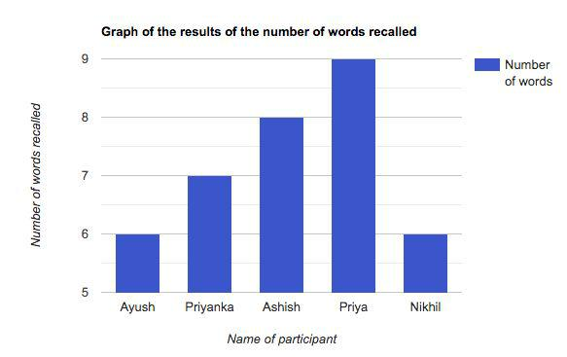

A bar chart showing the number of words recalled by each participant

Inferential:

The highest average of words recalled was in the first trial, where participants were not exposed to any music. When comparing trials 2 and 3, the average number of words recalled were 6 and 5 words respectively. This means that on average, participants could recall more number of words while listening to their favourite music, than unpreferred music. Both SDs are high enough to suggest a spread of data. The SD of 2.07 for the first trial showed a greater data spread around the mean than the SD for the second (1.51) and third

(1) trials.

The highest number of words recalled in Trial 1 was 13 (3 above the mean) and the lowest was 8 (2 below the mean). This suggests that most participants were able to recall easily in a silent environment. The highest number of words recalled in Trial 2 was 9 (3 above the mean), while the lowest was 5 (1 below the mean). This shows that participants could recall easily when they were listening to their favourite music. The highest number of words recalled in Trial 3 was 6 (1 above the mean), while the lowest was 4 (1 below the mean). This shows that participants were not able to recall as many words when they were listening to their least favourite music.

6

EVALUATION

The experiment was successful in demonstrating that musical preferences determine the ability to recall.

A possible limitation of using a repeated measures design is the problem of order effects. The results from each trial depend on which condition comes first. To reduce the problem of order effects, I have used a pattern of first testing the participants in silence, then in music, and the same pattern was used throughout the study for all participants.

The reason for choosing the above material for memorizing the words is because these are common words spoken everyday, if I used tough words that would have been difficult for some of the non native speakers of English.

The possible modification that we can do for further studies is that we can do the same test repeatedly for different genres of music. Different individuals prefer different music but still a lot of studies have found that classical music enhances learning power and rap music does not let the individual concentrate. It would be interesting to explore these aspects.

The strengths of the experiments are that there are enough trials and the methodology is validated and there are no outliers in the data. Another strength of the experiment is that the methodology was strictly followed for all candidates.

The study by Perham and Vizard (2010) showed that the preference of music does not have any significant impact on the performance of serial recall tasks and that any sounds except for stable state speech condition could mediate the irrelevant sound effect. The results of this study could be applied to students who like to listen to music during their study sessions and other educational systems that quiet condition would enhance the performance of memorisation and also recalling. The study also rejected the previous arguments that music could enhance the performance of memorisation and recall tasks by stating that all the sound conditions except for stable speech condition could mediate the irrelevant sound effect.

FUTURE IMPLACTIONS

The aim of the study was helpful in terms of making a focal point for the research and formulating a research question. The aim gave us clear direction in terms of what aspects of the experiment needs to be focused on and then this was the basis for the methodology.

The above results can be used by different professionals in terms of using the same methodology for a larger sample size and more diverse elements for the research. The above results lays out hypothesis for many future researchers.

Although the scope of the experiment was limited in terms of number of trials and complexity, the students and teacher could try various music forms to see if their cognitive ability of learning is enhanced.

But sgain there are studies that counter the above research like the study by Perham and Vizard (2010) showed that the preference of music does not have any significant impact on the performance of serial recall tasks and that any sounds except for stable state speech condition could mediate the irrelevant sound effect
7

BIBLIOGRAPHY

Atkinson, R. C., & Shiffrin, R. M. (1971). The control of short-term memory. Scientific American, 225(2), 82-91.

Christopher, E. A., & Shelton, J. T. (2017). Individual differences in working memory predict the effect of music on student performance. Journal of Applied Research in Memory and Cognition, 6(2), 167-173.

Ebbinghaus, H. (1885). Über das gedächtnis: untersuchungen zur experimentellen psychologie. Duncker & Humblot.

Fassbender, E., Richards, D., Bilgin, A., Thompson, W. F., & Heiden, W. (2012). VirSchool: The effect of background music and immersive display systems on memory for facts learned in an educational virtual environment. Computers & Education, 58(1), 490-500.

Perham and Vizard 2010​.2016. IB Psychology Blog. https://mikipsych.wordpress.com/2016/03/14/perham-and-vizard-2010/#:~:text=%E2%80% 9CCan%20preference%20for%20background%20music%20mediate%20the%20irrelevant%2 0sound%20effect%3F%E2%80%9D&text=This%20study%20showed%20that%20the,could%2 0mediate%20irrelevant%2​.

Additional references:

Standard deviation calculator

https://www.easycalculation.com/statistics/standard-deviation.php

Bar Graph Maker

https://www.rapidtables.com/tools/bar-graph.html

8

APPENDICES

Appendix 1: Participants’ consent form

Informed Consent Form

My name is Shriya. For my IB Diploma IA report, I am conducting a simple experiment on the effect of memory. This consent form is to inform you as to the procedure of the experiment and to gain consent for your participation.

The experiment will involve you in trying to remember a list of common words while listening to different music soundtracks, and then recalling them by writing afterwards. You will not be subjected to any physical or psychological harm, the data will be confidential and your anonymity will be protected. You may withdraw yourself or your data from the experiment at any time. For any further questions which you need to be answered before you sign this form, please contact me at ​bathulashriya@gmail.com​.

I understand the above conditions and give my consent to participate.
Name _____________________ Signature ___________________ Age _________

Appendix 2: Instructions of participation

Standardised instructions to participants

Welcome everyone and thank you all in advance for agreeing to participate in this Psychology memory experiment. The experiment will be conducted in 3 different trials for each participant separately. Each one will be exposed to three different musical environments:

Trial 1- without music

Trial 2- participants listen to their favourite soundtrack Trial 3- participants listen to their least favourite soundtrack

Trial 1

You will be given 5 minutes to memorise a list of 20 words. When the timer starts, you begin to memorise the list for 5 minutes, after which you’ll be given 2 minutes to write down the words that you were able to memorise, as many as you can on a paper.

Trials 2 and 3

You will be given 5 minutes to memorise a list of 20 words. When the timer starts, the music will begin to play and you start to memorise the list of words for 5 minutes, after which you’ll be given 2 minutes to write down the words that you were able to memorise, as many as you can on another paper (a separate sheet for each trial)

9

The words can be rehearsed in any order (free recall task)

When the timer stops again after 2 minutes, you must stop writing.

Do contact me for any other questions

Thank you again for agreeing to take part.

Appendix 3: Debriefing

Thank you for taking part in this experiment. While your papers are being collected, I would be sharing some details of the aim of the experiment: which was to test the effect of preferred music on memory. There were 5 participants in all. The word list was identical, except that each one of you was exposed to a different musical environment as per your choice of most preferred and least preferred soundtracks, which is why to make results fair, the first trial was conducted for everyone while being exposed to a silent environment.

We will share the results of this experiment with you. Please contact us if you need to ask any questions or want to withdraw yourself or your data.

Thank you all once again for your participation

Appendix 4: Word list for participants

- Reason

- Feeling

- Belong

- Leader

- Weak

- Father

- Student

- Resident

- Concern

- Advanced

- Country

10

- Consent

- Study

- Parent

- Number

- Others

- Question

- Money

- Party

- SlIng

Appendix 5: Important details of each participant

Name of the participant | Age of the participant
Ayush | 40
Priyanka | 42
Ashish | 43
Priya | 45
Nikhil | 42

Mean age of participants= ⁴⁰⁺ ⁴²⁺ ⁴³⁺ ⁴⁵⁺ ⁴²
5

- ²¹²₅

- 42.5 yrs

Appendix 6: Raw data and calculation of descriptive statistics

Name of the participant | Number of words | Number of words | Number of words
 | recalled- Trial 1 | recalled- Trial 2 | recalled- Trial 3
Ayush | 8 | 6 | 6
Priyanka | 12 | 6 | 4

11

Ashish | 10 | 7 | 6
Priya | 13 | 9 | 5
Nikhil | 9 | 5 | 4

Calculating the average number of words recalled in each trial

Mean number of words recalled (Trial 1)= ⁸⁺ ¹²⁺ ¹⁰⁺ ¹³⁺ ⁹
5

- ⁵²₅

- 10 words

Mean number of words recalled (Trial 2)= ⁶⁺ ⁶⁺ ⁷⁺ ⁹⁺ ⁵
5

- ³³₅

- 6 words

Mean number of words recalled (Trial 3)= ⁶⁺ ⁴⁺ ⁶⁺ ⁵⁺ ⁴
5

- ²⁵₅

- 5 words

Calculating the standard deviation of the number of words in each trial

_{S} ₌ √Σ(X−M)²
Formula used:
n−1

12
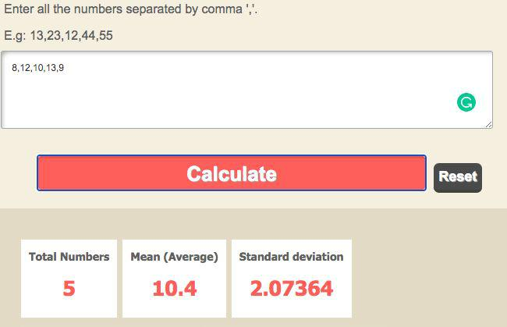

S.D ( Trial 1)= 2.07
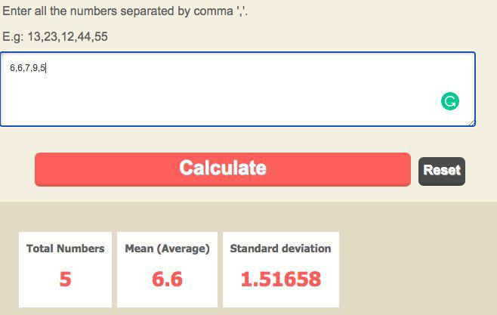

S.D ( Trial 2)= 1.516

13
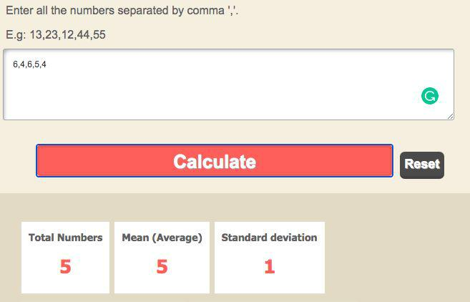

S.D (Trial 3)= 1

