The Dynamics of a Cantilever
Introduction
A cantilever is an inflexible structural element, a projecting beam that is fixed at one end and extend horizontally. In my day to day business, I come across several infrastructures that represent Cantilever like bridges designed to handle road, box girder made from prestressed concrete and trusses built from structural steel. All this tells how importance cantilevers are in mechanical engineering. They are a significant feature in modern architecture. Big bridges and rail traffic that uses trusses built from structural steel, often create amazing and interesting scenes and makes one wonder how they were constructed. However, time after time these structures may collapse. Well to me this has brought a lot of questions amongst them being how does a cantilever acts?
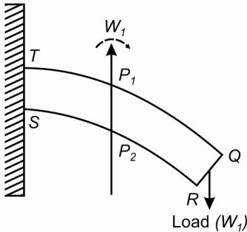
Figure 1 :- Cantilever diagram
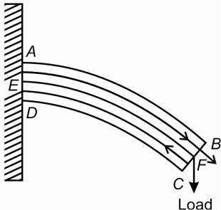
The load C, due to gravity, will pull the Beam as it applies a downward f force on it, making it to bend slightly. The force exerted by the load is eq equal to the force acting at point E. The Beam distributes the load in different different ways. Cantilever takes the load and redistribute up the Beam by compression compression and down through the post. As the distance between the load and and point E reduces, the downward force acting on the Beam reduce hence hence the deflection of the Beam reduce.
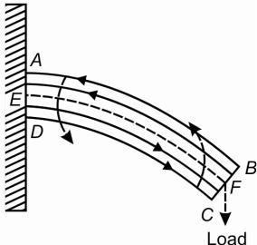

Figure 2 : - Behavior of a cantilever
The length of the distance affects the vertical length of deflection f; therefore, there is a relationship between the two lengths. The distance ‘a’ is proportional to deflection f hence they two will make a linear graph when a graph is drawn. When no force is applied to the Cantilever, it displays a horizontal position. It is because the action and reaction forces are equal.
f ∝ a^{b}
f= (ka^{b}) equation 1
log(f)=log(ka^{b})
log(f)=log(k)+log(a^{b})
Log (f) =log (k) +blog (a)…………equation 2
To practically find the relationship between the reflection length f and the distance a, I measured the deflection distance f in centimeters(cm): 5,10,15,20,25,30,35,40,45. My Cantilever is of 0.2cm thickness. It helped me ensure that I can observany change in deflection.
With this research, the engineer will be able to know the relation between the distance and the deflection length. As they are making the type of Cantilever, they will ensure that the downward force exerted at the Beam is less than the upward one exerted at the other end. This analysis will enable the Cantilever to last for a long time.
Hypothesis
The force applied by the load is equally applied at the other end of the Beam, but in the opposite direction, this makes our force to be constant. Our two variables, f and a, are proportional to each other, indicating that there must be some form of the logarithmic, linear relationship between the two: log(f)=log(k)+blog(a).
Variables
We have different types of variables from the experiment, that is, the independent variable and the dependent variables. The independent variables are variable that causes variation in other variables. Dependent variables are variables whose variation is caused by other variables.
For this experiment, the independent variable will be the intervals between the fixed part and the point on which the force is applied. Distance interval (cm): 5, 10, 15, 20, 25, 30, 35, 40 and 45. The dependent variable will be vertical depression. The changes in the distance intervals cause variation. The experiments also have various controlled variables, the variables that should be kept constant, these are;
Controlled Variables | Reason for Controlling these Variables
Length of the Cantilever | A change in the length of the Cantilever causes a variation in the vertical depression. Increasing the length of the Cantilever causes an increase in vertical depression and vice visas, hence it crucial to maintain a constant length.
The thickness of the Cantilever | An increase in the thickness of the Cantilever causes a decrease in the vertical depression and vice visa. It is, therefore, necessary to maintain the same thickness.
Mass of the slotted mass | Different masses of the slotted mass apply different forces of the Cantilever, therefore causing a variation in the lengths of the vertical depression.
The metal length hanging from the bench/table | An increase of metal length causes an increase in the mass of the suspended Beam, which causes an increase in the force of the Beam hence a high vertical depression is produced. To avoid this ensures that the metal beam is firmly connected to the G-clamp.
The material of the Cantilever | Different materials have a different rate of expansion, therefore bringing about variation in the vertical depression height.

Apparatus
We use the following instruments for the experiment : -
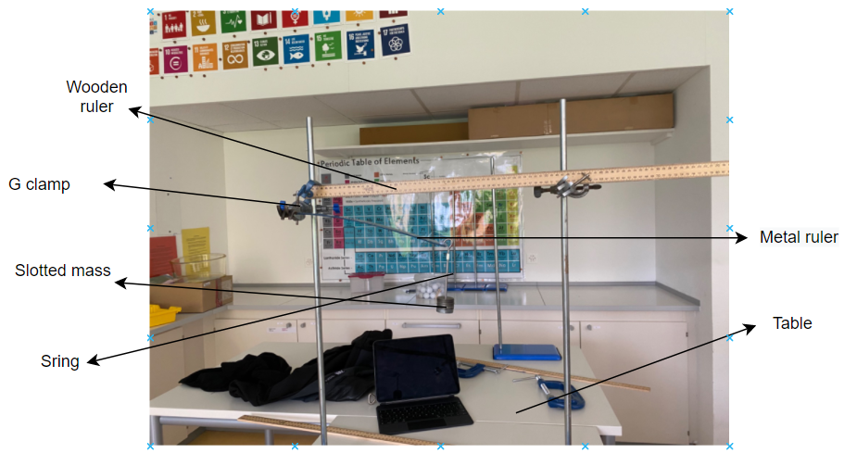
- 1 G clamp
- 1 wooden ruler (100 cm)
- Slotted mass (100 grams)
- Metal ruler (Steel with 1mm thickness)
- Vernier Caliper (error count 0.01cm)
- Masking tape
- Table
- An electric balance (error count 0.1 grams)
- One string

Method : -
Since the metal ruler is calibrated, make sure the metal length attached to the table is 10centimetre, and the spare 90 centimeters are suspending in the air. Use an electronic balance in measuring the mass of the slotted- mass. Maintain the constant weight of the slotted mass throughout the experiment. Ensure that no other solid supports the metal beam apart from G-Clamp and the table. Estimate the initial vertical displacement using the ruler. Calculate the initial vertical depression of the metal beam.

Data Collection
Move the string 5cm along the metal beam. Whenever the string slips downwards, put the masking tape. Use the wooden ruler to estimate the vertical displacement from the suspending metal's end to the floor. Repeat procedure 6 and 7 for other distances: 10cm, 15cm, 20cm, 25cm, 30cm, 35cm, and 40cm. Repeat the data collection procedures 6, 7, and 8 for attempt two and attempt 3.
Risk Assessment
The metal beam has a sharp edge and while taking the eye level reading one should ensure keeping some distance from the beam. The string used for hanging the mass can break any time, ensuring that nothing useful is placed under the slotted mass.
Data Analysis
The table shows the vertical distance (cm) and distance (cm)
 | The attempts to find the vertical distance between the floor and the end of the Beam in cm
Distance f ±0.05 | Trial i | Trial ii | Trial ii | Average vertical distance (cm)
0.0 | 39.5 | 39.5 | 39.5 | 39.5± 0.0
5.0 | 38.7 | 39.3 | 37.6 | 38.5±0.9
10.0 | 36.5 | 36.8 | 35.2 | 36.2 ± 0.8
15.0 | 34.0 | 33.6 | 33.0 | 33.5±0.5
20.0 | 31.0 | 30.6 | 29.9 | 30.5 ± 0.6
25.0 | 28.2 | 27.2 | 26.8 | 27.4±0.7
30.0 | 23.1 | 22.2 | 22.1 | 22.5±0.5
35.0 | 21.1 | 20.4 | 20.1 | 20.5±0.5
40.0 | 19.5 | 18.5 | 18.5 | 18.8±0.5
45.0 | 18.3 | 16.7 | 16.5 | 17.2±0.9
To find the mean displacement for row 3, I used:

$$\frac{Attempt 1+Attempt 2+Attempt 2}{3}$$
To get the mean for row 4;
$$\frac{36.5+36.8+35.2}{3}$$= 36.2

To calculate the range of the mean value, I used
$$\frac{Max value- Min Value}{3}$$
For row 4;
$$\frac{Max value- Min Value}{2}$$
$$\frac{36.8- 35.2}{2}$$= 0.8
Table 4 shows the vertical depression of the Beam and the distance in cm.
 | Depression(cm)
Distance f  ±0.05 | Attempt i | Attempt ii | Attempt iii | Average depression (cm)
0.0 | 30.5 | 30.5 | 30.5 | 30.5± 0.0
5.0 | 31.3 | 30.7 | 32.4 | 31.5± 0.9
10.0 | 33.5 | 33.2 | 34.8 | 33.8 ± 0.8
15.0 | 35.5 | 36.4 | 37.0 | 36.3± 0.8
20.0 | 38.5 | 39.4 | 40.1 | 39.3±0.8
25.0 | 41.3 | 42.8 | 43.2 | 42.4± 0.9
30.0 | 46.4 | 47.3 | 47.9 | 47.2±0.8
35.0 | 48.4 | 49.1 | 49.9 | 49.1± 0.8
40.0 | 50.0 | 51.0 | 51.5 | 50.8± 0.8
45.0 | 52.3 | 52.8 | 53.1 | 52.7±0.4

Calculation
The vertical depression the first row was evaluated using
Distance between the suspension point and the floor – Vertical distance
70cm – 39.5cm = 30.5 cm
Calculation of the error bar for the Vertical displacement
(±0.05) + (±0.05) = ±0.10 = ±0.1 cm
Calculating the average depression for row 3
$$\frac{Attempt 1+Attempt 2+Attempt 2}{3}$$
$$\frac{33.5+33.2+34.8}{3}$$= 33.8cm (1 decimal place)
Calculation of the error bar for row 3
$$\frac{Max value- Min Value}{2} \\ \frac{34.8-33.2 }{2}=0.8$$
Graphical Representation
NOTE. The two black lines between every point in the graph show the Error Bars, but the error bars are too small to be depicted
Graph (i) Exploring the cubic relationship between the two variables
NOTE. The two black lines between every point in the graph show the Error Bars.

Graph (ii) Quadratic relationship between vertical displacement and distance
NOTE. The two black lines between every point in the graph show the Error Bars.

Graph (iii) Linear relationship between vertical displacement and distance
NOTE. The two black lines between every point in the graph show the Error Bars.

From the data collected, graph one, the line intersects all the points, graph 2, the line intersects only four, and graph 3; it intersects two-point only. It shows that the data supports a cubic relationship, which is the opposite of our hypothesis. It could be due to deformation, as seen in Table 4. The depression distance increase from one attempt to the next. Attempt 1< Attempt 2 <Attempt 3. I, therefore, may conclude that the Beam was not elastic.
Table 3
Distance  ∆𝑐𝑚 = ±0.10 | Log (a) | Average depression(cm) | Log (f)
5.0 | 0.69897 | 31.5± 0.9 | 1.49831055
10.0 | 1 | 33.8 ± 0.8 | 1.5289167
15.0 | 1.17609126 | 36.3± 0.8 | 1.55990663
20.0 | 1.30103 | 39.3±0.8 | 1.59439255
25.0 | 1.39794001 | 42.4± 0.9 | 1.62736586
30.0 | 1.47712125 | 47.2±0.8 | 1.673942
35.0 | 1.54406804 | 49.1± 0.8 | 1.69108149
40.0 | 1.60205999 | 50.8± 0.8 | 1.70586371
45.0 | 1.65321251 | 52.7±0.4 | 1.72181062

Graph (iv) Logarithmic relationship between Distance and Depression.
NOTE. The two black lines between every point in the graph show the Error Bars.

log(f) = blog(a) + log (k)
log(k) = 1.426 ( vertical intercept)
n = 0.1541(slope)
log(f) = 0.7913log(d) + 1.426(Equation four)
f = kab
k = 101.426 = 26.7
f= 26.7a0.1541 (Equation five)
Table 3
Distance(cm)  a | Measured depression f1/cm | Calculated depression (f₂)  26.7a0.1541 | z = |f1-f2| | z/%  z’ = ( $\frac{z}{f1}$ )(100)
5.0 | 31.5± 0.9 | 34.2 | 2.7 | 8.57%
10.0 | 33.8 ± 0.8 | 38.1 | 4.3 | 12.7
15.0 | 36.3± 0.8 | 40.5 | 4.2 | 11.58%
20.0 | 39.3±0.8 | 42.4 | 3.1 | 7.89%
25.0 | 42.4± 0.9 | 43.8 | 1.4 | 3.3%
30.0 | 47.2±0.8 | 45.1 | 2.1 | 4.45%
35.0 | 49.1± 0.8 | 46.2 | 2.9 | 5.91%
40.0 | 50.8± 0.8 | 47.1 | 3.7 | 7.28%
45.0 | 52.7±0.4 | 48 | 4.7 | 8.91%

The R square value for the equation is quite high to 0.9372 and hence the equation is acceptable.

Conclusion
This experiment was to determine the relationship between the distance and the depression. There is a logarithmic relation between the two. Forces exerted on the Beam of a cantilever, the upward and the downward force, are equal, then the distance and the length of the vertical depression are directly proportional. We collect data by measuring the vertical distance from the floor and record in table 1. Then calculate the vertical depression in table 3. Afterward, compare different relationships between the distance and the vertical depression and represented them in graphs. The data was then converted to logarithmic form and plotted. All the variables were calculated, and the following equation formed:
log(f) = 0.1541log(a) + 1.426.
f=26.7a0.1541
After plotting the logarithmic graph, we notice that the regression line did not touch the error point. It may be because the Beam was not elastic and deformed. There was a change in the vertical depression as the distance and the external force increases. Overall the exploration was quite successful in exploring the relationship between the two variables and the results were close to the theoretical background knowledge

Evaluation
Additional Suggestions
The distance and vertical depression concept can be used in sport diving from cliffs. It can be used to find out the best place to stand on the diving board.
Merits, Demerits, and improvements
Sources of Errors | Evidence | Improvement
Beam Deformation  Beam deformation occurred during the second trial and the third trial. This deformation leads to an increase in vertical depression. | As the experiment's time increased, it causes the Beam deformation, thus causing an increase in vertical depression. | A new identical beam should be used after every trial. The Beam should be identical in every aspect.
Parallax Error. This error is brought about eye position or angle when reading the measurements. | This factor contributes to the inaccuracy level in the measurement. | For every trial, take an eye-level reading at a constant point and distance.
The string that holds the slotted mass broke four times during the experiment. Every time a string broke, a new string was used without considering the length of the strings. | The slotted mass exerted different weights on each of the several occasions where the string was changed. | Use a string made of more strong material, for instance, twisted fibers.

Strength | Effect
The metal ruler Beam had a thickness of 1mm. | The small thickness helped reduce the margin of Error.
Instead of sticking the Beam directly to the Beam, we used a string to hold the mass. | Attaching the slotted mass to the Beam makes the force exerted by the mass to be redistributed around the area in contact with the Beam instead, we use a string that had a negligible weight and surface area.

Bibliographies
Internet
"Depression Of Cantilever In Engineering Physics | Tech Glads." 2020. Tech Glads. https://www.techglads.com/cse/sem1/depression-of-a-cantilever/.
"Vibrations Of Cantilever Beams:." 2020. Emweb.Unl.Edu. http://emweb.unl.edu/Mechanics-Pages/Scott-Whitney/325hweb/Beams.htm.
Beams, Bending. 2020. "Bending Of Beams." Brainkart. http://www.brainkart.com/article/Bending-of-Beams_6852/.
"Single Load Cantilever Beam Deflection Calculator." 2020. EPSILON ENGINEER. https://www.epsilonengineer.com/single-load-cantilever-beam-deflection-calculator.html.
"Cantilever." 2020. Thefreedictionary.Com. https://encyclopedia2.thefreedictionary.com/cantilever.
"7.4 The Cantilever Method | Learnaboutstructures.Com". 2020. Learnaboutstructures.Com. http://www.learnaboutstructures.com/Cantilever-Method.
"Cantilever Beams - Moments And Deflections." 2020. Engineeringtoolbox.Com. https://www.engineeringtoolbox.com/cantilever-beams-d_1848.html.
"Cantilever Beam Shear Stress Calculation - The Best Picture Of Beam." 2020. The Best Picture Of Beam. http://www.cannondigi.com/cantilever-beam-shear-stress-calculation/.
"ANSYS - Cantilever Beam - Simcafe - Dashboard." 2020. Confluence.Cornell.Edu. https://confluence.cornell.edu/display/SIMULATION/ANSYS+-+Cantilever+Beam.
Mathewson, Glenn. 2020. "Cantilevers In The 2015 Code". Professional Deck Builder. https://www.deckmagazine.com/design-construction/framing/cantilevers-in-the-2015-code_o.
Books
Wilcox, R. M. (Ralph McIntosh). n.d. Theory And Calculation Of Cantilever Bridges.
Rogers, Jonathan, and Mark Costello. n.d. Cantilever Beam Design For Projectile Internal Moving Mass Systems.
Findley, C. F., 1887. Cantilever Bridges.
Crews, John H, K. N Shivakumar, and I. S Raju. 1987. Factors Influencing Elastic Stresses In Double Cantilever Beam Specimens. Hampton, Va.: National Aeronautics and Space Administration, Langley Research Center.
Ratcliffe, James G., 2010. Sizing Single Cantilever Beam Specimens for Characterizing Facesheet/Core Peel Debonding In Sandwich Structure. Hampton. Va.: National Aeronautics and Space Administration, Langley Research Center.

"Depression Of Cantilever In Engineering Physics | Tech Glads". 2020. Tech Glads. https://www.techglads.com/cse/sem1/depression-of-a-cantilever/.
"Vibrations Of Cantilever Beams:". 2020. Emweb.Unl.Edu. http://emweb.unl.edu/Mechanics-Pages/Scott-Whitney/325hweb/Beams.htm.
Beams, Bending. 2020. "Bending Of Beams". Brainkart. http://www.brainkart.com/article/Bending-of-Beams_6852/
"Single Load Cantilever Beam Deflection Calculator." 2020. EPSILON ENGINEER. https://www.epsilonengineer.com/single-load-cantilever-beam-deflection-calculator.html
"Cantilever." 2020. Thefreedictionary.Com. https://encyclopedia2.thefreedictionary.com/cantilever.
, "Cantilever Beam Shear Stress Calculation - The Best Picture Of Beam." 2020. The Best Picture Of Beam. http://www.cannondigi.com/cantilever-beam-shear-stress-calculation/
"ANSYS - Cantilever Beam - Simcafe - Dashboard." 2020. Confluence.Cornell.Edu. https://confluence.cornell.edu/display/SIMULATION/ANSYS+-+Cantilever+Beam
Mathewson, Glenn. 2020. "Cantilevers In The 2015 Code". Professional Deck Builder. https://www.deckmagazine.com/design-construction/framing/cantilevers-in-the-2015-code_o
Wilcox, R. M. (Ralph McIntosh). n.d. Theory And Calculation Of Cantilever Bridges
Rogers, Jonathan, and Mark Costello. n.d. Cantilever Beam Design For Projectile Internal Moving Mass Systems.

