Mathematics Internal Assessment

Calculating the cost of fencing for my agriculture land

November 2020

Table of Contents

RATIONALE: - 3
AIM…………………………………………………………………………………………………………………………………………………………4
INTRODUCTION………………………………………………………………………………………………………………………………………5
IMPOSING THE GRID ON THE IMAGE OF LAND………………………………………………………………………………………10
CALCULATING THE PERIMETER OF LAND………………………………………………………………………………………………13
ESTIMATING THE COST OF FENCING………………………………………………………………………………………………………21
CODING IN PYTHON……………………………………………………………………………………………………………………………….22
EVALUATION………………………………………………………………………………………………………………………………………….23
CONCLUSION…………………………………………………………………………………………………………………………………………24

Rationale: -
Majority of population in India, gets its income from the agricultural sector and likewise the agricultural land we own is a great source of income for our family. In recent times there were several thefts in the adjoining agricultural lands. We called an urgent meeting in which all the landowners were involved. It was unanimously decided that we would fence the land. It looked a simplistic job, and a contractor was hired. Hence, I decided to integrate this situation into my mathematics IA and try to estimate the cost of fencing. While doing some research I explored that as simple as this problem might look, finding the perimeter of a curve is not as easy task. This will help me verify the quotation given by the contractor and help make my family some cores business decisions.
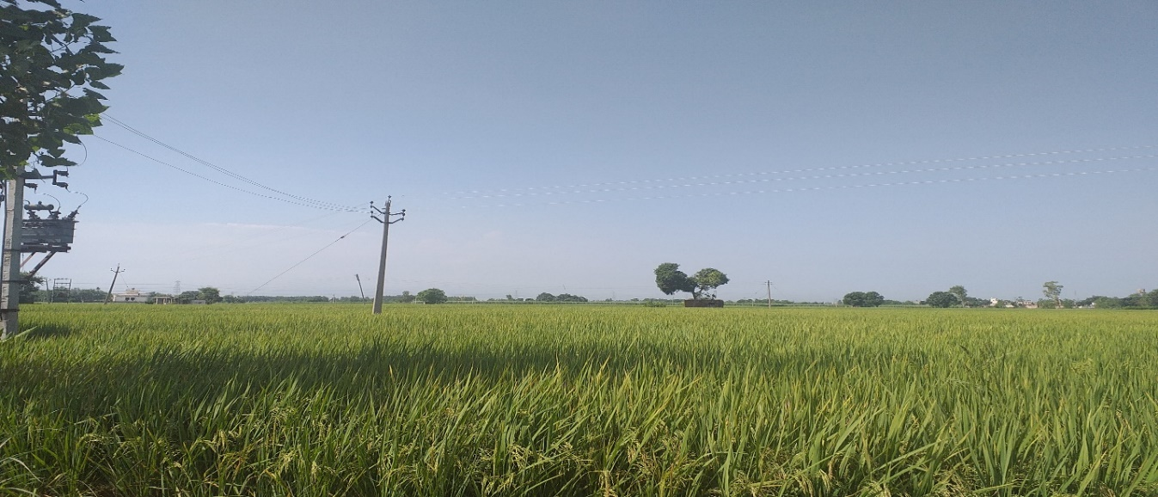
Hence my topic has wider implications in terms of planning the financial operations of the land and the process can be tough as its an irregular polygon. Lastly the exploration has practical uses in terms of determining the approximate costs for keeping the land safe ! Below is the rough boundary drawn on Google earth for the piece of land I will investigate: -
Image 1: Agricultural Land to be investigated
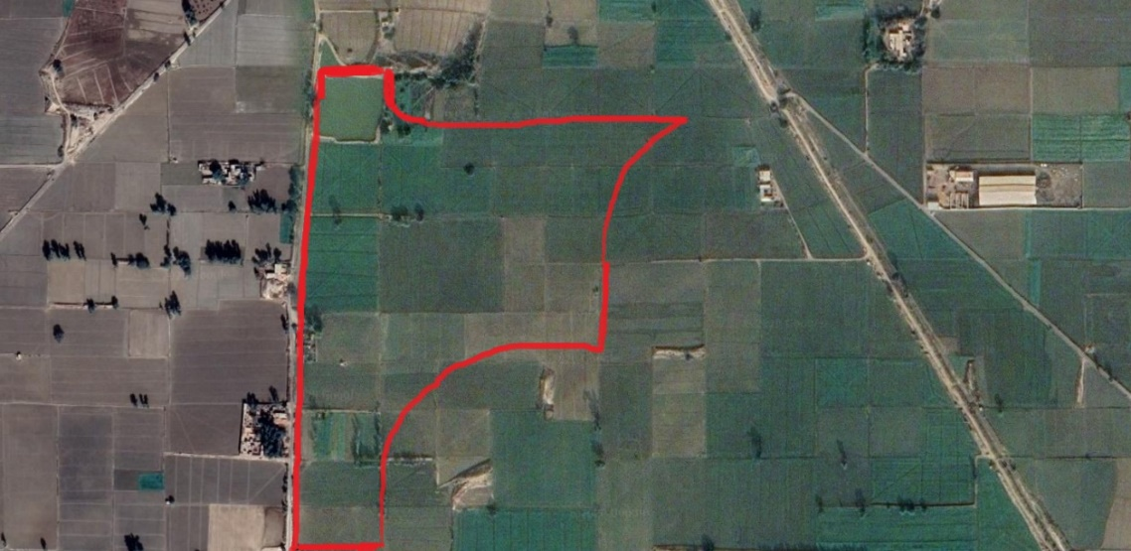
Image 2:- Determining the boundary of our land
Source: - Google Earth Editor: - Paint
Aim: -
The aim of the exploration is to find the perimeter of the land through mathematical techniques and using the Google Earth simulation. Then subsequently finding the cost of fencing the field by multiplying the perimeter with average cost quoted by the contracted pre kilometre

Introduction: -
During IBDP we have been taught various concepts regarding determining the area and perimeter of different shapes. Let us explore some of the key concepts with the most basic shapes: -
We can explore the shape rectangle
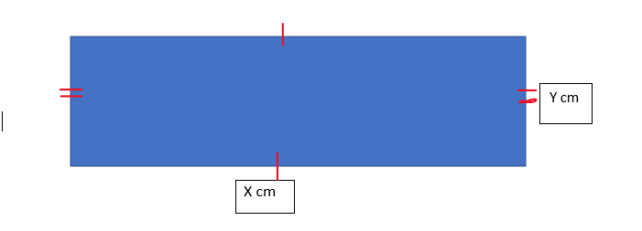
Image 3: Rectangle with sides X and Y
The perimeter of rectangle is = 2X+2Y
=2(X+Y)
Now we can move onto the perimeter of a curved shape, the circle: -
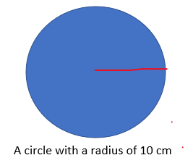
Image 4: A circle with a radius 10 cm
The circumference of the circle is = $2×π×R$
= $2×π×10$
= 20$π$
Now we talk about a small arc of a circle and if we are given the radius of the circle, we can find out the length of the arc with the following method: =

The length of the arc can be found by the following formula: -
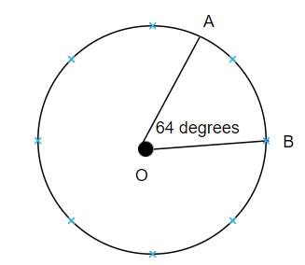
Image 5 : Arc of a circle AB with an angle of 64 degrees
Length of the arc = $\frac{θ}{360}×2π×R$
= $\frac{64}{360}×2π×4$
= 4.47 cm

Now we explore the distance formula which helps us find the distance with the given coordinates: -
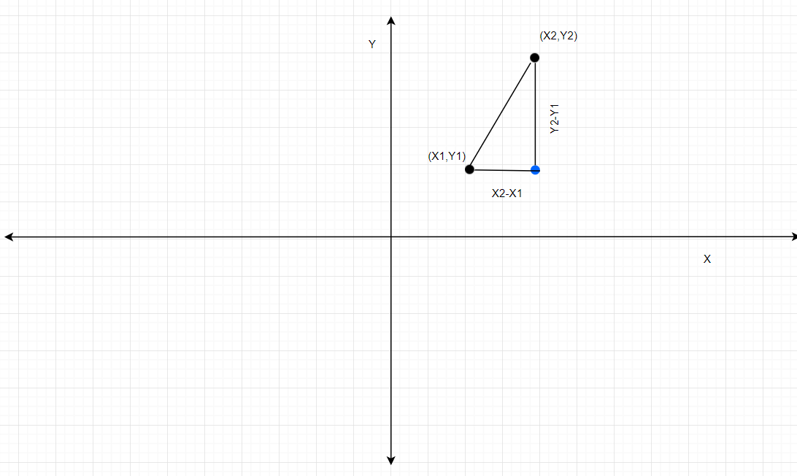
Image 6 : The distance formula using Pythagoras theorem
By simply applying the Pythagoras theorem we can find out the following distance formula. One side is ($X_{2}-X_{1}) and the other side is (Y_{2}-Y_{1})$: -
Length of a line in a coordinate plane = $\sqrt{(x_{1}-x_{2})+(y_{1}-y_{2})}$
But now when we tackle the real problem, we are faced with the challenge to find the length of a curve or a function. Hence, we are here to investigate through the IBDP course and online research to find a way to find the perimeter of a function. The method discovered is the Reimann Sums for finding the length of the given functions.
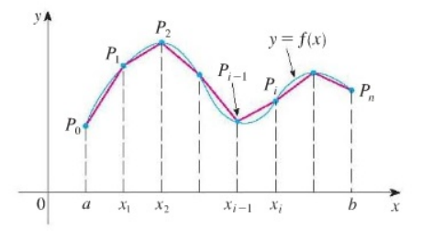
Image 7: The Deriving the Riemann sum
Source: nd.edu
Suppose we have a curve represented by $y =f(x)$ and for this investigation we consider the domain [a,b]. The assumptions we make here is that the function f(x) is differentiable and continuous on the given interval [a,b] and another assumption we make is that its derivative is also continuous on the given interval [a.b].
Now the length of each segment can be denoted by: - $\left|P_{i-1}P_{i}\right|$ where I = 1, 2, 3, 4…n.
To find an estimate length of the function we can add the length of each segment and this expression can be denoted by the following: -
$$L≈\sum_{i =1}^{n}{\left|P_{i-1}P_{i}\right|}$$
The reason it is an approximation, because the length of each small segment is not equal to the length of the function in that particular segment, rather its an approximation.
But certainly, if we increase the number of segments, we can get a more accurate result. Hence, we limit n which is the number of intervals and send it to infinity: -
$$L = \lim_{n ->∞}{\sum_{i =1}^{n}{\left|\left|P_{i-1}P_{i}\right|\right|}}$$
Now we change the representation of the interval. The distance between the x coordinates as referenced from the graph above is $∆x = \frac{b-a}{n}=\left|x_{i-1}x_{i}\right|$. Let us apply the distance formula that we applied above: -
$$\left|P_{i-1}P_{i}\right|=\sqrt{{(x_{i}-x_{i-1})}^{2}+{({f(x)}_{i}-{f(x)}_{i-1})}^{2}}$$
After using some simple algebraic tools we can represent the above equation as : -
$$\left|P_{i-1}P_{i}\right|=∆x \sqrt{1+[\frac{{({f(x)}_{i}-{f(x)}_{i-1})}^{2}}{x_{i}-x_{i-1}}]}$$
To make this formula into a definite integral, we need to introduce the mean value theorem and the theorem has the following statements: -
Let us take a function f(x) and we assume the following things: -
f(x) is continuous on the closed interval [a,b]
f(x) is differentiable on the open interval (a,b)
Now le us illustrate the function f(x) : -
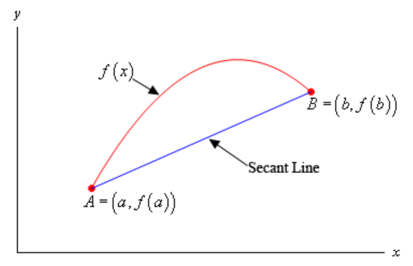
Image 8: Deriving the mean value theorem
Source: - Draw.io
To start with let us find the equation of the secant line by the slope intercept formula: -
$$y = f(a) + \frac{f(b)-f(a)}{b-a}(x-a)$$
Let us introduce another function g(x), and it equals to the difference between f(X) and the secant line. This leads us to the following expression: -
$$g(x) = f(x) - f(a) -\frac{f(b)-f(a)}{b-a}(x-a)$$
We know that g(x) is made from the function of f(x) which we already stated to be continuous on [a,b] which is a linear polynomial and hence we can conclude that g(x) is also continuous on the domain [a,b]. Similarly, by the same logic, g(x) is differentiable on the domain (a,b).
Now let us find the derivative of g(x) : -
$$\grave{g}(x) = \grave{f}(x) - \frac{f(b) - f(a)}{b - a}$$
Finally, we can conclude the following expression: -
$$g(a) = f(a) - f(a) - \frac{f(b) - f(a)}{b -a }(a-a) = f(a) - f(a) = 0$$
$$g(b) = f(b) - f(a) - \frac{f(b) - f(a)}{b - a}(b-a) = f(b) - f(a) - [f(a)-f(b)]=0$$
Now these three above conditions satisfy the Rolle’s Theorem, and we know that there must be a point c which satisfies a < c < b: -
$$0 = \grave{g}(c) = \grave{f}(c) - \frac{f(b) - f(a)}{b-a }$$
and this proves the mean value theorem: -
$$\grave{f}(c)=\frac{f(b) - f(a)}{b - a}$$
Now let us apply the mean value theorem to the above expression of Riemann sum: -
$$\left|P_{i-1}P_{i}\right|=\sqrt{{(x_{i}-x_{i-1})}^{2}+{({f(x)}_{i}-{f(x)}_{i-1})}^{2}}=∆x \sqrt{1+[\frac{{({f(x)}_{i}-{f(x)}_{i-1})}^{2}}{x_{i}-x_{i-1}}]}$$
Now let us apply the mean value theorem: -
$$L =\lim_{n ->∞}{\sum_{i =1}^{n}{\left|\left|P_{i-1}P_{i}\right|\right|}} = \lim_{n ->∞}{\sum_{i =1}^{n}{\sqrt{1+{\left|\acute{f}(x_{i})\right|}^{2}}}}∆x=\int_{a}^{b}{\sqrt{1+{\left|\acute{f}(x_{i})\right|}^{2}}}∆x = \int_{a}^{b}{\sqrt{1 +{\left|\acute{f}(x_{i})\right|}^{2}}} dx$$

Imposing a grid on the image of a land

We divide the picture in different parts to find the perimeter: -
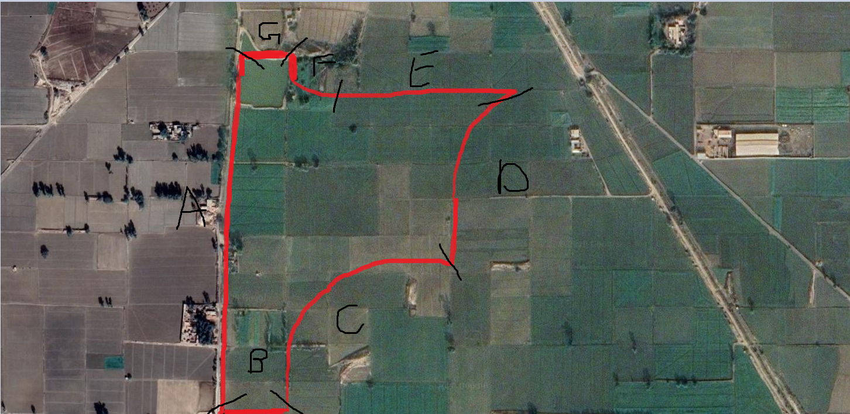
Image 9: - Dividing the picture into various regions based on their characteristics
The agricultural land’s boundary was divided into several parts and it was based on the mathematical tool for finding out the perimeter. The following table represses the classifications and the methods we will use to find out the perimeter: -
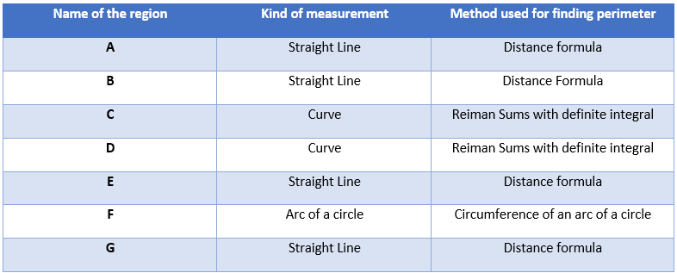
Image 10: The table representing the methods for each segment
Now for finding those specific coordinates, I imposed a 2d coordinate grid using the software GeoGebra on the image taken from Google Earth. Geo Gera gave us the following coordinates and I intentionally put all of them in the first quadrant for calculation purposes. The following represents the points on the image: -
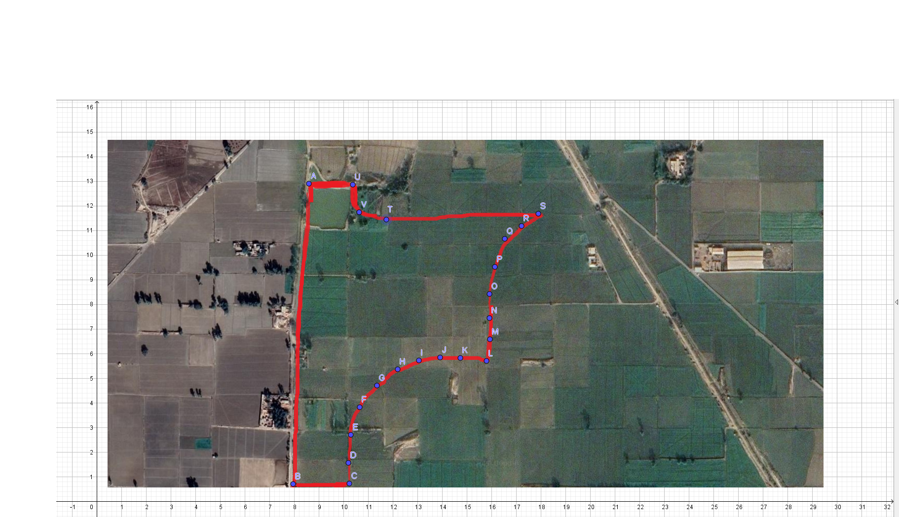
Image 11: Imposing points on the boundary using GeoGebra

Points | Coordinates (x,y)
A | (8.6, 12.9)
B | (7.96, 0.7)
C | (10.24, 0.72)
D | (10.2, 1.56)
E | (10.3, 2.7)
F | (10.66, 3.82)
G | (11.36, 4.7)
H | (12.2, 5.36)
I | (13.06, 5.72)
J | (13.92, 5.84)
K | (14.74, 5.82)
L | (15.8, 5.7)
M | (15.94, 6.58)
N | (15.92, 7.44)
O | (15.92, 8.42)
P | (16.14, 9.52)
Q | (16.54, 10.66)
R | (17.22, 11.18)
S | (17.9, 11.68)
T | (11.74, 11.44)
U | (10.38, 12.86)
V | (10.64, 11.74)

Image 12: Coordinates from GeoGebra
Note: - We did not round of the coordinates to 3 significant figures to be accurate and use the maximum decimal points given by GeoGebra.
There was a specific logic in placing points for example: - the straight lines perimeter can be found by just placing a start point and an ending point. The curves are placed with multiple points because we will use the Langrage’s Interpolation method to find out the function. The scale from ground to the picture was taken care by setting the google earth images as 1 unit is equal to 700 meters on ground.

Calculating the perimeter of the land
A
Region A was a straight line and hence we will take the start point and the end point which are A = (8.6, 12.9) and B = (7.96, 0.7) and apply the distance formula to find the perimeter of A : -
$$Length of a line in a coordinate plane = \sqrt{{(x_{1}-x_{2})}^{2} + {(y_{2}-y_{1})}^{2}}$$
$$=\sqrt{{(7.96-8.6)}^{2}+{(0.7-12.9)}^{2}}$$
=12.21 units’ square
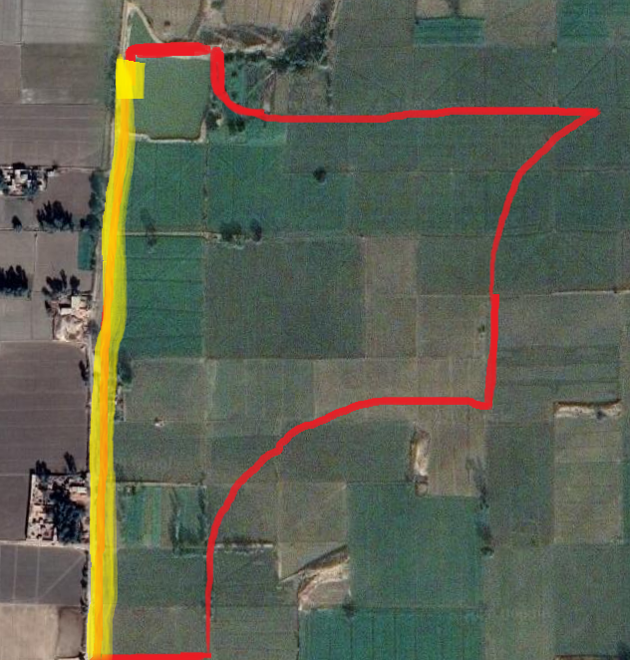
Image 13: Finding the perimeter of A
B and G
From the figure we can conclude that B and G have the same length and hence we can calculate one of them and then double it. Let us calculate B and the coordinates are: - B = (7.96, 0.7) and C = (10.24, 0.72).
Again, we need to apply the distance formula: -
$$Length of a line in a coordinate plane = \sqrt{{(x_{1}-x_{2})}^{2} + {(y_{2}-y_{1})}^{2}}$$
$$=\sqrt{{(7.96-10.24)}^{2}+{(0.7-0.72)}^{2}}$$
= 2.28
So, B and G together will be 5.56-unit square
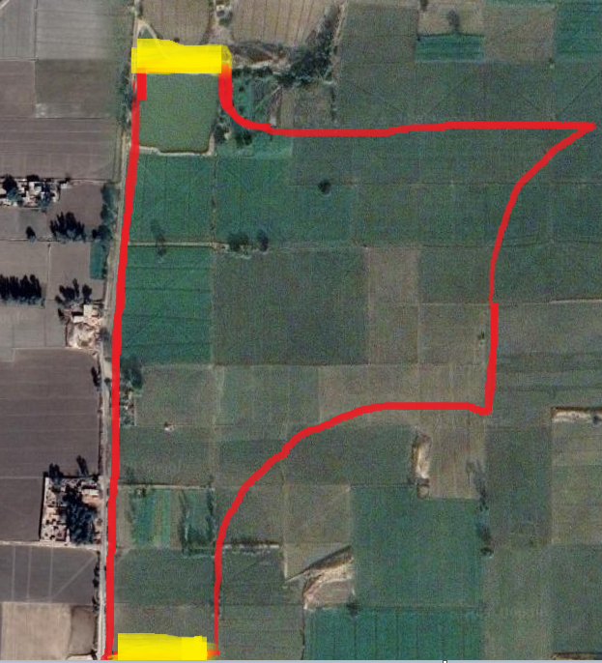
Image 14: Finding the perimeter of B and G
E
For E too, we need to apply the distance formula as it is a straight line seemed. The coordinates are as follows: - S = (17.9, 11.68) and T = (11.74, 11.44)
$$Length of a line in a coordinate plane = \sqrt{{(x_{1}-x_{2})}^{2} + {(y_{2}-y_{1})}^{2}}$$
$$=\sqrt{{(11.74-17.9)}^{2}+{(11.44-11.68)}^{2}}$$
= 6.16 units’ square
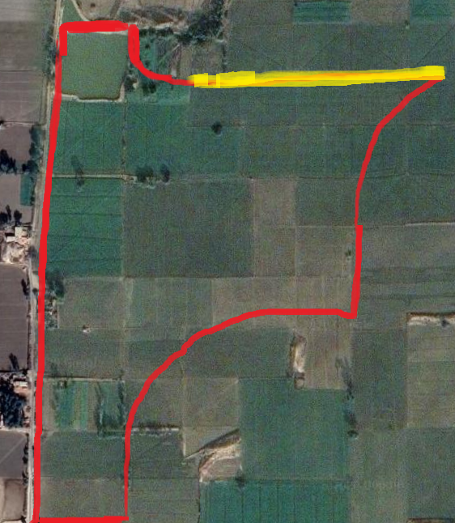
Image 15: Finding the perimeter of E
F
For F, we need to apply the arc length formula and from the Google Earth software. From the circle tool I was able to determine that the angle of the arc was 60 degrees for the circle arc and hence we can apply the following formula: -
$$Length of an arc = \frac{θ}{360}×2×π×R$$
Now the problem arises as we don’t know the radius of the whole circle, but we do have the three coordinates on the arc which is a part of the circle and from the following situation we can deconstruct the following diagram: -
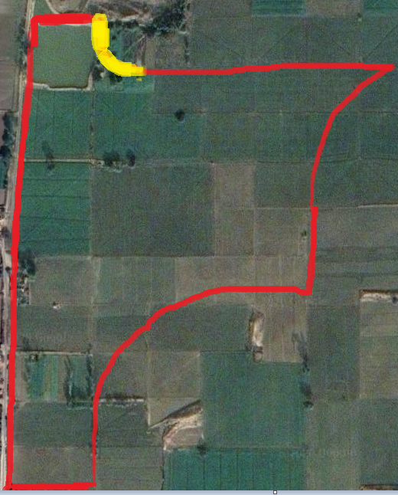
Image 16 : - Finding the perimeter of F
Image 17: - Determining the radius
We can apply the distance equation and then by forming a simultaneous equation we can get the centre of the circle: -
$$\sqrt{{(11.74-x)}^{2}+{(11.44-y)}^{2}}=\sqrt{{(10.64-x)}^{2}+{(11.74-y)}^{2}}$$
$$\sqrt{{10.38-x)}^{2}+{(12.86-y)}^{2}}=\sqrt{{(10.64-x)}^{2}+{(11.74-y)}^{2}}$$
Instead of solving these equations we can graph the two equations and find the intersection point to find the coordinates for the centre of the circle. We plotted the equations in Desmos
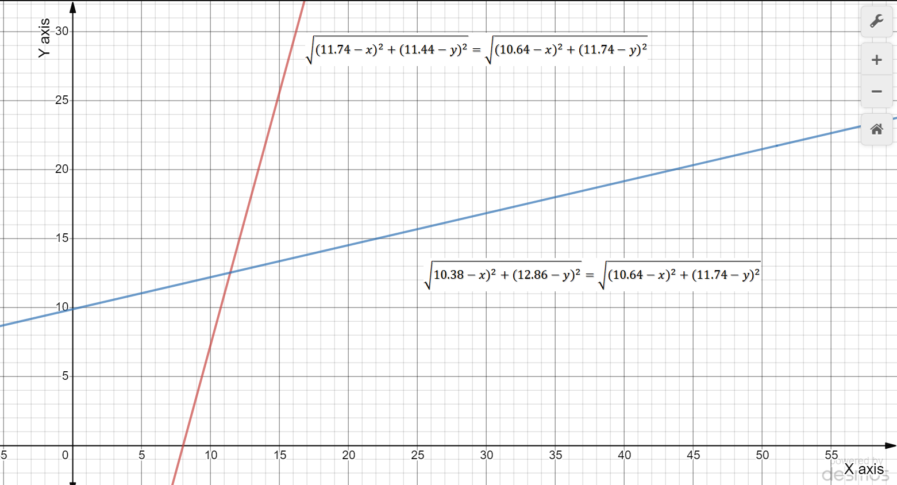
Image 18: Finding the intersection point
The results are Centre (11.44,12.51).
Hence now we can find the radius as follows: -
$$\sqrt{{ (11.74-11.44)}^{2}+{(11.44-12..51)}^{2}}$$
= 5.32 square
And now we can find the circumference of the sector: -
$$Length of an arc = \frac{θ}{360}×2×π×R$$
$$Length of an arc = \frac{60}{360}×2π×5.32$$
= 5.57 units’ square

C and D
Now these are curves and hence we need to use the method we derived above called the definite integral of Reimann Sum and for that we need a function. For the two curve we need a function.
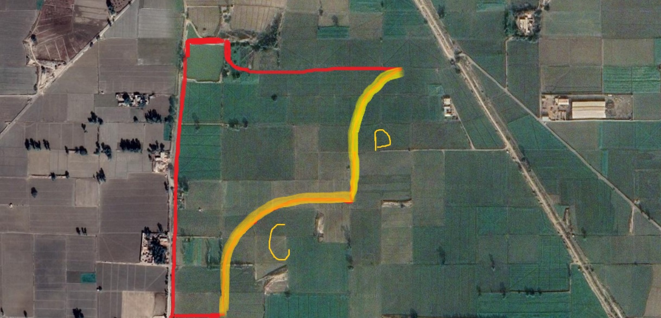
Image 19: Finding the perimeter of curves C and D
The coordinates for C and D curves are the following and they were not taken at two significant digits for accuracy and the highest decimal point given by GeoGebra: -

The C curve has the following coordinates The D curve has the following coordinates
C | (10.24, 0.72) | L | (15.8, 5.7)
D | (10.2, 1.56) | M | (15.94, 6.58)
E | (10.3, 2.7) | N | (15.92, 7.44)
F | (10.66, 3.82) | O | (16, 8.82)
G | (11.36, 4.7) | P | (16.14, 9.52)
H | (12.2, 5.36) | Q | (16.54, 10.66)
I | (13.06, 5.72) | R | (17.22, 11.18)
J | (13.92, 5.84) | S | (17.9, 11.68)
K | (14.74, 5.82)
L | (15.8, 5.7)

For finding the functions from a point we use the Lagrange polynomial Interpolation method. The method states that for a given set of points (x,y) with no two x same. The method can be explained by the following image:
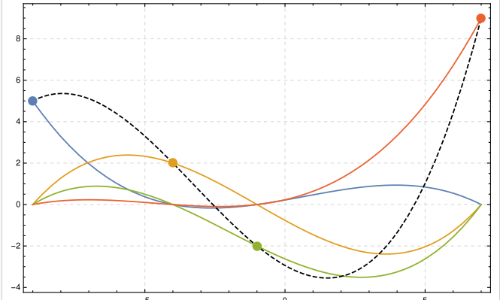-
Image 20: Deriving the LaGrange polynomial
We can see that there are four distinct points on the coordinate plane and for each there is function passing through that point. Lagrange polynomial finds the best fit for all the individual points and creates an independent function represented by the black dotted line. Hence this will be the best way to find out the polynomial with the given coordinates as we have to find the function which fits all the coordinates.
The formula for Lagrange polynomial function is as following: -
$$L(x) = \sum_{j=0 }^{k}{y_{j}l_{j}(x)}$$
And the langrage polynomial equals to: -
$l_{j}\left(x\right)=\prod_{0≤m≤k}{=\frac{x - x_{m}}{x_{j} - x_{m}}}$=$\frac{x - x_{m}}{x_{j} - x_{m}}.\frac{x - x_{m1}}{x_{j} - x_{m2}}.\frac{x - x_{m3}}{x_{j} - x_{m3}}$ +…………………
Let us apply the following Lagrange polynomial function to our equation: -
For curve C: -
$$C_{j}\left(x\right)= 0.72.\frac{x - 10.2}{10.24-10.2}.\frac{x - 10.3}{10.24 - 10.3}....................+5.7\frac{x - 10.24}{15.8-10.24}.\frac{x - 10.3}{15.8 - 10.3}........$$
The expression was calculated, and it cannot be displayed due to the volume of calculations.
Finally, we get the equation: -
−2.39239$x^{9}$+268.5$x^{8}$−13353.2$x^{7}$+386245$x^{6}$−7.16118×${10}^{6}x^{5}$+8.82581×${10}^{7}x^{4}$−7.23078×${10}^{8}x^{3}$+3.79747×${10}^{9}x^{2}$−1.16011×${10}^{10}x$+1.57076×${10}^{10}$
Lets simplify it for our further calculations by rounding off all the decimal places: -
$C_{j}\left(x\right)=$-2$x^{9}$ + 269 $x^{8}$ – 13353 $x^{7}+$386425$x^{6}$ + 7161180$x^{5}+88258100x^{4} - 723078000x^{3}+3797470000x^{2}- 11601100000 x + 15707600000$
Now let’s calculate the polynomial for the second equation: -
$$D_{j}\left(x\right)= 5.7.\frac{x - 15.94}{15.8-15.94}.\frac{x - 15.92}{15.8 - 15.92}.................+11.68\frac{x - 15.8}{17.9-15.8}.\frac{x - 15.94}{17.9 - 15.94}........$$
The expression was calculated, and it cannot be displayed due to the volume of calculations.
Finally, we get the equation: -
$D_{j}\left(x\right)=$−5114.6$x^{7}$+591260.$x^{6}$−2.92841×${10}^{7}x^{5}$+8.05524×${10}^{8}x^{4}$−1.32906×${10}^{10}x^{3}$+1.31532×${10}^{11}x^{2}$−7.22961×${10}^{11}$x+1.70253×${10}^{12}$
We simplify the equation for calculation purposes: -
$$D_{j}\left(x\right)= -5115x^{7} + 591260 x^{6} - 29284100x^{5}+805524000x^{4}-13290600000x^{3}131532000000x^{2}-72296100000x + 1702530000000$$
Now let us apply the formula of Reimann sums that we derived above: -
$$\int_{a}^{b}{\sqrt{1 +{\left|\acute{f}(x_{i})\right|}^{2}}} dx$$
As you can see, we also need to find the derivative of the functions and then find the integral: -
$C_{j}\left(x\right)=$-2$x^{9}$ + 269 $x^{8}$ – 13353 $x^{7}+$386425$x^{6}$ + 7161180$x^{5}+88258100x^{4} - 723078000x^{3}+3797470000x^{2}- 11601100000 x + 15707600000$
$\acute{C}(x)= -18x^{8}+2152x^{7}-93471x^{6}+2318550x^{5}+14322360x^{4}+353032400x^{3} -2169234000x^{2}+7594940000x - 11601100000$
$$D_{j}\left(x\right)= -5115x^{7} + 591260 x^{6} - 29284100x^{5}+805524000x^{4}-13290600000x^{3}+131532000000x^{2}-72296100000x + 1702530000000$$
$$\acute{D}(x)= -35805x^{6}+32347560x^{5}-146420500x^{4}+3222096000x^{3}-39871800000x^{2}+263064000000x – 72296100000$$
Now we can finally find the integrals: -
For curve C: -
$$\int_{a}^{b}{\sqrt{1 +{\left|18x^{8}+2152x^{7}-93471x^{6}+2318550x^{5}+14322360x^{4}+353032400x^{3} -2169234000x^{2}+7594940000x - 11601100000\right|}^{2}}} dx$$
And the bound for C will be b = 15.8 and a = 10.24 (From the coordinates table)
For curve D: -
$$\int_{a}^{b}{\sqrt{1 +{\left|35805x^{6}+32347560x^{5}-146420500x^{4}+3222096000x^{3}-39871800000x^{2}+263064000000x – 72296100000\right|}^{2}}} dx$$
And the bound for D will be b = 17.9 and a = 15.8 (From the coordinates table)
We solved these integrals using an integration calculator, as the calculations were too voluminous to do: -
For curve C the integral value was 9.71 and for curve D the value was 8.64
Total cost of fencing the field: -
Name of the part | Perimeter
A | 12.2
B | 2.28
C | 9.71
D | 8.64
E | 6.16
F | 5.57
G | 5.56

Total perimeter = 50.64 units
The scale on the Google Earth was set to 1 Unit equals to 700 meter and hence the total perimeter to be fenced is:
$$50.6×0.7=35.4 kilometers$$
The contractor said that per km he will charge 2000 INR with the copper wire included and hence the total cost comes down to: -
$$35.4 kilometers×2000 = 70800 INR$$

Coding in Python: -
As I am a computer science student, I was intrigued by the method of Riemann sums and wanted to model this method in Python. I am very much interested in mathematical science and hence I generated the following code:
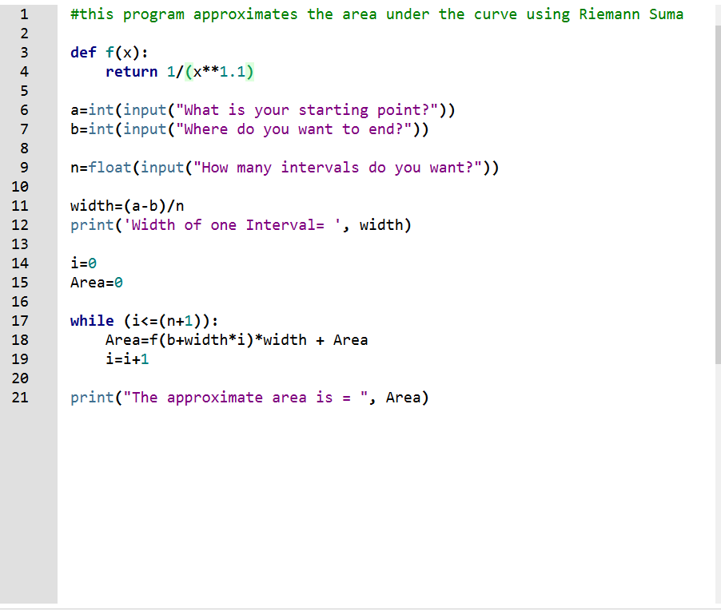
Image 21: Coding in Python
-You can define your function in the start of the program and currently I defined my f(X) as $\frac{1}{x^{1.1}}$
The function takes in the bounds and then takes in the number of intervals. For a sample testing of my function I decided on the following parameters and got the following results:
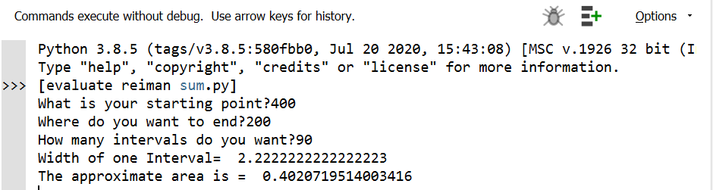- Image 21: Results of the polynomial

We can change what function we want to evaluate at the start of the code and get any desired answer. Although I did not run my function here because of the volume and complexity of calculations.

Evaluation: -
- The calculations were not manageable to be executed manually hence online calculators were used for the process. To improve this, we could have approximated our equation to perform the steps manually.
- With the given resources I could only use the only virtual earth mapping tool which is Google Earth, and it didn’t demarcate the specific boundaries our family’s land and hence approximations were drawn.
- While shifting the picture of Google Earth to GeoGebra, intense care was taken to not cause a resize of the picture.
- I could have used multiple scales and repeated the same process in order to find out the correctness of the result.
- The usage of significance figure was kept to 2 in most cases and hence the accuracy might be affected
- For curves, a big sample size of coordinates was taken so that correct and accurate functions are formed.
- An online geo-mapping service could be used to confirm the result
- For easy calculations and manual working, I could have been cautious in the start by placing the coordinate points as whole numbers as then the calculations become easier and there are fewer decimal points.
- There are some gates at the boundary wall which don’t need to be fenced and hence there might be an overestimation.

Reliability of the Reiman sum model:
There is always an error in the Reiman sum model and there is a special formula to estimate the error. Unfortunately, it’s very difficult to calculate the error as our integrals are leading to extremely high coefficients for the calculations. Although this is certain that through the method, the exact length of the curve is not estimated due to the error in the Reiman sum method.

Reliability of the Lagrange’s Interpolation model:
Advantages –
The answers for higher order polynomial are very accurate in our case.
For the higher order derivatives, the error of the derivative is significantly less, and the error decreases by $2^{n+1}$ if we decrease the distance between the interpolation by 2 points.
Disadvantage –
It becomes a hard job to calculate as the polynomial order increases and we need to evaluate the approximate solutions at each point and hence it leads to certain inaccuracies.

Conclusion

The exploration started with an investigation into the cost of fencing the family agricultural land and a map was taken off from Google Earth, and the land was located. The scale factor at that time was noted and it was 1cm to 700 meters and this was thoroughly calibrated while using Google Earth. The boundaries were manually drawn as Google Earth will not catch the subtle demarcations. A little piece of the boundary looked like an arc and hence the angle of the arc was measured by the internal tool in Google Earth. Then we explored the different methods for finding the perimeter in different cases. Then furthermore we proved the Reimann sum equation using the mean value theorem and established the base for our exploration.
We divided the boundary in seven different segments and each one was described, and the method of perimeter calculation as specified. In total three methods were used which were the distance formula, the arc of a circle and the Riemann sum. The distance formula was easy to apply and the method gave precise answers. Then we used the method using the radius and the angle. The situation was tricky as we did not have the radius of the circle and hence by forming a simultaneous equation using the distance formula, we determined the radius. Subsequently finding the length of the arc sector. Furthermore, we used Riemann sums and it presented extremely lengthy and unfeasible calculations and hence online calculators were used. It included the calculators of integrations and differentials and we came down to a result which were not extremely precise.
In the end, we added all the perimeters and converted it into the ground perimeter by multiplying It with the scale, which was 0.7 km. Hence, we found the perimeter of the land and multiplied it with the contractors price which 2000 INR per kilometer and the final price was determined to 70800 INR. Although an approximate number, my family members do have a correct idea of how much to budget for this important activity and to a great extent my exploration was successful.

References:
- https://internalassessments.files.wordpress.com/2018/01/wm-sarah-changs-mathematical-exploration.pdf
- https://math.dartmouth.edu/~m3cod/klbookLectures/409unit/arcLength.pdf
- https://tutorial.math.lamar.edu/Classes/CalcII/ArcLength.aspx
- https://www.derivative-calculator.net/
- https://www.emathhelp.net/calculators/calculus-2/arc-length-calculus-calculator/?ft=x&f=-96957x%5E4%2B%286.25464*10%5E6x%5E3%29-+1.5128*10%5E8*x%5E2%2B1.62596*10%5E6x-6.55238*10%5E9&a=10.50682&b=17.25173&steps=on&random_integer=10
- https://www.integral-calculator.com/
- https://www.expii.com/t/definite-integral-as-a-limit-of-riemann-sums-241-
- https://www.mathwords.com/a/arc_length_of_a_curve.htm
- Calculus Made Easy, Silvanus P. Thompson and Martin Gardner
- https://wiki.geogebra.org/en/Tutorials
- https://www.geogebra.org/a/14?lang=en
- More Calculus Books
- Google Earth

https://www.integral-calculator.com/

