Global Politics IA

UWC Atlantic College
How is the Enbridge Northern Gateway pipeline a cause of conflict between the First Nations in British Columbia and the Government of Canada?

Word Count: 1997

Introduction

Canada possesses the second largest oil reserves in the world behind Saudi Arabia.¹ Enbridge, an oil company, has proposed the “Northern Gateway” project, consisting of two 1,177 km pipelines from Alberta, where 97% of Canadian oil reserves are located, to British Columbia ( BC ).² 225 “super tankers” a year would transport oil from the coastal town of Kitimat to Asian ports.³ This essay addresses the question “How is the Enbridge Northern Gateway Pipeline a cause of conflict between the First Nations and the Canadian Government?” I pursued this issue because the pipeline could directly impact the future of the natural environment surrounding my home, as I grew up in Vancouver, living by the coast. Furthermore, I live next to a First Nations reserve, I have been very aware of the controversy of the First Nations within Canadian society and welcomed the opportunity to investigate it further. All around the world, a debate is going on regarding the reconciling of the perusal of profits and protection of the environment. Furthermore, challenging dynamics between the governments and minority groups exist worldwide. As this issue has parallels to other situations happening world wide, I feel that it is worthy of investigation. The struggle between the Canadian government and the First Nations involves “Key Concepts” involved in Global Politics such as Globalization, Power, Conflict, Human Rights, and Non-Violence. I explored these terms through first hand experience with non-violent protest, in the form of an anti-pipeline First Nations led rally and march through Vancouver.

- “ A Key Industry for Canada,” accessed August 10, 2014, http://www.total.com/en/energies-expertise/oil-gas/exploration- production/strategic-sectors/eho/oil-sands/canada-oil-sands/key-industry-canada.
- “Project Overview,” accessed August 5, 2014, http://www.gatewayfacts.ca/about-the-project/project-overview/.
- “Project Overview.”

Ongoing Debate:

Before officially approving the Northern Gateway Pipeline, the Canadian government, led by Prime Minister Stephen Harper, made the initiative’s benefits clear. The first advantage would be a “diversification of Canada’s energy markets”.⁴ Currently, US based oil companies’ account for 99% of Canada’s oil exports.⁵ There is a desire reduce reliance on US markets, and a belief that it is of “ vital interest”⁶ to be more interconnected economically with Asian countries and beyond through BC, the “Gateway to the Asia Pacific”⁷. Harper also believes that the “Western world would rather buy energy from stable democracies like Canada.”⁸ The pertinence of this point has been emphasized by the increasingly volatile situation in Iraq.⁹ Portions of Iraq have been taken over by militants.¹⁰ The situation has caused oil prices to swell, with the international benchmark breaching 114$ for the first time in 9 months on June 13th 2014.¹¹ Consequently, Canada’s oil has become an even more valuable commodity - a situation which has given me a greater understanding of the implications of living in a globalized world. The pipeline "would be a catalyst for a generation of substantial and widely distributed economic stimulus for Canada and a significant contributor to sustaining Canadian growth and
prosperity for many years into the future.”¹² This new vision of Canada as prosperous ‘petrol

- Ian Bailey, “ Northern Gateway not a Sure Thing, Harper Says,” The Globe and Mail, January 6, 2014, accessed July 20, 2014, http://www.theglobeandmail.com/report-on-business/industry-news/energy-and-resources/northern-gateway-not-a-sure-thing-harper- says/article16223614/)/.
- Theophilos Argitis, “ If Obama Doesn’t Approve the Keystone Pipeline, Another President Will, Says Harper,” National Post, February 10, 2014,

accessed July 22, 2014, http://business.financialpost.com/2014/02/10/keystone-oil-pipeline-harper/?
federated=1&
lsa=657c-7254.

- “ Harper Defends Independence of Pipeline Approval Process,”, CBC News, August 7, 2012, accessed July 24, 2014, http://www.cbc.ca/news/politics/harper-defends-independence-of-pipeline-approval-process-1.1130434.
- “ Building Markets, Growing Jobs,” Canada’s Pacific Gateway.
- Argitis, “ If Obama Doesn’t Approve the Keystone Pipeline, Another President Will, Says Harper.”
- Mark Shenk, “Oil Topping 116$ Possible as Iraq Conflict Widens,” Bloomberg News, June 16, 2014, accessed August 1, 2014, http://www.bloomberg.com/news/2014-06-15/oil-topping-116-seen-possible-as-iraq-conflict-widens.html.
- Shenk, “Oil Topping 116$ Possible as Iraq Conflict Widens.”
- Shenk, “Oil Topping 116$ Possible as Iraq Conflict Widens.”
- P. Eglington, R. Mansell, J. Ruitenbeek and R. Schlenker, “Public Interest Benefit Evaluation of the Enbridge Northern Gateway Pipeline Project: Update and Reply Evidence,” Wright Mansell Research Ltd.: 13, August 11,2014, https://docs.neb-one.gc.ca/ll-

state’ fueling the world has altered Canada’s international reputation for being an environmental steward.¹³ This shift was emphasized when Canada become the only nation to drop out of the Kyoto protocol¹⁴, which I now suspect was in order to develop Canada’s fossil fuel sector without having to face emission penalties. While the Canadian government is backs the pipeline, public opinion remains polarized.
71% of British Columbians oppose “allowing crude oil tankers through BC’s coastal waters”, and 57 % strongly disagree.¹⁵ The opposition is formed by community groups, environmental groups, politicians and, most significantly, the First Nations people whose lands and waters that they maintain a claim over would be traversed by the proposed pipelines and tankers.¹⁶ Enbridge has offered them “a 10 per cent equity stake in the project to be divided among the communities directly affected by the pipeline.”¹⁷ Only 11 out of 27 communities in BC have consented, most are adamantly opposed.¹⁸ First Nations leader Audrey Seigl said that “we survived hundreds of years of genocide… we will not allow what was done to us to be done to the earth”.¹⁹ Because consultation with the First Nations is required by law, these BC First Nations are the most influential of all of the pressure groups, and may bear the power to halt this project.²⁰

eng/llisapi.dll/fetch/2000/90464/90552/384192/620327/624798/833081/B83-4_-_Attachment_2_-_Public_Interest_Benefit_Evaluation_-
_Update_and_Reply_Evidence_-_A2V1R8.pdf?nodeid=832978&vernum=0.
- Cam Brewer ( Environmental Lawyer and former treasurer for Green Peace) in discussion with Author, June 17, 2014. ( See Appendix 1 ) 14 Bill Curry and Shawn McCarthy, “ Canada Formally Abandons Kyoto Protocol on Climate Change,” The Globe and Mail, September 6, 2011, accessed July 28, 2014, http://www.theglobeandmail.com/news/politics/canada-formally-abandons-kyoto-protocol-on-climate- change/article4180809/.
- “Opposition to Northern Gateway Pipeline and Tanker Proposal Strengthening,” Justason Market Intelligence, last modified October 11, 2012, accessed July 28, 2014, http://www.justasonmi.com/?p=3073.
- Brewer, interview.
- Julie Gordon, “ Many First Nations See No Compromise on Oil Sands Pipeline,” Reuters, April 21, 2014, accessed August 8, 2014, http://www.reuters.com/article/2014/04/21/canada-pipeline-aboriginals-idUSL2N0N716U20140421.
- Gordon, “ Many First Nations See No Compromise on Oil Sands Pipeline.” 19 Audrey Siegle, (Anti-Pipeline protest speech, Georgia Street, July 17, 2014.) 20 Brewer, Interview. ( See Appendix 1 )

Engagement Activity

At 1 pm on June 17th 2014, Stephen Harper announced the government of Canada’s approval of the Northern Gateway Pipeline.²¹ An hour later, I received a notification through social media that a rally was underway, which reminded me of the role of social media as a political tool. I raced out of the house to downtown Vancouver. The rally was strategically being held between the headquarters of Canada’s largest broadcasting company and the government’s office. The street blocks around the area were cleared, and I nervously made my way past several policemen on motorbikes monitoring the area.²² At the rally, I listened to First Nations representatives present speeches to a large crowd of both First Nations and “settlers”.²³ Afterwards, to the beat of First Nations drums, I marched with the crowd through the centre of the city, weaving through cars, stopping rush hour traffic.²⁴ Cheers of “Hey! Ho! Stephen Harper has got to go!” filled the air, joining signs which displayed messages ranging from “ British Columbia is not for sale” and “ Protect Aboriginal Land” to the more incendiary “ Enbridge – the real Eco-Terrorist” and “Down with Harper”. At Vancouver’s busiest intersections, everyone formed a massive circle, and we participated in native warrior chants.²⁵ A protestor gave me a bag of anti-pipeline buttons, which I distributed among bystanders. While marching, I interviewed local environmental lawyer Cam Brewer. Finally, we marched to a major bridge which we blockaded for an hour.²⁶
- Shawn McCarthy, Steven Chase, and Brent Jang, “ Canadian Government Approves Enbridge’s Controversial Northern Gateway Pipeline,” The Globe and Mail, June 17th, 2014, accessed August 5, 2014, http://www.theglobeandmail.com/report-on-business/industry-news/energy- and-resources/northern-gateway-decision/article19180594/.
Audrey Siegle, (Anti-Pipeline protest speech, Georgia Street, July 17, 2014.)
- See Appendix 2
- See Appendix 3
- See Appendix 4
- See Appendix 5
- See Appendix 6

Gene Sharp is a foremost authorities on Non-violent struggle, which he says include “peaceful methods of non-cooperation.”²⁷ Sharp postulates that the Non-violent struggle that I participated in “is based upon the very nature of power in society and politics.”²⁸ He defines power as the “totality of all influences and pressures.” He theorizes that the power that leadership posses is not “intrinsic”, rather, rulers are “Dependent for their political power upon the cooperation of their subjects.”²⁹ Therefore, through non-violent protest, the power of the ruler weakens.³⁰ I compared the event to Sharp’s list of 198 methods of Non-violent protest, and found that I was involved several of the methods of non-co-operation that he identified, including an “assembly in protest”, “public speeches”, “slogans”, “banners and posters”, “singing”, and “marching”³¹. Gene Sharp theorized that “once there is a willingness to suffer sanctions as a price of charge, non co-operation becomes possible.” This was demonstrable, as at the rally Chief Phillip accepted that “some of us are going to jail, because that’s what its going to take.” Experiencing this protest first hand gave me a much greater understanding of Sharp’s theories and of non-violent conflict as an avenue to attempt to bring about change.

Current Conflict

All around the world, the value of the natural environment is being weighed against potentially significant economic implications. I realized that the conflict between the First Nations and the government is really a microcosm of this global debate. The Canadian
Government pursues capitalist modernity, which according to Andrew Heywood, involves

- Gene Sharp, The Role of Power in Non-Violent Struggle, ( Boston: The Albert Einstein Institution, 1990) 10. 28 Gene Sharp, The Role of Power in Non-Violent Struggle, ( Boston: The Albert Einstein Institution, 1990) 1. 29 Gene Sharp, The Role of Power in Non-Violent Struggle, ( Boston: The Albert Einstein Institution, 1990) 10. 30 Gene Sharp, The Role of Power in Non-Violent Struggle, ( Boston: The Albert Einstein Institution, 1990) 11. 31 “198 Methods of Non-Violent Action,” Gene Sharp, accessed August 12, 2014, http://www.aforcemorepowerful.org/resources/nonviolent/methods.php.

“individual self-seeking, materialism, economic growth and so on.” Meanwhile, the First Nations appear to give weight to Green politics, also known as ecologism. Andrew Haywood defines ecologism as “A political ideology that is based on the belief that nature is an interconnected whole.” This seems like a logical position for the first nations to take, especially given their culture and heritage which places great importance on the environment – naturally, they are very concerned about fossil fuel consumption, global warming, and the social costs of general environmental degradation, which are all issues the ecologism attempts to address. I believe that many First Nations are adhere to reformist ecology, as they are interested not in halting economic growth entirely but in sustainable development. However, Enbridge is “responsible for over 800 spills between 1999 and 2010, with more than 25.67 million liters of oil released.”³² The proposed tanker route is through a narrow channel littered with pristine islands, which increases the risk of an ocean spill.³³ The pipeline project is seen as unsustainable development. The conflict over the pipeline has party arisen because, contrary to the Canadian government, the First Nations don’t believe that the social and environmental costs outweigh the economic benefits.

The pipeline issue also links to ethical issues regarding the First Nations. The pipeline creates a conflict, as if the project does go ahead despite First Nations opposition, the Harper government may be violating First Nations rights. In BC, the First Nations were “dispossessed of their lands” without treaties.³⁴ Therefore, it makes sense that at the rally that I attended, Siegle

- Richard Girard, “ Out on the Tar Sands Mainline: Mapping Enbridge’s Dirty Web of Pipelines, ” The Polaris Institute ( March 2012): 53, accessed August 5, 2014, http://www.tarsandswatch.org/files/Updated%20Enbridge%20Profile.pdf.
- “Story of Corporate Deceit: How Enbridge Erased BC Islands,” David Suzuki Foundation, accessed August 7, 2014, http://www.davidsuzuki.org/issues/oceans/projects/healthy-oceans/pacific-ocean-stories/story-of-corporate-deception-how-enbridge-erased- bc-islands-1/.
- “Indian Land,” last updated modified November 8, 2008, accessed August 17, 2014, http://www.firstnations.de/indian_land.htm.

welcomed the crowd to the “traditional unceded land of the Musquiem people”.³⁵ There are currently 59 different treaty negations of land claims, involving almost 2/3 of the First Nations people in B.C underway. According to the BC Treaty Commission, “BC treaty negotiations are arguably the most complex set of negotiations ever undertaken in the world”.³⁶ These legal processes which may formalize traditional land claims are important, as Article number 19 of the UN Declaration of the Rights of Indigenous Peoples, which Canada signed in 2010, as well as Canadian law, requires adequate consolation with the First Nations in order to proceed with any activity that occurs in their land. ³⁷ Article 26 specifies that “Indigenous peoples have the right to own, use, develop and control the lands, territories and resources that they possess by reason of traditional ownership”, while Article 29 goes on to declare that “Indigenous peoples have the right to the conservation and protection of the environment and the productive capacity of their lands or territories and resources.”³⁸ At the rally, Chief Stewart said that “…the Harper government has declared war on the rights of indigenous peoples…This is a human rights issue, and we have every right to protect the futures of our children and grandchildren.”³⁹ First Nations believe that even if their territories aren’t yet formally recognized by the state, they have right to stop pipeline development on their traditional lands. Chief Phillip at the rally when he said that said “I’m a pacifist, but I’m not sure for how much longer I’m going to remain that way”.⁴⁰ The frustration over the government’s disregard of First Nations rights may lead to

- Audrey Siegle, (Anti-Pipeline protest speech, Georgia Street, July 17, 2014.)
- “Aboriginal Rights,” BC Treaty Commission, accessed August 11, 2014, http://www.bctreaty.net/files/issues_rights.php.
- “ United Nations Declaration on the Rights of Indigenous Peoples,” United Nations, March 2008, accessed August 17, 2014, http://www.un.org/esa/socdev/unpfii/documents/DRIPS_en.pdf.
- “United Nations Declaration on the Rights of Indigenous Peoples,” United Nations, March 2008, accessed August 17, 2014, http://www.un.org/esa/socdev/unpfii/documents/DRIPS_en.pdf.
- Chief Stewart, (Anti-Pipeline protest speech, Georgia Street, July 17, 2014.)
- Chief Philip, (Anti-Pipeline protest speech, Georgia Street, July 17, 2014.)

other means of protest being sought out in the near future. The longer the conflict over the pipeline goes on, the higher the possibility that the conflict might intensify.

Conclusion:

The pipeline is causing a conflict, as expressed through non-violent protest, by clashing the rights and values of the First Nations with the Governments of Canada’s desire for the economic prosperity of the Canada. I believe that it’s possible for the First Nations and the government to resolve this conflict and work together on other, more sustainable development for both group’s benefit. The Northern Gateway pipeline presents the government with an opportunity to show the First Nations that, especially as signatories of the UN Declaration of the Rights of Indigenous Peoples, they respect those wishes which have been made clear by the non-violent protests. I think that if the government were to recognize the First Nations wishes (and the wishes of the majority of BC ) and not allow the pipeline to go ahead, it would be a historic decision which could even set a precedent worldwide for other disputes with aboriginal groups over the environments and the uses of traditional lands. The First Nations may realize that their voices are being taken into consideration, and as such will not be tempted to worsen the current conflict by turning to violent means of protest. The groundwork for meaningful conflict resolution, especially regarding the wider issue of First Nations land claims, could be established. The reality, however, is that, given the magnitude of the economic benefits, and it is unlikely that peace between the First Nations and the Canadian government over the pipeline will be reached in the near future.

Appendix 1

Transcript of Interview with Cam Brewer, July 17, 2014.

Author: What do you do at Ratcliff Law Firm?

Cam Brewer: Well this summer I’m an articled student. So what doe sit entail? It basically entails doing whatever legal work lawyers ask me to do. So a lot of my work has been focused

on the Kinder Morgan project, and because these national energy board approvals, which is the stage that its at, are incredibly complex and detailed there’s just a lot of detailed kind of boring work to go through the application and find pieces that we can use either for the media or for ourselves. And then the other legal things I’ve done, there are some cases, for example there’s a First Nations case – I’m going to go up to fort St. johns in July to represent because someone is suing them. The first nation has a lot of businesses, and one of them has a contract with this company, and then the contract went sideways and so now they’re suing each other. SO I do a lot of research , everything from the little things to a big thing I’m working on for example is the constitutionality of Burnaby bylaws vs. what the federal government says so the federal government says” We’re going to put this pipeline here” what powers do municipalities have over their bylaws that say “ you’re not meeting our building code or “ we’re not going to give you a building permit “ or “ we’re not to direct traffic” or “ we’re not going to supply you with water or fire services” … so that’s a constitutional issue regarding the division of powers eight o you do some research into what the case law is… so that’s a big question…
Author: How has that gone so far… do you think that the federal government does…

Cam Brewer: Well ultimately the federal government does have most of it, because the constitution says that that provinces have powers over municipalities but the federal government has power over pipelines which aren’t included because in 1867 when the constitution was drafted there weren’t such things as pipelines, but they are federal works and undertakings… and federal works are the physical things and undertaking are the businesses that surround the works. So the pipeline project is an undertaking, and because it is a federal undertaking, if they determine that it is in the best interest of Canada, they can put in wherever they want basically. But, its not quite that simple, there’s details about it.. do you frustrate the federal purpose by saying that you have to put it 10 ft over there rather than over here probably not – if you say that you have to move it 100 kilometers somewhere else maybe you do frustrate the federal purpose… and that’s the common law, the constitutional ( how the courts have interpreted the constitution).. so that part of it is kind of interesting.
Author: What implications do you foresee if the Northern Gateway project were to go forward?

Well I guess from the micro to the macro it’s a huge question… from the vey small scale there’s the potential of leaks and so on in all different places, and the fragile eco systems, both terrestrial and marine, through the mountains and on the coast and the tankers and the effect on the whales in there and how do you get to a mountain top somewhere in the winter time during a storm what do you do? I mean its hard enough to fix a pipeline… so all those sorts of problems… so if there was ever a leak it would really obviously screw up that whole area. The other thing is that at a sort of medium scale … the fact that people would just sort of give in. because there are pipeline proposals all over the place. There’s the Kinder Morgan one through

Burnaby the Northern Gateway one up there. There is the LNG pipeline proposal and Christy Clark’s idea that that’s going to save our province and that the whole future is that, its also the same idea that it’s the tar sands, so all the different pipeline – keystone etc. people will just think “ Oh well, its just going to go forward anyways… there is sort of this feeling that its inevitable… and then the problem with that is that of course it that it then allows us to just say “ Well we’re going to get every drop of oil out of the tar sands that we possibly can and we’re going to sell it. An so everybody in the world has a right to use it, we’re going to ignore the science around climate change, we’re going to ignore the science around what’s happening in the tar sands itself and because now we’ve got connections these markets, and we’re not even going to bother adding value to it because we’re not going to put refineries in Canada we’re just going to export the raw materials as fast as we possibly can. We’re basically becoming a petro state. We just forget our values Globally, our responsibilities to other countries, especially developing countries, the vulnerable countries around the climate change around, we forget our responsibility to be a citizen that look more broadly beyond our own selfish interests, and all we think about is the value in the short term in selling the tar sands so if the pipeline goes through it just locks un into this future of draining the tar sands and selling it to the world. So that, to me is the bigger issue. The National Energy Board said, and I’m not sure about the scope of the hearing for Northern Gateway pipeline, but for the kinder morgan pipeline, they said “ We’re not going to talk about it. We’ve decided that the scope of the evaluation will not consider any upstream concerns about the tar sands and how we’re going to continue to pull out all the oil sands and sell it, and we’re to consider any downstream concerns about who is buying the oil and what they’re going to do about it, and we’re not going to talk about climate change. One of the pushbacks ( Ecojustice/ForestEthics) is saying that the scope should be broadened because there are all these other issues, but the NEB said no, we’re not going to talk about that at all, we’re just going to talk about the route of the pipeline.
Author: So the national energy board is under the National Energy Board Right?

Cam Brewer: It’s a body, which determines whether federal works and undertaking are within the national interest. The Harper Government just a few years ago changed the law so that even if the national energy board says its not a good idea, Steven Harper can still say “ we’re going to o it anyways”.SO if they say yes – he’ll approve it. If they say no – he’ll approve it. And again it comes back to the idea of a petro state – we’re not considering any other alternatives, we’re just saying “ Oh we’ve got all this oil – lets sell it”. That’s what makes it so frustrating – I mean the hearing is a joke, its totally biased, it’s a pre-determined outcome, and even if you say no, Steven Harper will approve it anyway. If we give in, we’re committed to selling the tar sands oil regardless of what we know about climate change. And then there are the first nations – that’s going to be the more complicated trying to put it through because there are so many nations in

the way and the courts have been very strong about the approval, so its going to be more difficult to get it past the first nations.
Author: Do you think that Canada becoming a petro state is damaging to Canada’s reputation?

Cam Brewer: Yes – I think our reputation in the last 0 years globally has really gone backward – you know back in the Pearson Trudeau sort of years it was developed this idea that we’re a responsible nations, and wield soft power as a global citizen in a whole bunch of ways, everything from pulling gout of the treaty to combat desertification.. why did we do that? It makes no sense… it ruins the reputation of the country and it and out political ability to do other things that we do want to do, because we’re not responsible global citizens any more.
Author: Concerning the Enbridge pipeline in particular, who do you see as being the most influential pressure group?
Cam Brewer: Definitely the First Nations as they’re in the strongest position legally… because of the NEB and the way it is all set up, every environmental group can say oh this is awful but in the end it is up to harper to decide – Christy Clark has just really been waffling… she wanted to be elected she came up with those conditions. They’re all crap…as long as she can save face on it she’ll just approve it.. with the first nations though, because it can take so long to work through all the individual court cases hat might come out of it, t has to happen is if it goes through their territory ey can either claim a right f various kinds or title, which is a ype of right. If they are claiming title, and the strength of their claim is relatively strong, then there has to be a concomitantly strong consultation, the stronger the claim the stronger the consultation. If they completely object to it and so on, then that process can take a very long time, so suddenly it doesn’t matter what the NEB has said or what harper has said, it moves out of the executive branch and moves into to he court which can then hold it up, or ages because its not just one, its many, many first nations.. the company will just get frustrated, you know we can’t wait another 20 years to go through all the court cases so lets just pipe it east though Ontario or down to Texas or something. The other thing is that if there is enough political pressure in BC, if there are enough people against it, and Christy Clark starts to think that her reputation and her ability to be continue premier and the popularity of her party depends on her being on the right side of this issue she might then block it in some way. Again it then comes back to legally, she can’t really block it, but it becomes incredibly politically difficult for Stephen Harper to push a pipeline through here when the province is so completely opposed to it. So that might work, but I think it’s secondary to the First Nations.

Appendix 2

Police Monitor the Rally. Photo Taken By Author, July 17th, 2014.

Appendix 3
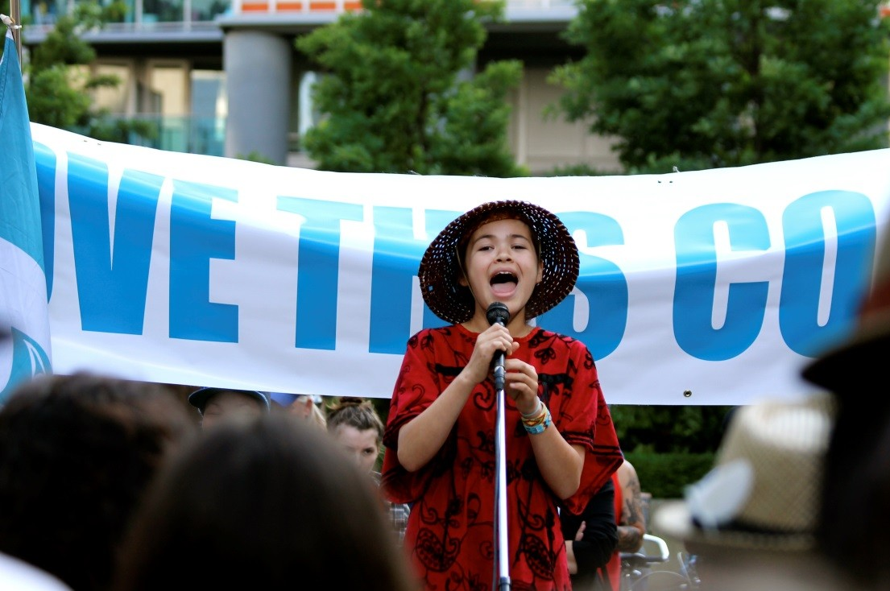

First Nations Speaker at Rally. Photo taken By Author, July 17th, 2014.

Appendix 4
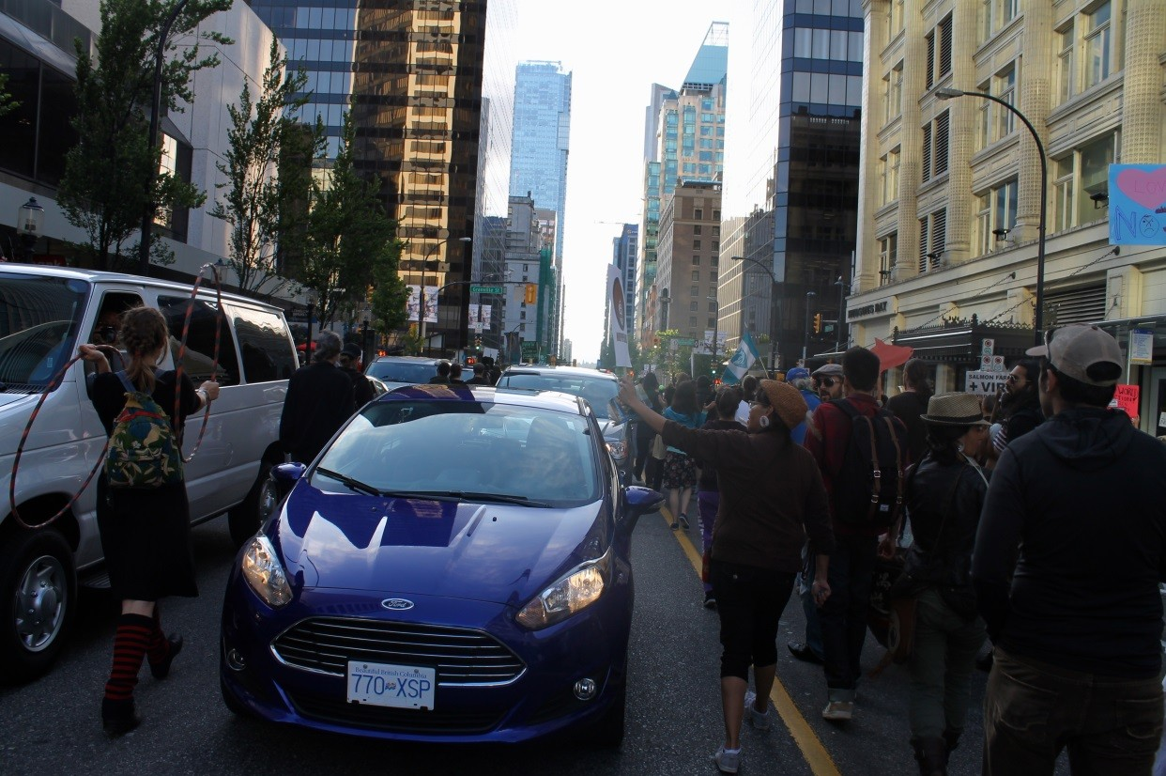
Protestors March Through traffic. Photo Taken by Author, July 17th 2014.

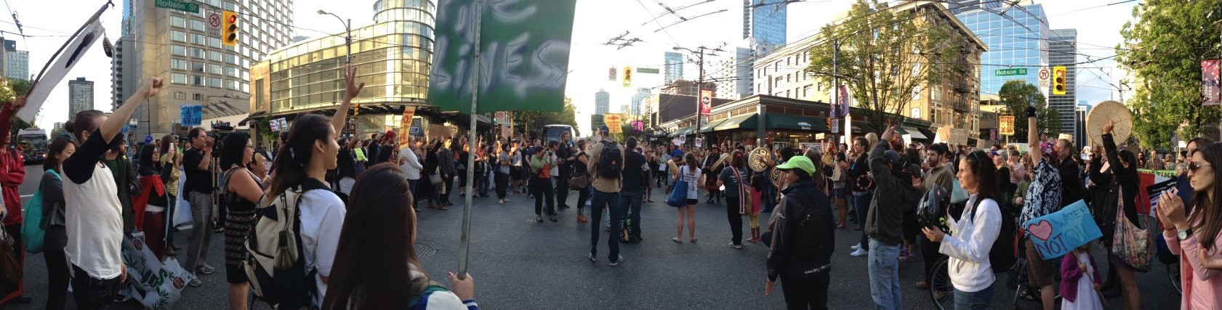
Appendix 5
Native Warrior chants in one of Vancouver’s busiest intersections. Photo taken by Author July 17th, 2014.

Appendix 6
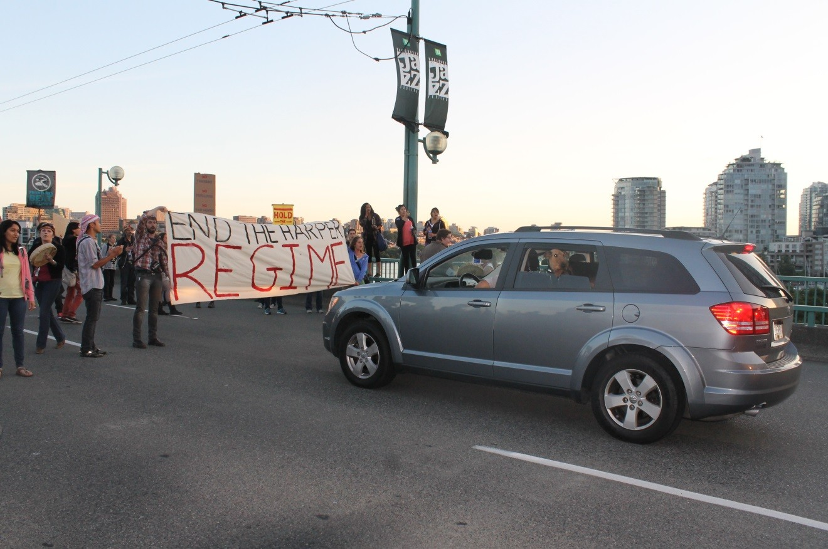
Protestors Blockade the Georgia Street Bridge. Photo Taken by Author, July 17th 2014.

Bibliography

Argitis, Theophilos. “ If Obama Doesn’t Approve the Keystone Pipeline, Another President Will, Says Harper.” Bloomberg News, February 10, 2014. Accessed July 22, 2014. http://business.financialpost.com/2014/02/10/keystone-oil-pipeline-harper/?
federated=1& lsa=657c-7254.

Bailey, Ian. “ Northern Gateway not a Sure Thing, Harper Says.” The Globe and Mail, January 6, 2014. Accessed July 20, 2014. http://www.theglobeandmail.com/report-on-business/industry- news/energy-and-resources/northern-gateway-not-a-sure-thing-harper-says/article16223614/)/.

BC Treaty Commission. “Aboriginal Rights.” Accessed August 11, 2014. http://www.bctreaty.net/files/issues_rights.php.

CBC News. “ Harper Defends Independence of Pipeline Approval Process.” August 7, 2012. Accessed July 24, 2014,.http://www.cbc.ca/news/politics/harper-defends-independence-of-pipeline-approval- process-1.1130434.

Chief Philip. (Anti-pipeline Protest Speech, Georgia Street, July 17, 2014.) Chief Stewart. (Anti-pipeline Protest Speech, Georgia Street, July 17, 2014.)
Curry, Bill, and McCarthy, Shawn. “ Canada Formally Abandons Kyoto Protocol on Climate Change.” The Globe and Mail, September 6, 2011. Accessed July 28, 2014. http://www.theglobeandmail.com/news/politics/canada-formally-abandons-kyoto-protocol-on- climate-change/article4180809/.

David Suzuki Foundation. “Story of Corporate Deceit: How Enbridge Erased BC Islands.” Accessed August 7, 2014. http://www.davidsuzuki.org/issues/oceans/projects/healthy-oceans/pacific-ocean- stories/story-of-corporate-deception-how-enbridge-erased-bc-islands-1/.

P. Eglington, R. Mansell, J. Ruitenbeek and R. Schlenker. “Public Interest Benefit Evaluation of the Enbridge Northern Gateway Pipeline Project: Update and Reply Evidence.” Wright Mansell Research Ltd.: 13. August 11,2014. https://docs.neb-one.gc.ca/ll- eng/llisapi.dll/fetch/2000/90464/90552/384192/620327/624798/833081/B83-4_-_Attachment_2_-
_Public_Interest_Benefit_Evaluation_-_Update_and_Reply_Evidence_-_A2V1R8.pdf? nodeid=832978&vernum=0.

Enbridge. “Project Overview.” Accessed August 5, 2014. http://www.gatewayfacts.ca/about-the- project/project-overview/.

First Nations. “Indian Land.” Last updated modified November 8, 2008. Accessed August 17, 2014. http://www.firstnations.de/indian_land.htm.

Girard, Richerd. “ Out on the Tar Sands Mainline: Mapping Enbridge’s Dirty Web of Pipelines. ” The Polaris Institute ( March 2012): 53, Accessed August 5, 2014. http://www.tarsandswatch.org/files/Updated%20Enbridge%20Profile.pdf.

Gordon, Julie. “ Many First Nations See No Compromise on Oil Sands Pipeline.” Reuters, April 21, 2014, accessed August 8, 2014, http://www.reuters.com/article/2014/04/21/canada-pipeline- aboriginals-idUSL2N0N716U20140421.

Historica Canada. “ Land Claims.” Accessed August 10, 2014. http://www.thecanadianencyclopedia.ca/en/article/land-claims/.

Indian and Northern Affairs Canada. “A History of Indian and Northern Affairs.” Accessed August 10, 2014. https://www.aadnc-aandc.gc.ca/eng/1314977281262/1314977321448.

Justason Market Intelligence. “Opposition to Northern Gateway Pipeline and Tanker Proposal Strengthening.” Last modified October 11, 2012. Accessed July 28, 2014. http://www.justasonmi.com/?p=3073.

O’Neil, Peter. “ Protests Won’t Stop Northern Gateway Pipeline, Minister Says.” Vancouver Sun, December 7, 2011. Accessed August 9, 2014, http://www.vancouversun.com/business/Protests+stop+Northern+Gateway+pipeline+minister+says/ 5820908/story.html.

Sharp, Gene. The Role of Power in Non-Violent Struggle. ( Boston: The Albert Einstein Institution, 1990).
Sharp, Gene.“198 Methods of Non-Violent Action.” Accessed August 12, 2014. http://www.aforcemorepowerful.org/resources/nonviolent/methods.php.

Siegle, Audrey. (Anti-pipeline Protest Speech. Georgia Street, July 17, 2014.)

Shenk, Mark. “Oil Topping 116$ Possible as Iraq Conflict Widens.” Bloomberg News, June 16, 2014. Accessed August 1, 2014. http://www.bloomberg.com/news/2014-06-15/oil-topping-116-seen- possible-as-iraq-conflict-widens.html.

Total Energy. “ A Key Industry for Canada.” Accessed August 10, 2014. http://www.total.com/en/energies-expertise/oil-gas/exploration-production/strategic- sectors/eho/oil-sands/canada-oil-sands/key-industry-canada

United Nations. “United Nations Declaration on the Rights of Indigenous Peoples.” March 2008. Accessed August 17, 2014. http://www.un.org/esa/socdev/unpfii/documents/DRIPS_en.pdf.

