CARIBBEAN ADVANCED PROFICIENCY EXAMNINATIONS
(CAPE) ENVIRONMENTAL SCIENCE
(2017-2018)
Name of candidate: Shoneta Tyrell Name of school: St. Stanislaus College Centre number: 090047
Candidate number: 0900470704
Research title: The Effects of Waste Disposal Management on
four livestock farms

Title
The effects of waste disposal management on four livestock farms.

Problem Statement
Agriculture is one of the main sources of foreign exchange within the Guyanese society. It contributes to elevating the country's GDP and GNP by providing job opportunities for families within these communities.
However due to improper management practices, agricultural practices that are done nearby or along water bodies have had significant effects on the ecosystems. There has been an increase in improper farm waste disposal resulting in water contamination.

Objectives
- To determine the impacts of farm waste in four farms in region 4 (Demerara- Mahaica)
- To conduct water quality tests
- To investigate the waste disposal management of four livestock farms.

Methodology

For the research objectives to be answered it was necessary to collect data which would be later analysed, this was achieved through applied research, which was effective in this study as it specifically aims at observing and recording data from various environments and of such would be more beneficial to the field of study. The results presented by this research would yield qualitative and quantitative data, i.e. data that is presented in a non-numerical form and is an in- depth analysis of a complex situation using word, and data that is presented in a numerical form that can be used to generate findings, respectively.
Sources of information are often categorised as primary or secondary depending on their originality. In this research, both of the above methods were used to fully understand the research topic. Primary sources of information provide first- hand accounts of the research topic. The primary sources of information that were used for this study included interviews, experiments and site visits. The following data gleaning methods were carried out by a group of students who conducted site visits to four different livestock farms along the Demerara- Mahaica coast. The site visits were conducted on the 06th and 14th of February, 2018 respectively. Primary qualitative data was collected in the form of notes, pictures, interviews and observations of the sites while the collection of primary quantitative data was achieved through the collection and analysis of water samples for pH level, salinity level of dissolved oxygen and total suspended solids. These provided the original materials on which the research was based and helped the researcher to glean more knowledge of the current issues surrounding the research topic.
Secondary sources describe, discuss, interpret, comment upon and process primary sources. However, they often lack the freshness and immediacy of the original material. Secondary sources of information were useful however, as being third hand information they were able to help the researcher to understand much about the effects of waste disposal on livestock farms based on the information published by individuals and groups who previously researched similar problems. Some of the secondary sources included newspaper articles, online articles along with government findings and studies.

Literature review

Often when the discussion of waste management is raised, agricultural waste is brought to the table- as it should be. The justification of this statement is derived from the observation of the exponential growth of the world's human population and the need to provide food security in its countries, which in turn leads to the expansion and intensification of agricultural systems to meet these food demands and the changes in the dietary patterns of some places. This steady evolution of sorts has its downsides however, since the increase in food production will also give rise to the increase in waste which by extension impacts the environment.
In the Caribbean, (and by extension, Guyana) this is also the case. In this research however, more emphasis will be placed on the effects of waste in the livestock sector. The major structural changes occurring in the livestock sector are associated with the development of industrial and intensive livestock production systems, which often involve large numbers of animals concentrated in relatively small areas. Intensive livestock systems increasingly depend on feed concentrates that are traded domestically and internationally. And without proper management, these changes are exerting growing pressure on the environment and particularly on water quality. Most of the water used for livestock drinking and servicing returns to the environment in the form of liquid manure, slurry and wastewater. Livestock excreta contain considerable quantities of nutrients, oxygen depleting substances and pathogens and, in intensive systems, also heavy metals, drug residues, hormones and antibiotics. When livestock is concentrated, the associated production of wastes tends to go beyond the buffering capacity of surrounding ecosystems, thereby polluting surface waters and groundwater. The U.S. Environmental Protection Agency (EPA) defines waste as "any garbage or refuse, sludge from a wastewater treatment plant, water supply treatment plant, or air pollution control facility and other discarded material, including solid, liquid, semi-solid, or contained gaseous material resulting from industrial, commercial, mining, and agricultural operations, and from community activities."
Therefore, to study the effects of farm waste on the environment, proper waste disposal management systems must be researched and understood. According to www.wrfound.org.uk,
¨Waste management is the precise name for the collection, transportation, disposal or recycling and monitoring of waste. This term is assigned to the material, waste material that is produced through human being activity. ¨ Thus, the impacts of farm waste management on the environment is directly connected to the collection, transportation, disposal or recycling and monitoring of the aforementioned type of waste. To study the relationship between farm waste management and its impacts, the researcher turned to secondary sources of information.

Information gleaned from a research article written by K.A. Akaani entitled 'Poultry Wastes Management Strategies and Environmental Implications on Human Health in Ogun State of Nigeria' states ¨Activities in livestock production facilities can cause environmental problems such as odour nuisance and land pollution resulting from improperly discharged manure. In addition, some odorous substances from these facilities may present health hazards. ¨ Here, we see two effects of the mismanagement of farm waste in Nigeria, where the relationship between farm waste management and its effects, is shown in greater detail. The improper treatment of waste can contribute to the increase in health-related issues as most manures contain four main gases, mainly; hydrogen sulphide, methane, ammonia, and carbon dioxide. And in high concentrations, these gases pose serious health risks- such as oxygen depletion which can result in asphyxiation, headaches, dizziness, e.tc.
Water quality must also be considered in this study as the introduction of farm waste into water bodies can lead to many other environmental constraints, this is evidenced by this report published by the Food and Agriculture Organization of the United Nations Rome, in the year 2017 where it digressed that, ¨The livestock sector is growing and intensifying faster than crop production in almost all countries. The associated waste, including manure, has serious implications for water quality. Aquatic ecosystems are also affected by agricultural
pollution; for example, eutrophication caused by the accumulation of nutrients in lakes and coastal waters has impacts on biodiversity and fisheries. Water-quality degradation may also have severe direct impacts on productive activities, including agriculture. ¨ From this statement we see water quality can be affected by the management of farm waste disposal and also can be used as an indicator in determining the viability of water bodies located around or near agricultural plots. Water quality analysis uses parameters to show the standard of the water being tested. A few of these are:
- pH of the water.
Is used to indicate the alkalinity or acidity of a substance. It is a scale from 1.0 to 14.0. Acidity increases as the pH gets lower.¹ This parameter can also be referred in a research presented by Dagne D. Hill, in which study shows that ¨in the U.S., the pH of natural water usually ranges between 6.5 and 8.5. At extremely high or low pH values the natural water becomes unsuitable for most organisms. Very acidic waters have the ability to cause heavy metals such as copper to be released into the water [9]. ¨
- Presence of nitrates
Occurs in trace quantities in surface water.

- Total of suspended solids

¹ Cassie. V, Da Sliva. P, Lancaster. A, Orford. (2014) Environmntal science, A Caribbean examinations council study guide. United Kingdom: Oxford university press.

Measures the suspended and dissolved solids in a body of water. As it relates to the typical levels of TSS in natural water, www.fondriest.com reports that in the USA, ¨In most situations, a total suspended solids concentration below 20 mg/L appears clear, while levels over 40 mg/L may begin to appear cloudy. ¨
- Dissolved oxygen
The amount of oxygen readily available in aquatic bodies for use by organisms. Oxygen is important for the maintenance of aquatic life. According to http://www.state.ky.us, ¨ As dissolved oxygen levels in water drop below 5.0 mg/l, aquatic life is put under stress. The lower the concentration, the greater the stress. Oxygen levels that remain below 1-2 mg/l for a few hours can result in large fish kills. ¨
- Salinity
Refers to the concentration (by weight) of salt in water, as expressed in parts per million (ppm). The parameter for fresh water is equal to less than 1,000 ppm of salt; any value above indicates saline water.²
The above parameters reflect the nature and use of the water and the decrease in the water quality of a water body would indicate an imbalance in the ecosystem due to external effects, such as agricultural pollution. Therefore, it cannot be stressed enough, that the sampling, analysing and monitoring of water bodies is important in the management of farm waste disposal. Water analysis monitors the state of farms and waterways and quantifies the loads of farm waste reaching water bodies. Furthermore, to help in the improvement of water quality and sustainable agricultural farm waste disposal practices, good waste management strategies must be pursued. Three principles surrounding the waste management strategy in agriculture includes:
- Reducing waste produced by agricultural activities
- Preventing long term degradation or restriction of land used for agriculture due to the application of waste
- Assisting in the uptake and responsible use of waste for agricultural production systems. The above principles can be achieved by a number of great waste management methods, such as:
- Composting
Composting is a process by which organic wastes are broken down by microorganisms, generally bacteria and fungi, into simpler forms. The microorganisms use the carbon in the waste as an energy source.³

² . ^ same as above
³ https://ag.umass.edu/crops-dairy-livestock-equine/fact-sheets/waste-management-composting

- Implementing bio digesters can be an effective way to reduce organic content of animal waste while harnessing methane that can be used or sold for electricity. However, this technology is not necessarily cost-effective for small-scale farms infrastructure. Establishing cooperatives in farm-intensive communities could ease the financial burden from individual small farms and allow for building of infrastructure, such as waste pipelines for more efficient transport of waste to treatment/storage facilities

Presentation of data
Table 1.0 shows the results recorded from the water quality tests conducted

Farm | pH | Do  (Mg/l) | Salinity  (ppm) | TSS  (Mg/l)
St. Stanislaus college farm | 6.83 | 0.88 | 91.4 | 34
Edun poultry farm | 6.50 | 0.82 | 179 | 27
GLDA farm | 7.23 | 0.48 | 189 | 72
Mohammed poultry farm | 6.83 | 3.52 | 137 | 12

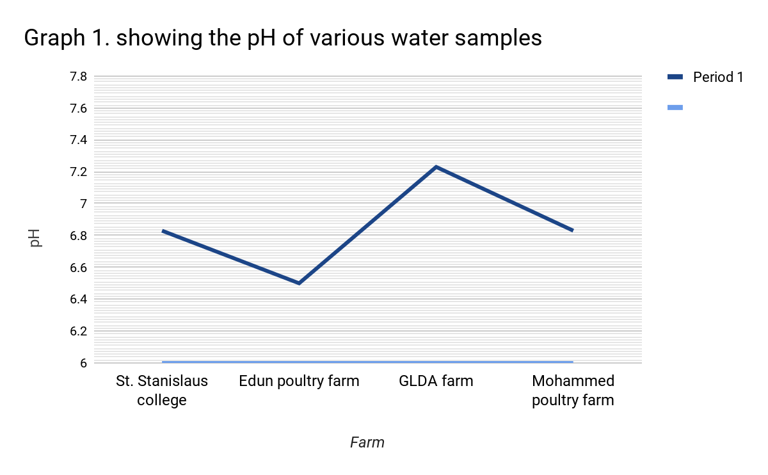

The line graph shows the pH values recorded for water samples collected at four different farms.

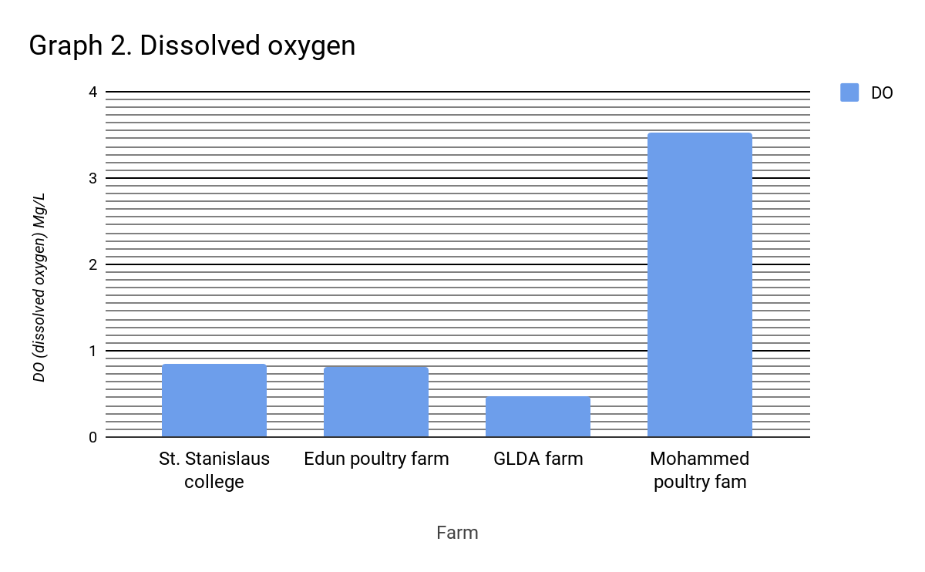

The bar graph above shows the data collected for the amount of dissolved oxygen measured for four various water samples from four farms.

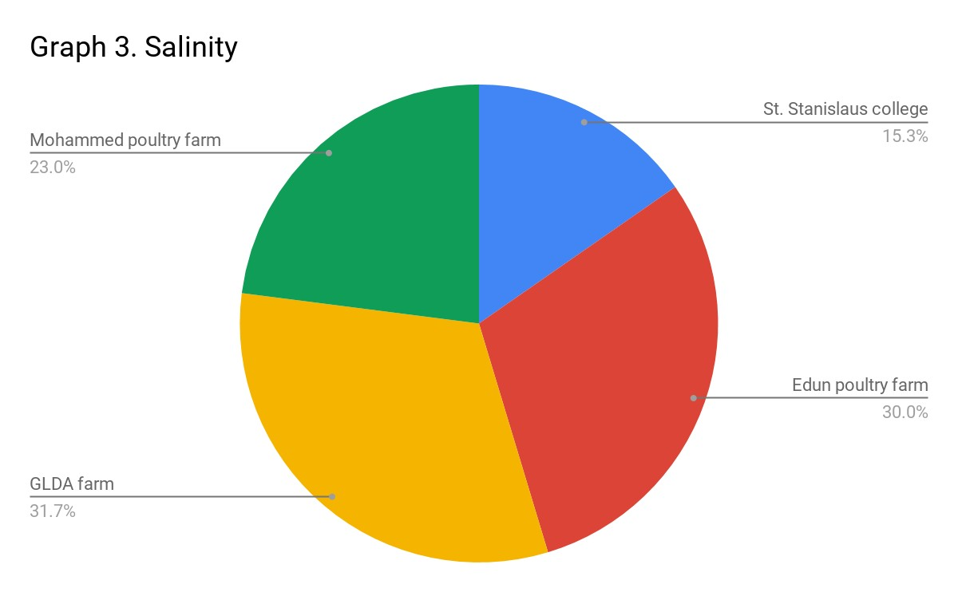

The pie chart above shows the level of salinity recorded from the water samples collected from four different livestock farms.

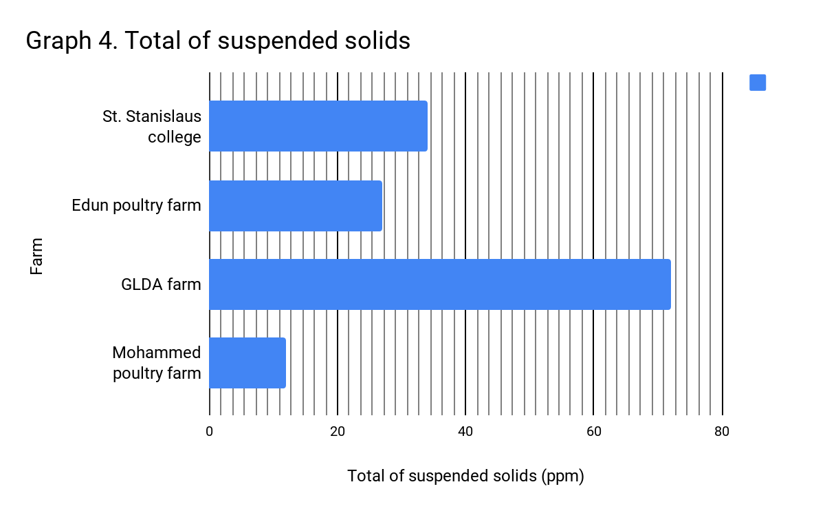
The bar graph above shows the total of suspended solids (ppm) in the water collected from the four different sites.

Analysis of data

Graph 1 illustrates the pH level of the water samples collected from the four sites of study. According to the data collected, the general trend in pH shows that most of the farms had a pH around 6.50 and up, this shows that most of the water had a slight acidity. However, this wasn't the case with the GLDA farm, whose water sample had a pH level of 7.23, which showed that the water was more on the neutral in nature.
Graph 2 shows the level of dissolved oxygen in the water samples of the sites. Most of the farms had a low level of dissolved oxygen except Mohammed poultry, who boasted of a high 3.52 Mg/L of dissolved oxygen in the analysis of their water samples. This result can further be correlated with the low level of total suspended solids recorded in Graph 4.
In the analysis of graph 3, which depicts the salinity levels of the water samples from the four sites, shows that most of the water's salinity levels ranged from 90-140 ppm. This range of values showed that most of the water on the farms were generally fresh as no farm's water sample exceeded a 1000 ppm, which would have indicated slight saline water.
Graph 4 showed the total of suspended solids for the water samples collected. Upon analysis of the water samples, it was observed that Mohammed's poultry farm had the least number of total suspended solids with a value of 12 Mg/L as compared to other farms with 27 Mg/L and above. The can be further interpreted to say that Mohammed's poultry farm had the best waste disposal system as compared to GLDA farm, who reach an all-time low at 72 Mg/L.

Discussion

Manure management is one of the main concerns in livestock production. Manure needs to be stored, treated, handled and disposed of – or preferably reused – safely. Manure treatments include composting and anaerobic fermentation, which can produce valuable organic fertilizers and soil conditioners. Intensive livestock operations such as feedlots that concentrate livestock need to be managed as point sources of pollution and should follow specific national regulations.
The livestock sector is growing and intensifying faster than crop production in almost all countries. The associated waste, including manure, has serious implications for water quality, as shown in this study where the effects of waste disposal management on livestock farms were investigated. This investigation involved the use of water quality tests, which were used as parameters in testing the effectiveness of the waste disposal systems on the farms of interest and its effects on the water quality. From the data gathered, analysed reports show that generally the water quality standards gleaned from the results of the research were influenced by the activities undertaken near the respective water bodies.
From the research, we saw that SSCF, Edun's , GLDA and Mohammed's farms all reported pH levels of 6.83, 6.50, 7.23 and 6.83 respectively. When we compare the above given data values with the requisites of the research conducted by Dagne D. Hill, we see that the farms had healthy pH levels, which shows the absence of minerals and chemicals such as nitrates, ammonia and phosphates- chemicals that are usually present in fertilizers and pesticides. Hence, this data can be proven credible as most of the farms were only livestock oriented and had little or no sort of crop husbandry which contributed to the healthy pH levels analysed.
Also, data showed that all of the farms had low levels of salinity. None of the farms had ppm's exceeding 1000, which showed the lack of salinity in the water bodies. SSCF had an especially low salinity level of 91.4 ppm. This indicated overall freshness in the water and showed that the farms did not suffer from extreme agricultural pollution, which illustrates some good waste disposal management practices. The study showed however that most of the farms had deplorable levels of TSS, as three of four of the farms reported levels of TSS exceeding 40 mg/L (I.e. above 40 mg/L indicates cloudiness in the water). These high levels of TSS on the farms have negative effects as high levels of TSS indicates the presence of microbes and provides a hospitable environment for micro bacterial growth which reduces the standard of the water and can harm animals who may drink it in the long run, contributing to bad health. The high levels of TSS may be due to the runoff of wastewater from the pens of the animals; this wastewater includes manure, mud, rocks, e.tc. which contributes to the turbidity of the water. The only farm that reported low levels of TSS was Mohammed's, who scored a TSS value of 12 mg/L.
Finally, the levels of DO recorded for each farm was shocking and gave a great insight to the ecological balance (or lack thereof) of the aquatic ecosystems in each water body of the farms

studied. All of the farms reported shockingly low levels of DO. SSCF, Edun's, GLDA and Mohammed's farm each reported DO levels of 0.88, 0.82, 0.48 and 3.52 respectively. The normal DO level for freshwater capable of supporting aquatic life ranges from 5.0 mg/L to 7.0 mg/L and above, this is according to http://www.state.ky.us. This showed that the low levels of DO available negatively affected the population size of the aquatic ecosystem. The low levels of DO are probably due to the decay of organic material in water caused by either chemical processes or microbial action on untreated sewage or dead vegetation. This water quality result therefore then, can be linked to the TSS levels reported. As high TSS levels promotes microbial growth which reduces the amount of DO available, as the bacteria uses it to increase their population size.
Hence it can be stated that the farms studied had low water standards which is due to the inefficiency of the waste disposal management systems undertaken and as such, the aquatic ecosystems of the farms were largely affected.
Overall, to minimise the effects of farm waste on the environment, proper waste management programs and technologies must be implemented and these programs and technologies must be in accordance with the principles of waste management strategy mentioned in the literature review.
A few waste management practices that can therefore be undertaken include:

- Composting- This is a sustainable waste management practice that converts a large volume of accumulated organic waste into a usable product. When organic wastes are broken down by microorganisms in a heat-generating process, waste volume is reduced by almost 50%, many harmful organisms including pathogens and weed seeds are destroyed, and a useful, potentially marketable product is produced. In a dairy operation, the majority of organic wastes will likely be manure combined with spoiled hay and feed, and animal bedding. Adding compost to soil increases organic matter content. This, in turn, increases the population and diversity of the beneficial microorganisms and earthworms in the soil and therefore improving many soil characteristics and allows for the slow release of nutrients for crop use in subsequent years.
- Implementing bio digesters can be an effective way to reduce organic content of animal waste while harnessing methane that can be used or sold for electricity. However, this technology is not necessarily cost-effective for small-scale farms due to the expense of building initial infrastructure. Establishing cooperatives in farm-intensive communities could ease the financial burden from individual small farms and allow for building of infrastructure, such as waste pipelines for more efficient transport of waste to treatment/storage facilities.

Conclusion

From the study conducted, it can be concluded that the effects of waste disposal management were the loss of aquatic biodiversity and high probabilities of contracting health issues due to the low quality of water. These effects were reflective of the waste disposal management systems undertaken by the farms of study. Reflective, because water quality analysis generally shows the hospitality of the aquatic ecosystems of the water bodies studied and according to findings, the low quality of the water bodies studied shows that the waste disposal management methods undertaken by the farms were not effective in maintain ecological sustainability. This is based on the recordings of low levels of DO and large amounts of TSS in the water quality analysis of each farm.

Recommendations

- All of the farms should adapt better ways to control the runoff of livestock excreta, wastewater and animal feeds, as the high levels of TSS reported shows that the above particles are not handled responsibly.
- All the farms of study should research and/or use methods that will increase the levels of dissolved oxygen in their surrounding water bodies. Chemicals such as Calcium peroxide increases the availability of oxygen in water.
- The farms should implement better waste disposal management methods as the current ones undertaken are inefficient in maintaining ecological sustainability, as shown from the water quality analysis.
- Investments should be made for frequent water quality analysis on the farms, as this would inform the farmers/ directors of the state of the farm's ecosystems.

Bibliography

- Kent, Michael. (2000) Advanced biology. London, Oxford: Oxford printing press
- Cassie Vindra, Da Sliva Phillip, Lancaster Alana, Orford Jillian. (2014) Environmental science- a Caribbean examinations council study guide. Great Clarendon Street, Oxford: Nelson Thornes
- Durant, Claire. (2013) Biology for CAPE examinations. London: Macmillan publishers limited.
- Oram, Brian. (2014) Stream water quality- importance of total suspended solids/ turbidity. www.water-research.net/index.php/stream-water-quality-importance-of-total- suspended-solids-turbidity
- Myers, Donna. (2010) Why monitor water quality? https://water.usgs.gov/owq/WhyMonitorWaterQuality.pdf

Site visits ENTRY NO: 1 DATE: 02/06/2018
SITE: St. Stanislaus College BACKGROUND
The SSCF is the only agriculture school farm in the country and is a premiere training institution for agriculture students, technicians and farmers in Guyana.
It is located at 69 North Sophia and also houses the St. Stanislaus Training Centre (SSTC), the Dairy Products Unit (DPU) and the Greenhouse Vegetable Production Unit. The 13-acre complex is owned by the St Stanislaus College Association (SSCA) formerly the St Stanislaus Old Boys Association.
Objectives:

- to conduct water quality tests
- To observe farm waste management
- To carry out interviews with farmers and farm help
- To take photographs of the site Activities:
- A throughout observation of the farm was conducted
- Observations were made of the waste management practices carried out on the farm
- Locations were identified that would be ideal for the water quality tests
- Water samples were collected in clear bottles from the aforementioned locations, to be tested for various water quality parameters in a laboratory.
- An interview was conducted with the farm's primary care taker. Observation:
- Some parts of the farm were unsanitary
- Waste was kept in a vermin- compost
- Some of the animal waste are given to people for their domestic use.

Images

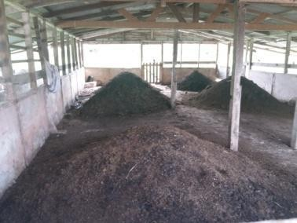

Image 1 shows the piles of vermin-compost found on the farm.

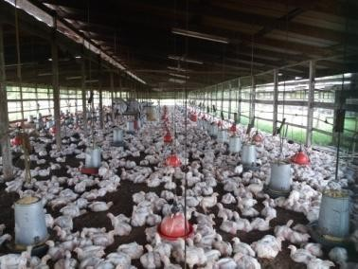
Image 2 shows the layout of the farm’s poultry pen
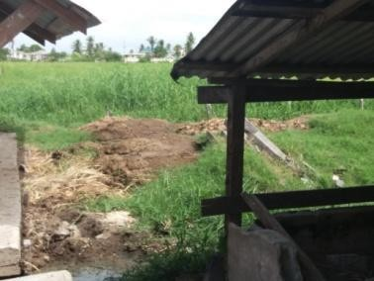

Image 3 shows livestock excreta being dried to be later distributed.

Comments

- The unhygienic conditions of the farm's operations can contribute to negative environmental effects over a period of time.
- The use of vermin- compost has some disadvantages, as it can produce offensive odours if not managed properly and offensive odours usually contain gases (such as methane) that may pose health hazards.
Follow up activities

- Water samples were collected to be later analysed in a laboratory.

-

ENTRY NO: 2 DATE: 02/06/2018
SITE: GLDA- Guyana livestock farm BACKGROUND
The GLDA is the single institution which is mandated to implement and coordinate the development of livestock activities in Guyana; hence the GLDA has the responsibility in defining, adapting and implementing a number of initiatives that are aimed at improving the production parameters and the health and welfare status of the livestock within the sector.
Objectives:

- to conduct water quality tests
- To observe farm waste management
- To carry out interviews with farmers and farm help
- To take photographs of the site Activities:
- A throughout observation of the farm was conducted
- Observations were made of the waste management practices carried out on the farm
- Locations were identified that would be ideal for the water quality tests
- Water samples were collected in clear bottles from the aforementioned locations, to be tested for various water quality parameters in a laboratory.
- An interview was conducted with the farm's primary care taker. Observations
- Wastes were disposed in special sites on the farms in pits.
- Animal waste were given to people to be used as fertilizers
- Animal waste was also utilized as fertilizers on the farm
- The pens/ living spaces of the livestock were sanitary.

Images
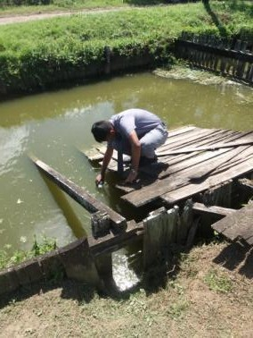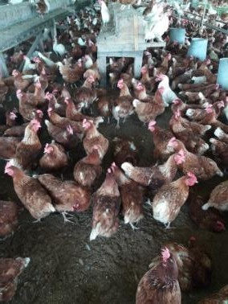

Figure 1. shows the water sample being collected from a small pond.
Figure 2 shows one of the breeds of
chicken being reared on the farm
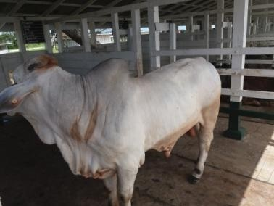

Figure 3 shows a pure breed cattle reared by the farm for cross-breeding

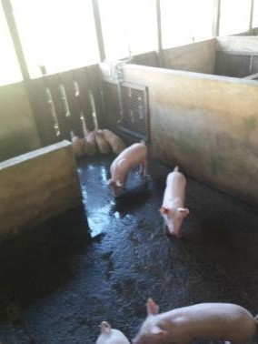

Figure 4 shows the layout of a pig sty on the farm

Comments

- The sanitary conditions of the poultry pens indicated effective animal husbandry and good waste disposal- which increases animal yield and lowers the likelihood of the animals contracting diseases.
- Waste being disposed in pits may cause problems in the long run. Problems such as the contamination of fresh water from the runoff of wastewater- which can be formed from the mixing of rainwater and the waste disposed in pits.
Follow up activities

- Water samples were collected to be sampled and analysed in a laboratory.

ENTRY NO: 3 DATE: 02/14/2018
SITE: Edun's farm BACKGROUND
Obliquely opposite the mechanic’s workshop is Edun’s Poultry Farms and Hatchery which supplies the poultry sector in the community with feed and baby chicks. According to Sharda Edun, in 1985 her father-in-law Abu Edun started making feed for his personal use.
Later, “other farmers came in and were interested in buying feed and from then to now we have good support from the area.” Edun’s has since grown to include the farm, feed factory and a hatchery. The company also produces eggs which are sold both locally and internationally.
Taken from: https://www.stabroeknews.com/2011/features/01/16/craig/ Objectives:
- to conduct water quality tests
- To observe farm waste management
- To carry out interviews with farmers and farm help
- To take photographs of the site Activities:
- A throughout observation of the farm was conducted
- Observations were made of the waste management practices carried out on the farm
- Locations were identified that would be ideal for the water quality tests
- Water samples were collected in clear bottles from the aforementioned locations, to be tested for various water quality parameters in a laboratory.
- An interview was conducted with the farm's primary care taker. Observations:
- Wastes were disposed in special sites on the farms in pits.
- Animal waste were given to people to be used as fertilizers
- Animal waste was also utilized as fertilizers on the farm
- The pens/ living spaces of the livestock were sanitary.
- Poultry houses were technologically advanced.

Images

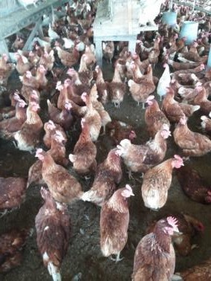

Figure 5 shows the breed of chickens reared on the farm

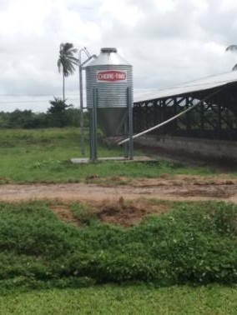

Figure 6 shows a water tank used for feeding chickens

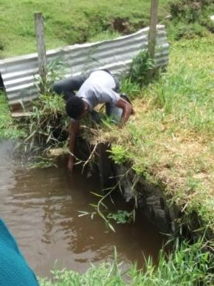

Figure 7 shows a water sample being collected

Comments

- The sanitary conditions of the poultry pens indicated effective animal husbandry and good waste disposal- which increases animal yield and lowers the likelihood of the animals contracting diseases.
- Waste being disposed in pits may cause problems in the long run. Problems such as the contamination of fresh water from the runoff of wastewater- which can be formed from the mixing of rainwater and the waste disposed in pits.
Follow up activities

- Water samples were collected to be sampled and analysed in a laboratory.

ENTRY NO: 4 DATE: 02/14/2018
SITE: Royal farm BACKGROUND
-

Objectives:

- to conduct water quality tests
- To observe farm waste management
- To carry out interviews with farmers and farm help
- To take photographs of the site Activities:
- A throughout observation of the farm was conducted
- Observations were made of the waste management practices carried out on the farm
- Locations were identified that would be ideal for the water quality tests
- Water samples were collected in clear bottles from the aforementioned locations, to be tested for various water quality parameters in a laboratory.
- An interview was conducted with the farm's primary care taker. Observations
- Wastes were disposed in special sites on the farms in pits.
- Animal waste were given to people to be used as fertilizers
- Animal waste was also utilized as fertilizers on the farm
- The pens/ living spaces of the livestock were sanitary.
- Poultry houses were technologically advanced.

Images
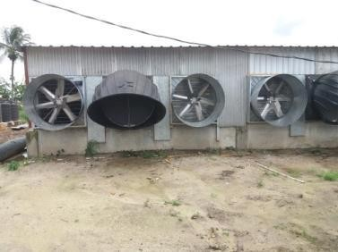

Figure 8 shows compost site

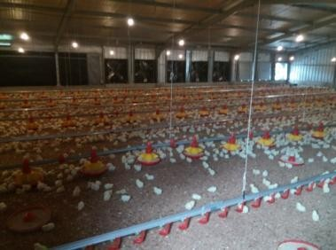

Figure 9 shows the layout of the poultry pen
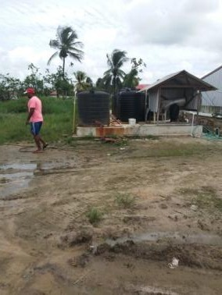

Figure 10 shows a water source used for feeding animals

Comments

- The sanitary conditions of the poultry pens indicated effective animal husbandry and good waste disposal- which increases animal yield and lowers the likelihood of the animals contracting diseases.
- Waste being disposed in pits may cause problems in the long run. Problems such as the contamination of fresh water from the runoff of wastewater- which can be formed from the mixing of rainwater and the waste disposed in pits.
Follow up activities

- All the water samples collected were taken to a laboratory and analysed for parameters related to water quality.

LAB 1

Title: pH of water

Aim: to investigate the pH of water samples collected for the sites visited Background
pH is a measure of how acidic/basic water is. The range goes from 0 - 14, with 7 being neutral. pH of less than 7 indicate acidity, whereas a pH of greater than 7 indicates a base. pH is really a measure of the relative amount of free hydrogen and hydroxyl ions in the water. Water that has more free hydrogen ions is acidic, whereas water that has more free hydroxyl ions is basic. The pH of water determines the solubility (amount that can be dissolved in the water) and biological availability (amount that can be utilized by aquatic life) of chemical constituents such as nutrients (phosphorus, nitrogen, and carbon) and heavy metals (lead, copper, cadmium, etc.)
Materials/Apparatus: water samples, beakers, pH meter, litmus paper Method
- The beakers used for the testing of the pH of water were all washed and dried with distilled water.
- The beakers were labelled Mohammed's farm, Edun's farm, GLDA and SSCF respectively.
- Each beaker was filled the water samples collected from the respective farms
- Prior to the tests, the pH meter was calibrated.
- the pH meter was rinsed with deionised water and the tip was submerged in beaker Mohammed's for 1 minute, or until a reading was shown.
- The same was done with blue litmus paper, and a colour change was recorded
- The results were recorded in the observation table below.
- Steps 1 to 7 were repeated for the next beakers. Observations/ Results
Table 3.0 shows the pH levels for the various water samples

Site | Colour of litmus paper | pH
St. Stanislaus College Farm | Green | 6.83
GLDA Farm | Green | 6.50
Edun’s Farm | Green | 7.23
Mohammed’s farm | Green | 6.83

Limitations

- Calibration curve of the pH meter was not always at 0
- Temperature fluctuations can influence results Precautions
- Ensure that the samples were all measured to the same amount
- Ensure that there are no additions to the chemical composition of the water

Discussion
In this lab, the pH levels of water were recorded. According to the general trend on graph 1, the line graph shows that most of the water samples had a general pH from between 6.5 to 7.5, which shows the water was mostly neutral. This inference was also shown with the colour of change of the litmus paper from blue to green- where green shows neutrality. Also, it was observed that SSCF and Mohammed's farms had the same level of pH- which shows similarities in the chemical composition of the water samples.

Conclusion
It can be concluded that the pH of each of the sites were found and recorded, in which most of the water samples boasted of a neutral pH- which is natural for freshwater.

LAB 2
TITLE: Salinity
AIM: to determine the salinity of the water of the four sites visited. BACKGROUND
Salinity refers to the concentration (by weight) of salt in water, as expressed in parts per million (ppm). Water that is saline contains significant amounts of dissolved salts, the most common being sodium chloride (NaCl). There are three main factors influencing water salinity worldwide. These are ocean currents, which affect the travel and mixing of salt laden water; evaporation rates by the sun; human activities; specifically, the dumping of waste and pollution, and the erosion of the natural environment.

Materials: Refractometer Spoon
Water sample (4) Bottle with cork
Procedure:

- The water sample was collected from the various sites and placed inside of a sealed bottle

- The rounded end of the refractometer was opened along with the angle end which was left exposed.
- Several drops of the first sample were poured from a spoon unto the exposed prism, covering the surface completely.
- The prism was then covered by re-adjusting the plate back into position.

- The salinity reading was then observed by looking through the rounded end of the refractometer at the area where the white and blue areas met.
- After the measurements were recorded, the prism was wiped with a soft, damp cloth until there was no more water droplets left.

Limitations

  - Light intensity can interfere with the results of the sample Precautions:
  - Ensure no air pockets are on the refractor meter when water is added, it must be air free.
  - Ensure prism is cleaned thoroughly before testing a next sample. Observations/ Results
Table 4 shows the results recorded for the salinity of the water samples

Site | Salinity
St Stanislaus College Farm | 91.4
GLDA Farm | 179
Edun’s Farm | 189
Mohammed’s Farm | 137

Discussion
Salinity refers to the movement and concentration of salt, in landscapes. Both soil and natural waters can become saline. Hence, salinity can be described as either soil salinity or water salinity. In this experiment, it was observed that most of the farms had very low levels of salinity (.i.e. ppm didn't exceed 1000) and hence, the water bodies mostly contained fresh water which was suitable for livestock consumption.

Conclusion
It can be concluded that the salinity of all the water samples tested were found to be below 1000 ppm which indicates saline water and were hence fresh.

LAB 3
TITLE: Level of dissolved oxygen
AIM: to determine the dissolved oxygen levels of the four sites of interest. BACKGROUND
The dissolved oxygen (DO) is oxygen that is dissolved in water. The oxygen dissolves by diffusion from the surrounding air; aeration of water that has tumbled over falls and rapids; and as a waste product of photosynthesis. A simplified formula is given below:
Photosynthesis (in the presence of light and chlorophyll):

Carbon  dioxide | + | Water | --------------  > | Oxygen | + | Carbon-  rich foods
CO2 |  | H2O |  | O2 |  | C6H12O6
Fish and aquatic animals cannot split oxygen from water (H2O) or other oxygen-containing compounds. Only green plants and some bacteria can do that through photosynthesis and similar processes. Virtually all the oxygen we breathe is manufactured by green plants. A total of three- fourths of the earth’s oxygen supply is produced by phytoplankton in the oceans.
Materials/ Apparatus: Manganese sulphate, Water sample (4), Bottle with cork, Alkali-Iodide- azide, Stopper, Sulphuric acid, Erlenmeyer flask and Starch indicator

Procedure:

- Bottle with field samples were taken
- 1ml of manganese sulphate was added
- 1ml of alkali-iodide-azide was then added
- Stopper was replaced and the solution was mixed
- 1ml of sulphuric acid was then added
- The stopper was replaced and shook to mix
- 201ml of sample was titrated in Erlenmeyer flask
- 1 ml starch indicator as added to the mixture
- Sample was titrated until it was clear Observations/ results
Table 5 showing the results recorded for the level of dissolved oxygen in the water samples

Site | Dissolved Oxygen
St Stanislaus College Farm | 0.88
GLDA Farm | 0.82
Edun’s Farm | 0.48
Mohammed’s Farm | 3.52

Discussion

In this experiment, the levels of dissolved oxygen were recorded. Interpreting the data shown in the above graph, it was noted that most of the farms had low levels of dissolved oxygen except Mohammed poultry, who boasted of a high 3.52 Mg/L of dissolved oxygen in the analysis of their water samples. This shows that Mohammed's farm water supply was better able to supplement the oxygen demand of the aquatic organisms and plants found in its environs.
Conclusion

It can be concluded that most of the water samples had low levels of dissolved oxygen, except Mohammed's farm, which shows that the oxygen demand for the aquatic systems were not being fully provided due to the lack of oxygen.

LAB 4

TITLE: Total suspended solids

AIM: to investigate the total of suspended solids in each water sample collected from the four sites
BACKGROUND

TSS of a water or wastewater sample is determined by pouring a carefully measured volume of water (typically one litre; but less if the particulate density is high, or as much as two or three litres for very clean water) through a pre-weighed filter of a specified pore size, then weighing the filter again after the drying process that removes all water on the filter. Filters for TSS measurements are typically composed of glass fibres. The gain in weight is a dry weight measure of the particulates present in the water sample expressed in units derived or calculated from the volume of water filtered (typically milligrams per litre or mg/L).
Materials/ Apparatus: Filter paper, scale, funnel, beaker Method
- A piece of filter paper was weighed as accurately as possible
- A one litre sample of water was filtered through the weighed filter paper
- The filter paper was allowed to dry completely
- The filter paper was reweighed

Observations/ Results

Table 6 shows the results recorded for the total suspended solids in the water samples

FARM | TOTAL SUSPENDED SOLIDS
St. Stanislaus College Farm | 34
Edun Farm | 27
GLDA Farm | 72
Mohammed Farm | 12

Discussion

Total suspended solids give a measure of the turbidity of the water. Suspended solids give water a milky or muddy appearance due to the light scattering from very small particles in the water. In this report, it was analysed that Mohammed's had the lowest TSS at 12 ppm as compared to GLDA with 72. This can be interpreted to show that Mohammed's farm had the best waste disposal system as compared to the other farms.
Conclusion

It can be concluded that the TSS of the farms were measured and recorded. In which results show that the levels of TSS recorded for each farm was high, with GLDA having the highest level of TSS.

