RESEARCH PROPOSAL AND ACTION PLAN

Research Question: Should Telon expand by investing into a new range of clothing for women in an attempt to diversify further and increase profitability?

Eeshita Wade

Word count:

Research proposal

Question- Should Telon expand by investing into a new range of clothing for women in order to diversify further and increase profitability?

- Rationale for study
Telon is a designer brand for men based in Mumbai, India established in 1986. Along with a mix of traditional hand tailoring and modern cutting-edge technology, this brand focuses on traditional Indian clothing like kurta, sherwani and formal wear. However, after consultation with the owner of this business, it was noted that this brand faced difficulties in the case of expansion of the business.
Telon by the sale of only high-end designer clothing for men has been well established in the market because of its promotional strategies. It has been recognized and promoted by celebrities and sportsmen which has increased brand awareness for the business.
This brings us to our research question, if Telon were to launch a new women’s line of clothing would it be able to solve the problem of expansion? By launching a new women’s line, Telon would be entering a new market and hence diversifying. The degree of risk associated with this step is quite high, however it may be a potential solution to the problems faced and increase profitability.

- Areas of syllabus to be covered

Unit 1.3 | SWOT analysis | Assessment of possible successful future strategies
Unit 1.3 | Ansoff’s Matrix | Analyzing degree of risk associated with the growth strategy-diversification
Unit 1.4 | Stakeholders’ interests | How different stakeholders would be affected as a result of diversification and expansion
Unit 1.6 | Growth and expansions | Achievement of business growth through different ways-benefits and limitations
Unit 1.7 | Force field analysis | Mapping opposing forces against the change
Unit 3.5 | Ratio analysis | Assess profitability of possible solutions
Unit 4.2 | USP, Market Planning | Analyzing the USP of the brand
Unit 4.5 | Promotion, PLC | Marketing plans and promotion strategy which would extend the maturity stage of the new products that may be launched

- Possible sources of information
- Interviews with the Owner of Telon India-inside information from the owner’s perspective.
- Questionnaire for regular customers -customer’s view on the current position of the brand and possible solutions proposed.
- Organizations/Individuals to approach
- Owner of Telon
- Financial and Marketing Managers
- Customer focus groups

- Methods of data collection and the reason for choosing them
Method of data | Type of data  (primary or secondary) | Reason
Interviews | Primary | Insider perspective on the changes and possible solutions proposed
Surveys/Questionnaire | Primary | Stakeholders perspective on the change
Customer reviews | Secondary | Customers perspective on the already established brand products

- Anticipated difficulties
Difficulties | Solution
Hesitation to release financial information | Confidentiality assurance
Replies from questionnaires may be vague | Designing a well focused survey
No in-person meetings due to the pandemic situation | Contact through frequent emails and interviews online

Action plan
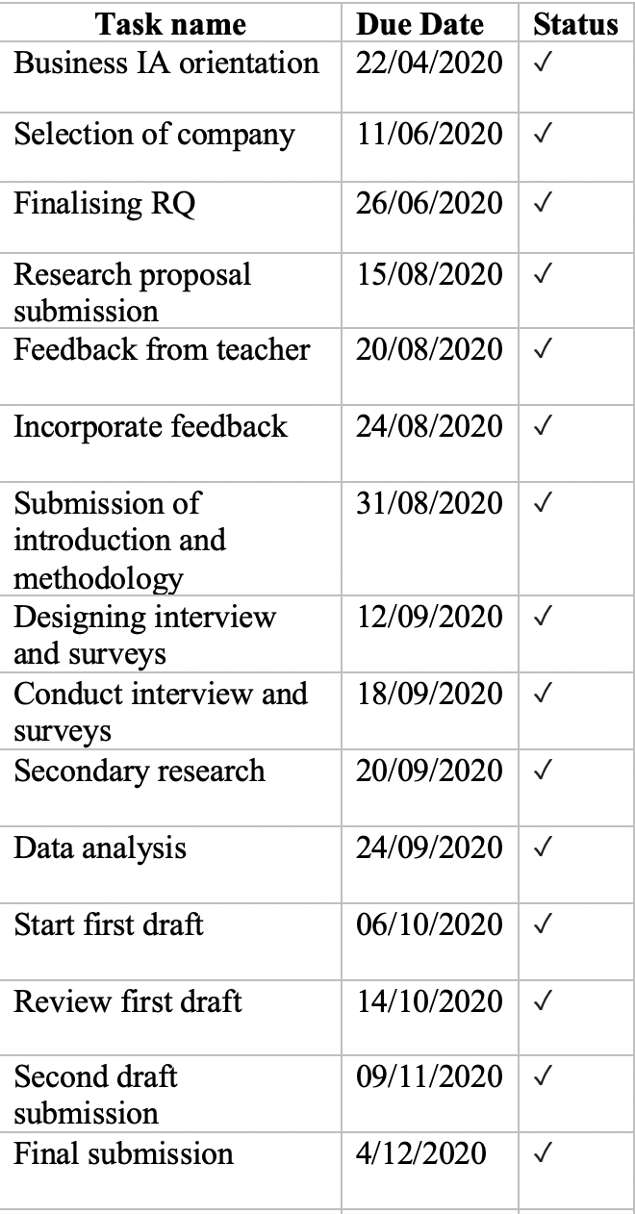

Introduction
Telon is a clothing brand selling high-end designer wear for men. Telon uses a mix of traditional hand tailoring and modern technology prioritizing the art of craftsmanship in order to make the best attire as desired by its customers. This brand has been recognized by a number of celebrities and sportsmen in India which is an advertising bonus for it. However, expansion remains a problem for this brand. Telon has two stores, both located in Mumbai, India. Through favorable promotional strategies the brand has been able to establish itself well in the market but since the brand only focuses on clothing for men, they have not been able to diversify, if this brand were to expand by introducing a women’s line of clothing it would be entering a whole new different market which may be a possible solution to its problem of expansion. The clothing industry is highly competitive especially women’s clothing which is an extremely flooded market. For a business to be successful it should be able to develop successful marketing and promotional strategies. The new products introduced by the brand should have their own USP that will attract customers, increase profitability and hence be a solution to the problem faced by Telon. The idea of diversification that is introducing a new product in a new market can be linked to the Ansoff’s Matrix. The stakeholder’s will also be affected as a result of this change. It is hoped that this step would increase profitability for the business which will be assessed through the Ratio Analysis. In order to expand the maturity stage of the new products that may be introduced, important promotional and marketing strategies are required. All the opposing forces against the decision will be analyzed through a force field analysis.
Using various business concepts and tools, the following research question would be explored:
Should Telon expand by investing into a new range of clothing for women in an attempt to diversify further and increase profitability?
Methodology
The triangulation of qualitative and quantitative data has enabled us to answer the research question and analyze if this step would be able to solve the main problem of expansion as faced by the brand and at the same time increase profitability.
The data was collected through structured interviews with the owner, structured surveys of customers, customer reviews as well as an analysis of competitors. The structured interview with the owner gave an insider’s perspective on the issues that may be faced due to diversification in terms of competition, costs. This helped in analyzing if this step would generate more revenues than costs and increase profits or vice-versa. Since interviews with the owner would have elements of bias, it is essential to obtain an outsider’s perspective.
A structured survey of customers was done through random sampling as well as snow ball sampling by asking customers regarding their experiences with Telon to understand the business better from the consumer’s perspective. Customer reviews online enabled to develop an understanding of the strengths of the brand and analyze the current position of the brand. Analysis of the brand’s competitors has allowed reference to similar steps that have been taken by competitors and how it benefitted them. Employing all these data techniques will allow accurate findings and hence achieve apt results.

Main results and findings

STRENGTHS | WEAKNESSES
Traditional hand tailoring, modern technology  Craftsmanship  Old legacy of 35 years  Celebrity endorsements | Lack of trained sales staff  Staff retrenchment
OPPORTUNITIES | THREATS
Franchise options  Expansion into multinational firms by exporting overseas | Foreign brands, Multinational firms
 | Products
 | Existing | New
Existing | Market penetration  Traditional Men’s wear | Product development  New clothing line for men, more casual products
New | Market development  Export of existing traditional Indian wear for men abroad | Diversification  Women’s line of clothing
Table 1: SWOT analysis

Markets

Table 2: Ansoff’s Matrix
Financial information
Product | Labor cost
Shirt | 500 per piece
Suits | 5000 per piece
Sherwani | 3000 per piece
Trousers | 500 per piece
Table 3: Cost of labor per piece of clothing

Total costs of production for each piece of clothing =
Total cost of labor + additional costs of design and fabric (depending upon the piece of clothing)

Total revenue earned = Rs. 5,00,00,000+

Estimated investment in women wear- Rs. 30000000-50000000

Sources of finance for investment
- Retained profits
- Bank loans

Force field analysis
Driving forces Restraining forces
Increased profitability (4) Increased costs of production (4)

Introduction of a woman’s clothing line

Increase in the cost of labor/
Franchise/ export options (3) Employing new skilled staff (3)

Increased brand recognition (2) Increased competition (3)

Figure 3: Lewin’s force field analysis

Analysis

Table 1 shows SWOT analysis. SWOT stands for the strengths, weakness, opportunities and threats for the business. SWOT analysis is a form of strategic analysis that identifies and analyses main internal strengths and weaknesses and external opportunities and threats that will influence the future direction and success of a business. A thorough review of the website along with structured interviews with the owner of the business, helped in obtaining sufficient qualitative data regarding the internal strengths and weaknesses of the business. The main strength of Telon as viewed from the website is the combination of traditional hand tailoring along with modern technology. Traditional hand tailoring is a practice that was started in India decades ago and it reflects the rich heritage and culture of India as it marks true craftsmanship. With the numerous advancements in technology, true craftsmanship and hand tailoring has lost its value. Telon’s ability to mix this traditional hand tailoring along with the advancements in technology is unique and hence can be viewed as a strength. Telon has an old legacy of 35 years and maintained its position in the market through the sales of men wear. A number of celebrities have recognized Telon and endorsed the brand by wearing its clothes. This has helped in the promotion and recognition of the brand. The introduction of traditional hand tailoring is unique from competitors, however craftsmanship requires important skills that are lacked by most people due to the convenience of technology, therefore the lack of skilled staff remains a weakness for the brand.
When we see the view opportunities for Telon, there are franchise options. This has been done by one of the competitor’s of Telon, Manyavar. Manyavar has expanded their business by setting up franchise all over India as well as in overseas countries such as UAE and Bangladesh which has had significant impacts on the profits of the brand. These franchises are a threat to Telon. The multinational firms and franchises that have set up in India have a much higher reach to people than Telon.
A SWOT analysis will help in directing whether diversification will be beneficial given the business’ strengths and weaknesses and the external opportunities and threats. SWOT analysis is used as an analytical tool for future strategies, however since it is a tool completely based on qualitative analysis, there is no measure of how these strengths and opportunities will be profitable or how weaknesses and threats can lead to losses.

Table 2 indicates an Ansoff’s Matrix. Ansoff’s Matrix is a model used to show the degree of risk associated with four growth strategies of market penetration, market development, product development and diversification. Market penetration aims at achieving higher market share by selling existing products in existing markets. For Telon, this can be done through the sale of traditional Indian and formal wear for men which is their existing products in the same market. In order to achieve higher market share, the brand could make a few changes such as introducing new designs, expanding variety of options. The risk associated with this growth strategy is the least as it involves introducing the same product with minor alterations in the same market. The second growth strategy is product development which involves the introduction of a new product in an existing market, this growth strategy can be done by Telon through introduction of more casual wear. Since Telon specializes only in high-end designer wear, the introduction of a casual line of clothing for men would be an example of product development. The risk associated with this is high as there will be high competition and this step would take the main focus of the brand away which is designer wear. The third market strategy is of market development, selling an existing product in a new market, this can be done by exporting traditional Indian clothing to different countries, this has also been listed as an opportunity in Table 1: SWOT analysis. Indian traditional clothing is in huge demand overseas, exporting it to countries abroad can be beneficial to the business. The limitation of this is high transport costs. The fourth growth strategy is what thr research question is aimed at: Diversification. Diversification is introducing a new product in a new market. For Telon, this can be done by introducing a women’s clothing line thereby entering the market for women wear.
Figure 3 shows Lewin’s force field analysis, an analytical process used to map the opposing forces within an environment where change is taking place. In regards to the research question, the change taking place is diversification. As it is clearly indicated in the figure above, the opposing forces to this decision are greater than the driving forces.
Competitor’s analysis
Manyavar is an ethnic brand, that mainly focused on men’s wear Kurta, Sherwani, Indo-Western clothing, similar to Telon, Manyavar’s main focus was mostly men’s clothing. In 2016, Manyavar launched Mohey, a women’s celebration wear label to sell Indian traditional wear for women, lehengas and sarees. In the year 2016-2017, post the introduction of women’s wear, Manyavar reported a profit of Rs 111.3 crores on a revenue of 610 crore.
Financial analysis

Bibliography

- Business Management for the IB diploma, Peter Simpson and Alex Smith
- https://telonindia.com/about-us/#1482331744414-7dfde362-88a0
- https://www.livemint.com/Companies/iLOG0eO8yRcnlr7Fd7XltJ/Manyavar-owner-Vedant-Fashions-planning-IPO-in-second-half-o.html
- https://www.nextbigbrand.in/story-of-manyavar-from-starting-at-an-rs-10000-to-rs-4500-crore-brand/

