Extended Essay

Business Management Higher Level

Topic: Analysis of OYO's Marketing Strategies in the Budget and Mid-Segment Hospitality Industry.

Research Question: To what extent has the utilization of marketing strategies contributed to OYO becoming the market leader in the Indian market?

Session: May 2021
Word Count: 3902

Table of Contents
Introduction 3
Methodology 5
Tools Used 6
Main Body 8
Blue Ocean Strategy 8
Create Uncontested Market Space 9
Products/Service 9
Make the Competition Irrelevant 11
Market Development 11
Place 12
Promotion 13
Create and Capture New Demand 15
Product Development 15
Diversification 17
Break the Value-Cost Trade-Off 18
Market Penetration/Price 18
Price 19
Value Innovation 20
The Extended Marketing Mix 21
People 21
Process 22
Physical Evidence 22
Conclusion 25
Bibliography 27
Website 27
Newspaper Article 28
Books 28

Introduction
OYO is also known as “Own Your Own,” is a private company in the hospitality industry that has integrated the fix and flip model, the idea of reviving old worn down properties to add value while injecting the OYO style. OYO also operates as a hotel aggregator. They optimize their website and app to draw sales for unsuccessful individual hotels while franchising their logo and services, which is the brand’s USP. The franchisee undergoes more outstanding operational management techniques, technological advancement, and marketing, which increases and improves the occupancy rate of these small-scale hotels. OYO also ensures their customer receives superior services for unbeatable prices, allowing them to be the largest market shareholder in the hotel aggregator sector.
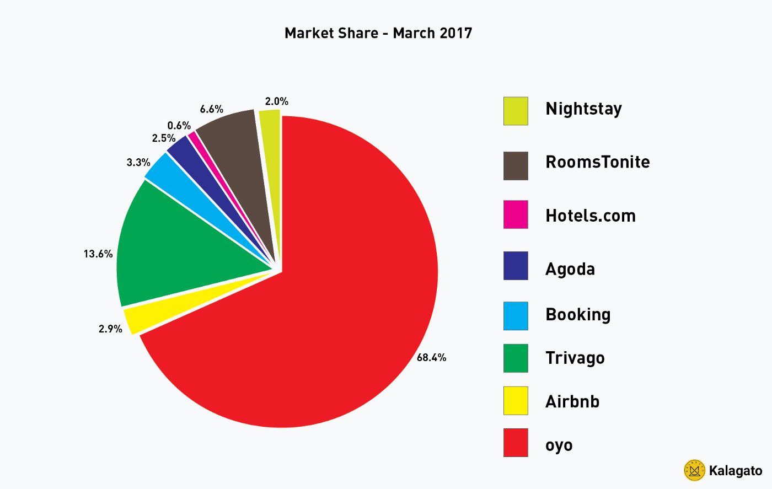
Figure 1: Market Share of Hotel Aggregator in the Indian Market
The pie chart above shows that OYO holds the largest market share as a hotel aggregator at 68.4% as of March 2017. However, the second-largest shareholder is one of OYO’s competitors Trivago, although only holding 13.6%. OYO needs to evaluate its marketing strategies and manage its services to have recurring customers to maintain its market share.

The business’s core success comes from the founder and CEO, Ritesh Agarwal, who established the company in 2013 and is the second youngest self-made billionaire in India. OYO has had a significant expansion, both domestically and internationally, in the past years. It has also been established in 80+ countries with 1.2 million rooms across hotels and homes. It has become the world’s third-largest hotel chain and one of the fastest-growing chains of leased, franchised hotels, homes, living, and workspaces.

The exponential growth and success of OYO have led us to the focus of this essay; analyzing the marketing strategies utilized by the company and their effect on its competitors-- FabHotels and Treebo. Therefore leading to the research question, “To what extent has the utilization of marketing strategies contributed to OYO becoming the market leader in the Indian market?”.

Methodology
This research will not be conducting any primary research as it is challenging to have direct contacts with the organization OYO as it is a multinational company (MNC). For that reason, the investigation of the marketing strategies utilized by OYO is supported by secondary sources such as:

Websites- To collect background information about the organization OYO and the hospitality industry as a whole. The limitation of websites is they may have bias and incorrect information; hence it is essential to compare the data between multiple sources. (OYO Official Blog, OYO Website, Forbes)

Newspaper Articles- will provide credible and up-to-date information about OYO and the hospitality industry, helping understand the competition and the market share. The limitation of using newspaper articles is that once it has been published, there is no further editing leading to false information. It could be overcome by using relevant and up to date credible news articles to eliminate the news becoming outdated. (Economics Times, Hindustan Times, India Today).

Business Books- will help understand the various theories which are going to be used within the essay. (Paul Hoang 3rd Edition Business Management Textbook, W. Chan Kim Blue Ocean Strategy)

Tools Used
This essay will focus on the marketing topic from the Business Management course syllabus. The tools used to analyze the marketing strategies utilized by OYO are the Ansoff Matrix, 7 P’s of Marketing (Price, Product, Promotion, Place, People, Process, Physical Evidence), and the Blue Ocean Strategy.

The Blue Ocean Strategy- is a tool to analyze and evaluate businesses that open up a new market space and create new demand. Its objective is to create and capture uncontested market space to make the competition irrelevant in the industry. This theory is based on the fact that market boundaries and industry structure are not given and can be reconstructed by industry players’ actions and beliefs.

Ansoff Matrix- is the tool that helps identify the growth strategies utilized by OYO to obtain the market leader of India. The tool’s limitation is that it does not examine the hospitality industry’s competition, therefore, hinders with the analysis.

7P’s of Marketing- the tool helps this essay understand OYO’s marketing strategy presently, although the limitations are, it does not analyze the future implementation of data.

Besides the marketing strategy, the essay also uses OYO’s financial document to explore and understand the market share, comparing it to its competitors to answer the research question effectively.

Main Body
OYO initially started as a hotel aggregator, which is the software that searches for hotel suppliers who have vacant rooms available; in other words, a booking engine. However, OYO has moved into the franchising model after the investment from Soft-Bank. The franchising model allows OYO to improve these individual hotel’s services at a reduced operational cost and does not require much capital to expand; therefore, it can cater to multiple market segments. OYO has invested and worked on its online website and mobile app technology to digitize all aspects of the process and create a tech-empowered ecosystem. Artificial Intelligence (AI) powers the websites and apps to improve customer service. It assesses different metrics, such as time of the day, weather, and location, to understand the rooms a customer prefers.

Blue Ocean Strategy
The blue ocean strategy is the idea that the industry does not exist today; in other words, the industries are operating in unknown market spaces. These industries are labeled and known as the blue ocean as they are unexplored and untainted by competition. In terms of opportunity and growth, they have great potential. Therefore, the blue ocean strategy creates new demand in uncontested market space, making the competition irrelevant.
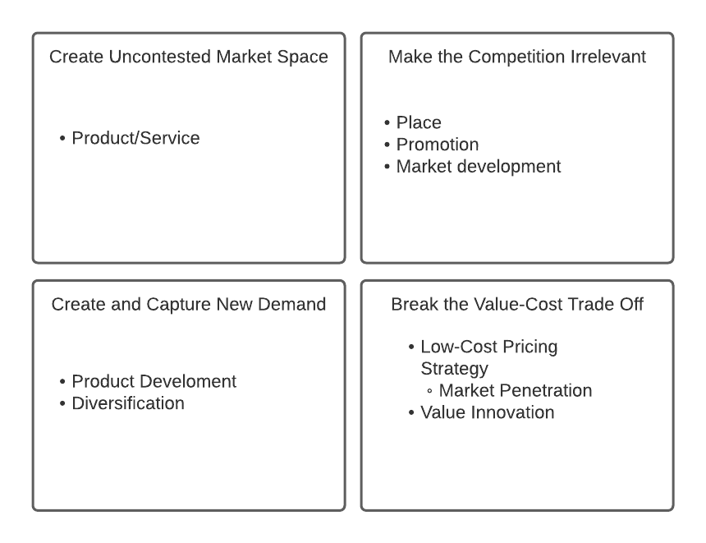
Figure 2: Blue Ocean Strategy

Create Uncontested Market Space

Products/Service
OYO has successfully created and catered to the market space known as the hospitality industry’s budget and mid-tier market. The luxury hotel chains like Marriot, Accor, and IHG have introduced subsidiary chains where Marriot found Fairfield, Accor introduced IBIS, and HotelF1 and IHG launched Holiday Inn Express, these all were introduced to reach the budget and mid-tier market in India. However, the prices ranged between ₹3000 - ₹6000 INR, which was too much. Therefore, these subsidiary chains were ineffective as they operated as a luxury hotel by providing exceptional facilities; therefore, they did not cut back on their expenses and were unsuccessful.
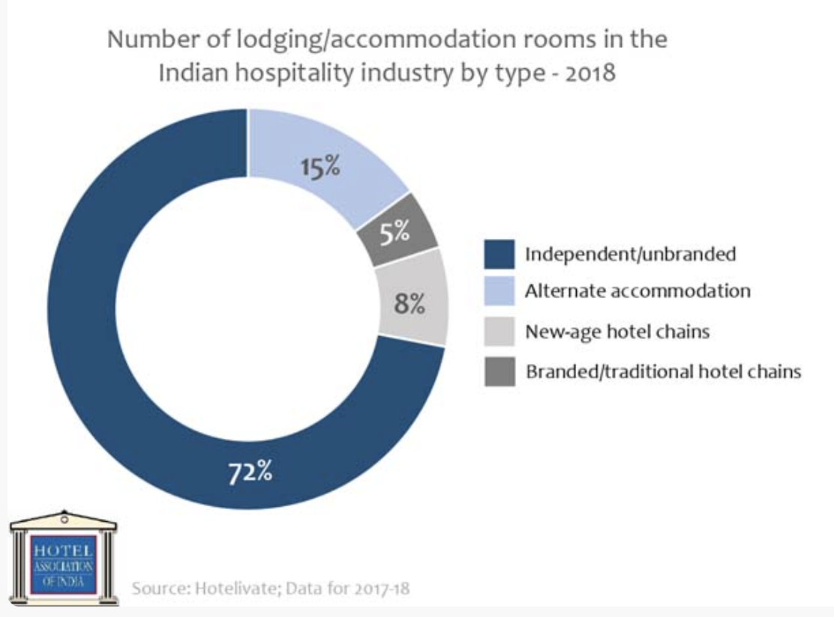
Figure 3: Pie Chart Representing various Hotel Types in the Indian Market

Figure 3 above represents the 72% of the Indian market occupied by individual and unbranded hotels. This market is targeted to the budget and mid-tier market; however, it is inefficient due to the lack of marketing strategies, technological advancements, and service quality. Therefore OYO initially targeted this market by using the partial inventory model, which is only to hold a few rooms. It allowed OYO to scale and build the brand name without committing sales to these hotels. However, it was a liability for OYO to operate in the partial inventory model as it did not control the quality of service. Therefore, over time, OYO has introduced the full inventory model or the franchise and manage model, which requires guaranteed occupancy; in other words, it assures revenue to individual hotels. This model is more beneficial for OYO as it controls and assures the quality of service is maintained while receiving approximately 22% commission for each hotel.

These individual hotels partner with OYO to improve their quantitative figures and benefit from an extensive customer database through the website and app. OYO offers customers improved services and effortless booking methods to these individual hotels. This business model of franchising the service has worked to the advantage of OYO as it does not require them to withhold the expansion due to a lack of finance and become the market leader in India’s hospitality industry.

Make the Competition Irrelevant

Market Development
This is a strategy that focuses on selling existing products in new markets. The advantage of the growth strategy is that OYO is already familiar with the product; therefore only has to do market research. However, OYO has to strategize and alter its promotional strategy and prices from country to country but may fail due to cultural changes.

OYO has strategically kept the competition irrelevant by expanding the business rapidly; Investors like SoftBank Group, Greenoaks Capital, Sequoia India, Lightspeed India, who back OYO, have also allowed their operations to expand domestically and internationally. Expanding the business has created brand awareness for the company. OYO has targeted and hit 500 cities out of the 4000 cities in India. Comparatively, the competitors Treebo and FabHotels, who do not have large investors, only hold 500 properties each throughout India.

Place
OYO started the business by having one hotel partner located in Gurgaon, India, later expanded all over India after multiple funding rounds by different investors. OYO successfully managed to expand its operations to 80+ countries internationally and 1.2 million rooms. OYO currently runs in other countries besides India like Malaysia, UAE, Nepal, China, Brazil, Mexico, UK, Philippines, Japan, Saudi Arabia, United States, Vietnam, Indonesia, and Sri Lanka. The expansion to multiple countries has helped OYO build brand recognition, as each hotel has standardized facilities; therefore, customers have a specific set of expectations that are always satisfied. As OYO has a hotel aggregator’s experience and operates its online website and app, it connects the customer to the hotels allowing them to get a price and book for a specific date. Therefore, it has helped them accommodate its customers with trust and comfort and can build customer relations.

OYO strategizes its investment location on factors such as the area of a town and the market segment. For instance, OYO invests and builds the OYO SilverKey and OYO B Direct, aimed at business travelers in corporate locations, making it accessible. OYO prefers to expand in metropolitan cities like Bengaluru, Delhi, Mumbai, Gurugram, and Hyderabad, allowing them to accommodate tourism. These cities also have a higher occupancy rate as these are the cities with the highest population.

Promotion
OYO has utilized both above the line (ATL), a paid-for promotional method through independent mass-media sources, and below the line promotional strategies (BTL), which use non-mass media promotional activities to control directly.

OYO does outdoor advertising by utilizing its properties to promote unique OYO graphics of the logo with LED’s, which is an ATL promotional strategy. This promotional method draws attention to the public and makes it easier for customers to locate the hotel from a distance. An advantage of using this advertising method is the marketing cost decreases as it is a one time expense, whereas a billboard would cost the company a monthly fee.
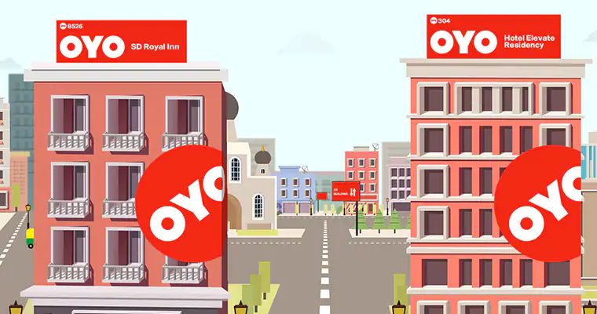
Figure 4: OYO Branding Strategy
OYO uses several different BTL promotional strategies like direct marketing, sales promotions, publicity, and sponsorships.

However, OYO’s primary promotional method is sales promotion, as it gives various types of deals to new and recurring customers. It also gives all new customers an experience to book at lower prices. This marketing type allows the customer to assess the service while building trust and possibly becoming a recurring customer.

OYO also does direct marketing to its existing customer base, by sending out emails and brochures regarding the next promotion. A benefit of having AI power the website and app is it tracks each customer's move, and this allows the company to market directly to a target audience during different promotions, therefore, is more efficient.

OYO has also gained publicity by sponsoring the Indian IPL team Royal Challenger Bangalore. This marketing method is highly beneficial for OYO as there are approximately 250 million views in a season. Simultaneously OYO also has Indian actors like Raveena Tandon and Manoj Bajpai, famous Bollywood actors, in their marketing campaign. The advantage of using Bollywood actors and the IPL team to represent the business gives credibility to customers when these actors become the company’s face. It also gives the customers approval to the quality of the services. However, these promotional methods could cost a fortune but do not guarantee any sales. Therefore, OYO has a program known as the “OYO Circle,” an affiliate and influencer program. In this program, the influencer and affiliates are paid a starting 5% commission upon sales, however, which could increase by drawing more successful bookings. This marketing method is highly beneficial as this allows influencers to join and be the face of the company and OYO is only paying for a successful booking.
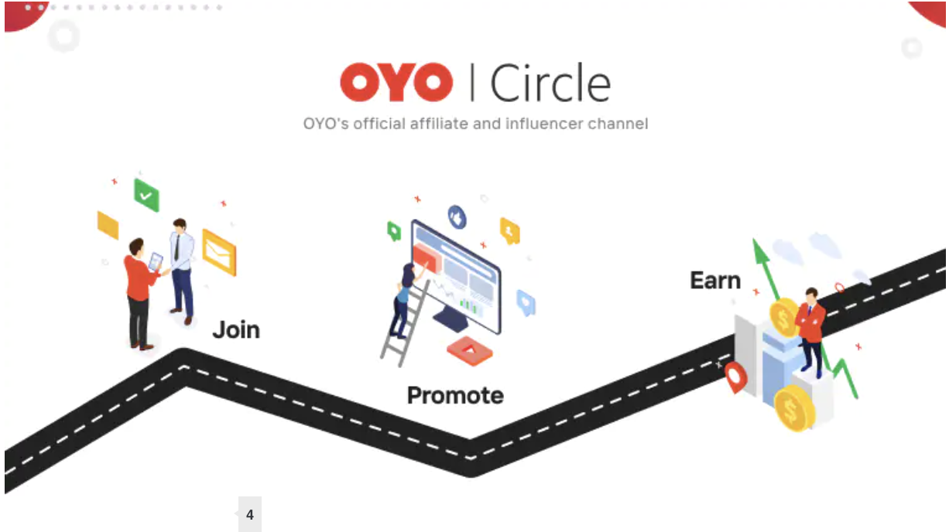
Figure 5: OYO Circle Influencer and Affiliate Program
OYO’s marketing strategy to target the younger demographic is using social media platforms such as Facebook, Instagram, and Twitter to obtain its customer base and convert it to bookings. As seen in figure 6, as of 2019, a cumulative of 67% of Indian users using social media are below the age of 29. Therefore, social media marketing is helping OYO to build brand recognition.
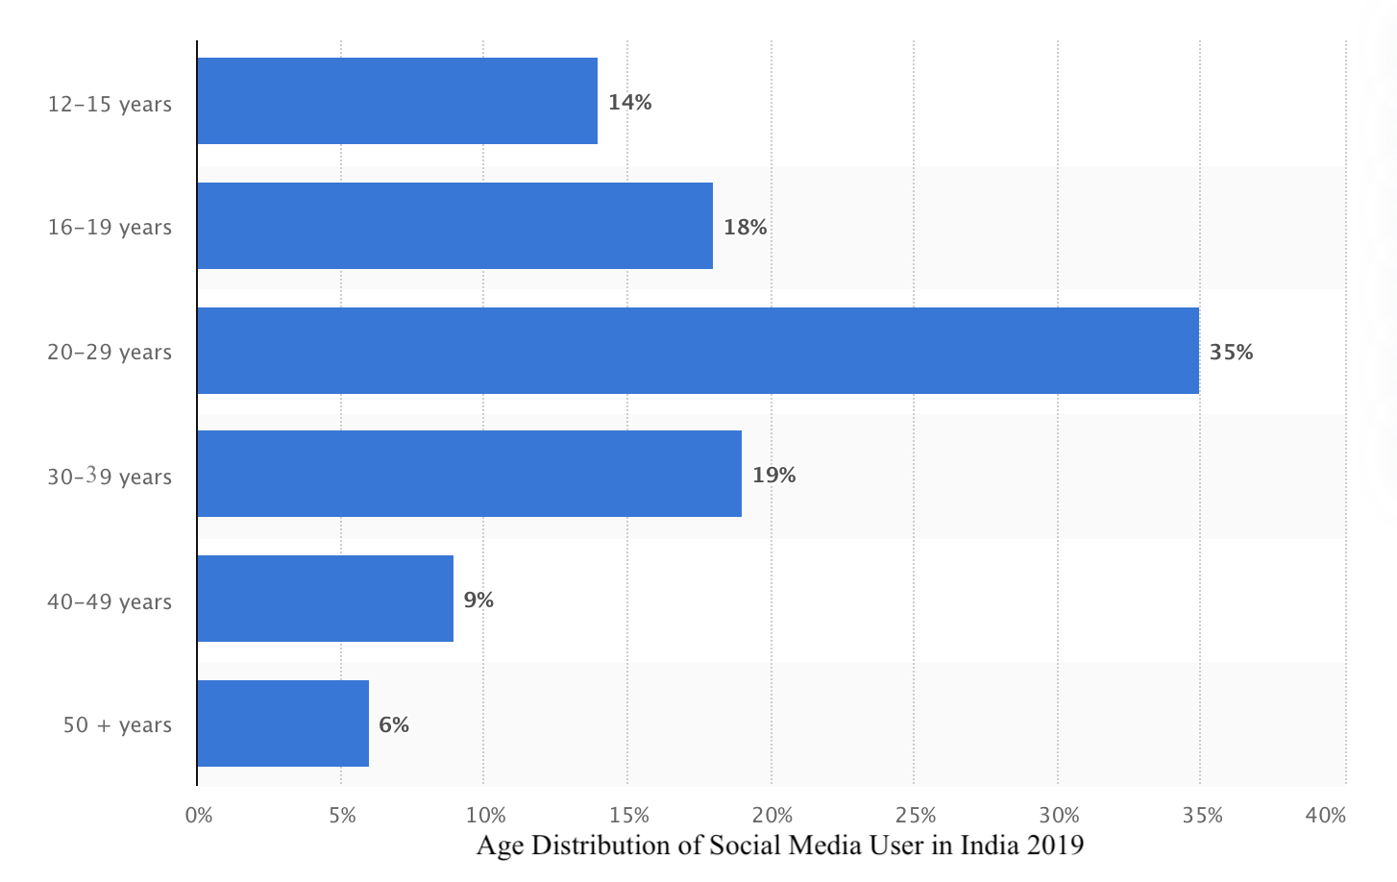

Figure 6: Age Distribution of Social Media User in India

Create and Capture New Demand

Product Development
Product development is a growth strategy where the business focuses on selling new products in existing markets to succeed; brand development is essential. Therefore OYO has divided its customer segments into four and has accommodated different hotel types for each; these include: adventure travelers, leisure travelers, business travelers, and family travelers.

Adventure travelers are the market segment that wants to explore attraction independently or in small groups, also known as backpack travelers. The main objective of their travel is to experience the destination as a local at a low budget. OYO accommodates these travels with the OYO studios where it allows them to book either single occupancy or twin sharing, which makes the room cost-effective for the customer.

Leisure travelers are the people who are traveling for a vacation from their day-to-day life. OYO accommodates them with the OYO townhouse, “smart rooms” with special facilities like 24/7 kitchen services. These hotels have a more effective service than the OYO flagship, which is the standard hotel. The service is priced at a premium, however, is lower than the luxury hotel chains’ subsidiary companies.

Business travelers are accommodated by two different services OYO B direct and the OYO Silver Key. The OYO B Direct has a service where they provide the customer with GST invoices reimbursement, which helps customers with tax deduction. The OYO Silver Key is a more luxurious service, and it usually accommodates travelers like executives and corporate clients. These hotels are located around corporate offices in the town for easier accessibility. OYO targeting the business traveler segment is highly beneficial as large corporations and small businesses have frequent business trips. By providing a unique service for the segment, OYO is establishing and creating recurring customers.

Family travelers are those who travel in large groups and look for spacious and comfortable stays. OYO accommodates this group with two different services: firstly, OYO homes, which are private homes fully furnished. Secondly, the OYO flagship is leased buildings designed to give a homely atmosphere at the hotel’s comfort. These two services target both larger families with homes that facilities extra rooms and smaller families with apartments that accommodate single rooms. The OYO homes is a valuable service for the Indian market. The average Indian family size is 4.4 people per family; this shows OYO homes would be utilized for family travel.

Diversification
Diversification is a growth strategy that focuses on selling new products in new markets. This strategy allows firms to gain market share and have a diverse product portfolio. There are two types of diversification: related diversification and unrelated diversification.

OYO has diversified into the wedding business where they operate the website and app weddingz.in. OYO partners with banquet halls and vendors to book wedding venues at fair prices. This is a related diversification; as this service is used by families that are a customer segment OYO already targets, although the services have been changed.

OYO has not cooperated in any unrelated diversification in the business plan. The company’s focus is to expand the business internationally to become the market leader and get recognized in the hospitality industry.

Break the Value-Cost Trade-Off

Market Penetration
Market Penetration is a strategy where the business focuses on selling its products in an existing market. This strategy is used when the business wants to increase its market share of its current products; this can be achieved by offering competitive prices and customer loyalty schemes.

OYO aims to increase its market share by expanding the same service to its existing customers in different locations. OYO also frequently develops the OYO app, which has brought 2x more customers than the competitors. This has also led to an increase in revenue by 5x. With the company MoEngage, the CRM tool can predict four factors: the customer’s city prediction, personalization, recommendation, and engagement. The city prediction helps the system identify the user’s location, which helps OYO target the market and provide the right offer for each user. Personalization is the process where the software analyzes the pattern of the usage of the apps and website. The recommendation is to conclude the customer’s pattern; it markets with the right city, right locality, and the right category. This method of marketing has increased the sales revenue 2x. Lastly, engagement with the user daily through the app is one of the objectives achieved by a program called OYO Q, a quiz that allows the user to engage daily. It has helped OYO to understand and build its customer, which is essential for a service business. OYO working with MoEngage and integrating newer technology has made target marketing a easier process.

The OYO wizard is a customer loyalty subscription model where the wizard member can avail of exclusive discounts, offers, deals, and cash back advantages. The OYO wizard helps to obtain market growth as these customers become loyal to the company and become recurring customers as they are treated with appreciation. OYO also offers popular packages and hot selling deals to non-subscription members; however, they do not avail of the same exclusive deals. OYO offers them deals as it converts sales.

Price
OYO utilizes a loss leader pricing strategy, which is selling a product below its price value. The OYO hotel prices approximately range from 999 INR to 4000 INR. The pricing varies from hotel to hotel and is considered using two factors: the location and the specific hotel facilities. Despite OYO using the low-cost pricing strategy, OYO manages to have additional discounts on building loyal and recurring customers. OYO, in recent years, has been incurring losses in order to build its brand image. However, it is essential and a long term investment for OYO to take these losses as they build a more extensive database of recurring customers. The pricing strategy has been beneficial for OYO as it allows them to cater to a larger demographic as the average cost of a hotel in India ranges from ₹ 2200 to ₹ 10500. In contrast, OYO has the option of hotels as low as 999 INR per night, half the average cost of a hotel in India, while keeping the hotel’s facilities competitive to a 3-star hotel.

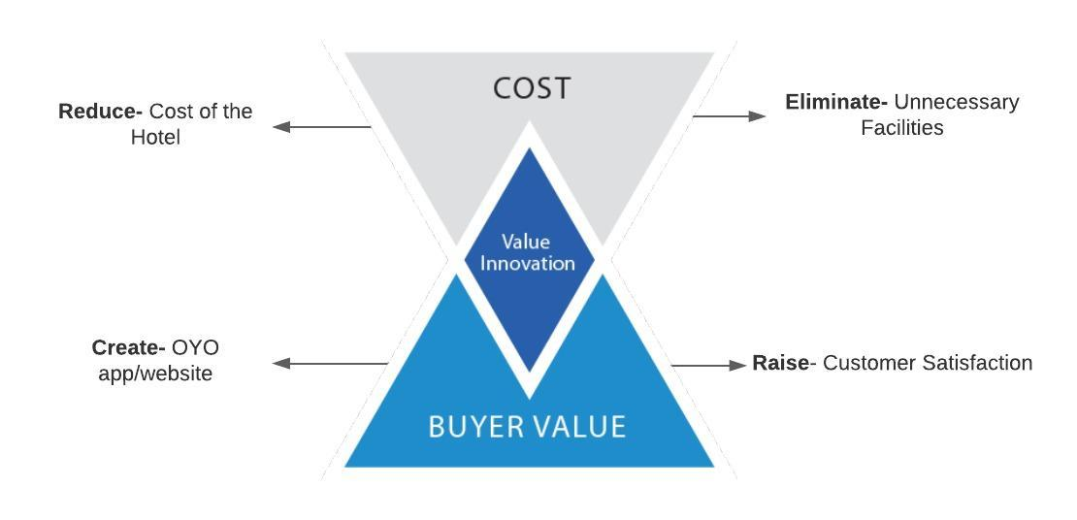
Value Innovation
Figure 7: Value Innovation (Blue Ocean Strategy)

Value innovation is the pursuit of differentiation and low cost. The idea is to create value for both the customer and the company. In the case of OYO, the value innovation is it provides hotel stays at low prices. However, it keeps the standards of staying in a 3-star hotel. OYO can provide the value as they have identified the following: eliminate and reduce cost.

On the other hand, raise and create buyer value. OYO has eliminated unnecessary facilities offered in 3-star hotel-like lounges, spas, and sports clubs. Which has ultimately reduced the overall maintenance cost; hence can offer low prices. Simultaneously OYO has raised customer satisfaction by maintaining hygiene and standard facilities like free wifi, clean bathrooms, flat-screen TVs. OYO has created a user-friendly app for the customer to locate its hotel. They also provide hotel owners with a property manager website to keep everything organized.

The Extended Marketing Mix

People
OYO has multiple teams set up in order to have fast and efficient customer service. OYO is taking the initiative to work with the Indian government to train employees under the #OYOForSkillIndia as a lot of them come from the unorganized segment. These employees will be trained to do necessary skills like cleanliness, cooking techniques, garbage disposal, etiquette and manners, essential tourism awareness, first aid, and client handling. OYO has regular surveys from the customers using the app to get feedback and to ensure all hotels are operating to the standard of OYO.

Process
OYO partners with individual hotels that struggle with attracting customers, hence utilize the OYO database. After the hotel is registered with OYO, it sends out its maintenance team to renovate the hotel and accommodate the facilities of OYO hotel’s standards. There are also regular maintenance checks to ensure it is operating to the standards. The customer gives feedback and complaints through the website and app, allowing OYO to take direct action on the hotels that do not comply with OYO’s standards. However, OYO maintains and takes the standards and policy seriously as their partnering hotel’s operations could negatively impact the entire business of 44,000 hotels. The hotel’s partner needs to cooperate to regulate and maintain the brand and to draw more customers.

Physical Evidence
The physical evidence that is standard and provided in the hospitality industry’s service are the different facilities. In the case of OYO, it has decreased its facilities compared to its competitor. However, all of its partnered hotels must have A/C Rooms, Wifi, TV, Clean Linen, and hygienic washrooms to partner with OYO. There are additional OYO B and OYO Silver Key facilities, which accommodate conference rooms for the business traveler segment. These are the facilities provided in a standard 3-star; hence, maintaining those standards at lower prices than a 3-star hotel is beneficial for OYO’s image.

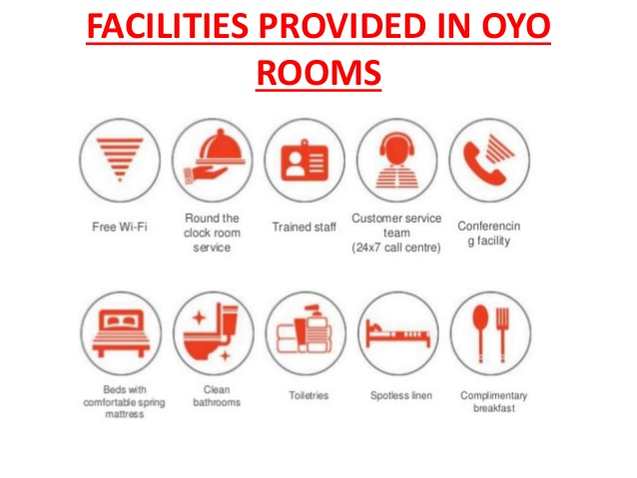
Figure 8: Standardized Facilities Provided in OYO Room

Conclusion
To conclude, the various tools analysis, shows that OYO hotel has astonishing marketing strategies in place to target its market to obtain a high market share. OYO has become the leading hotel in the Indian market as it has established itself as a low-cost hotel in the hospitality industry. OYO differentiates each of its properties by targeting a specific customer segment. Despite OYO being a low-cost hotel, its success has come because it has helped a struggling market of unbranded hotels to obtain a brand image by using the branding of OYO. However, in the long term, OYO has to maintain its services to be a successful business as franchising to individual hotels could damage the company’s image if standards are not up to the mark, mainly as the business operates in the service industry where expectations have to satisfy its customers. OYO has to maintain customer satisfaction as the hotel only provides standard facilities. However, it has successfully had recurring customers due to the various deals and promotions.

The blue ocean strategy has allowed us to understand the market space OYO operates in and the competition. Analyzing OYO’s Ansoff matrix and the 7P’s of marketing gave an understanding of the marketing strategy to dominate the market and make its competition irrelevant.

Despite having multiple secondary sources to back this analysis, there were possibilities of bias as information was taken from the OYO blog; hence it was necessary to look into multiple sources. The analysis would have been more credible if there were primary sources used as the credibility of the information would increase, although bias still would be a factor. Another limitation of the research was there was limited access to information of OYO competitors online. This made it difficult to compare the marketing strategies used in the industry and how OYO has differentiated itself from its competitors.

Bibliography

Website
Chen, James. "Flipping Definition." 08 Sept. 2020. Web. 15 Mar. 2020.
"About OYO." Oyorooms.com. Web. 15 Mar. 2020.
Hashmi, Aatif. "OYO Hotels & Homes Seek to Raise $1.5 Billion." Official OYO Blog. 10 Oct. 2019. Web. 23 Mar. 2020.
KalaGato. "OYO Dominates with 68% Market Share." Medium. Medium, 19 Aug. 2017. Web. 23 Mar. 2020.
"Complete Guide to Hotel Aggregator Technology." Alliance Reservations Network. 26 Dec. 2018. Web. 4 Apr. 2020.
"WHAT ARE RED AND BLUE OCEANS?" Blue Ocean Strategy. 08 Jan. 2021. Web. 28 Mar. 2020.
Berry, Navin. "HAI Makes a Pitch to the Central Government, Pushes for Sharing Industry's Best Practices to Cater to the New Normal." Destination India. Destination India, 14 Apr. 2020. Web. 10 Apr. 2020.
Hashmi, Aatif. "OYO Hotels & Homes Grow Operations to over 500 Cities in India." Official OYO Blog. 09 Sept. 2019. Web. 3 June 2020.
Lum, Wai Leong, Prakash Maru, Kiran Kaur, PhilHarmonic, Akhilesh Kapoor, Aman Jain, Tanveer Kaur, and P.K. Ling. "OYO Business Model: How Does Oyo Make Money?" Business Strategy Hub. 05 June 2020. Web. 4 June 2020.
Team, MBA Skool. "Oyo Rooms Marketing Mix (4Ps) Strategy." MBA Skool-Study.Learn.Share. MBA Skool, 19 Apr. 2020. Web. 4 June 2020.
Vidhi Mehra. "Top 5 Types Of Most Luxurious Stay Options OYO Rooms Offers!" Guide: Best Places to Visit. 17 Oct. 2019. Web. 4 June 2020.
John. Arcgis.com. Web. 7 June 2020.
"OYO Hotels Are Now Easier to Spot." Official OYO Blog. 09 Nov. 2017. Web. 7 June 2020.
Keelery, Published by Sandhya, and Oct 16. "India - Internet Users by Age Group 2020." Statista. 16 Oct. 2020. Web. 7 June 2020.
"Marketer Spotlight: The Role of a Robust CRM in OYO Rooms' Growth Story." MoEngage Blog. 10 Nov. 2020. Web. 21 June 2020.
Hashmi, Aatif. "OYO Wizard Is Here to Reward You!" Official OYO Blog. 01 Apr. 2020. Web. 3 July 2020.
"Cost of a Trip to India & the Cheapest Time to Visit India." Champion Traveler. Web. 7 July 2020.
Jain, Abhinav. "HOW OYO PLANS TO PROVIDE SKILL TRAINING TO LAKHS OF WORKERS." Official OYO Blog. 09 Mar. 2016. Web. 22 July 2020.
Oyo, and Nagin Patel. "WE ARE DOING SOCIAL MEDIA RIGHT!" Official OYO Blog. 10 Aug. 2016. Web. 23 July 2020.
Hoteltalk. "3 Star Hotel Classification - List Of Required Facilities and Services." HotelTalk. 07 Nov. 2019. Web. 23 July 2021,
Potluri, Poorna Chandra Rao. "Oyo Rooms Ppt." SlideShare. 23 Apr. 2017. Web. 23 July 2020.
Dhimole, Rahul, and Name *. "Blue Ocean Strategy Summary." Better Than Before. Web. 3 Aug. 2020.
Oyo. "OYO Circle - Our Official Affiliate and Influencer Program." Official OYO Blog. 06 Jan. 2020. Web. 4 June 2020.

Newspaper Article
Bureau, ET. "Oyo Changes Business Model from Aggregation to Franchise." The Economic Times. Economic Times, 08 Dec. 2017. Web. 23 July 2020.
Www.ETCIO.com. "How Homegrown Oyo Leveraged Technology to Transform the Hospitality and Real-estate Sector - ET CIO." ETCIO.com. 18 June 2019. Web. 23 July 2020.
Admin@thepassage.cc. "Budget Hotel Industry Remains a Tough Nut to Crack." Thepassage.cc. Web. 3 Aug. 2020.
"Hotel Rooms: Independent/unbranded Segment Still Dominates with 72 per Cent Share." @businessline. The Hindu BusinessLine, 03 Apr. 2019. Web. 23 July 2020.
Bureau, ET. "Oyo Funding: Oyo to Raise $1.5 Billion in Latest round of Funding." The Economic Times. Economic Times, 08 Oct. 2019. Web. 27 July 2020.
"Ritesh Agarwal: OYO Expands International Presence, Enters Sri Lanka." The Economic Times. Economic Times, 13 Dec. 2018. Web. 3 Aug. 2020.
"IPL 2020 off to Great Start as Viewership Increases by 15 per Cent." Hindustan Times. 02 Oct. 2020. Web. 3 July 2020.
Chakrabarty, Roshni. "Major Problems in Hotel Management: Why Is the Industry Struggling to Maintain Standards in India?" India Today. 09 Jan. 2020. Web. 23 July 2020.

Books
HOANG, PAUL. BUSINESS MANAGEMENT 4TH EDITION. Place of Publication Not Identified: IBID, 2018. Print.
Kim, W C, and Renée Mauborgne. Blue Ocean Strategy: How to Create Uncontested Market Space and Make the Competition Irrelevant. Boston, Mass: Harvard Business School Press, 2005. Print.

Chen, James. "Flipping Definition." 08 Sept. 2020. Web. 15 Mar. 2020.
"About OYO." Oyorooms.com. Web. 15 Mar. 2020.
"About OYO." Oyorooms.com. Web. 15 Mar. 2020.
Hashmi, Aatif. "OYO Hotels & Homes Seek to Raise $1.5 Billion." Official OYO Blog. 10 Oct. 2019. Web. 23 Mar. 2020.
"WHAT ARE RED AND BLUE OCEANS?" Blue Ocean Strategy. 08 Jan. 2021. Web. 28 Mar. 2020
HOANG, PAUL. BUSINESS MANAGEMENT 4TH EDITION. Place of Publication Not Identified: IBID, 2018. Print.
HOANG, PAUL. BUSINESS MANAGEMENT 4TH EDITION. Place of Publication Not Identified: IBID, 2018. Print.
"Complete Guide to Hotel Aggregator Technology." Alliance Reservations Network. 26 Dec. 2018. Web. 4 Apr. 2020.
Bureau, ET. "Oyo Changes Business Model from Aggregation to Franchise." The Economic Times. Economic Times, 08 Dec. 2017. Web. 23 July 2020.
Www.ETCIO.com. "How Homegrown Oyo Leveraged Technology to Transform the Hospitality and Real-estate Sector - ET CIO." ETCIO.com. 18 June 2019. Web. 23 July 2020.
"WHAT ARE RED AND BLUE OCEANS?" Blue Ocean Strategy. 08 Jan. 2021. Web. 28 Mar. 2020.
Admin@thepassage.cc. "Budget Hotel Industry Remains a Tough Nut to Crack." Thepassage.cc. Web. 3 Aug. 2020.
Hashmi, Aatif. "OYO Hotels & Homes Grow Operations to over 500 Cities in India." Official OYO Blog. 09 Sept. 2019. Web. 3 June 2020.
Lum, Wai Leong, Prakash Maru, Kiran Kaur, Phil Harmonic, Akhilesh Kapoor, Aman Jain, Tanveer Kaur, and P.K. Ling. "OYO Business Model: How Does Oyo Make Money?" Business Strategy Hub. 05 June 2020. Web. 4 June 2020.
Hashmi, Aatif. "OYO Hotels & Homes Grow Operations to over 500 Cities in India." Official OYO Blog. 09 Sept. 2019. Web. 3 June 2020
"Ritesh Agarwal: OYO Expands International Presence, Enters Sri Lanka." The Economic Times. Economic Times, 13 Dec. 2018. Web. 3 Aug. 2020.
Team, MBA Skool. "Oyo Rooms Marketing Mix (4Ps) Strategy." MBA Skool-Study.Learn.Share. MBA Skool, 19 Apr. 2020. Web. 4 June 2020.
Vidhimehra. "Top 5 Types Of Most Luxurious Stay Options OYO Rooms Offers!" Guide: Best Places to Visit. 17 Oct. 2019. Web. 4 June 2020.
Hashmi, Aatif. "OYO Hotels & Homes Grow Operations to over 500 Cities in India." Official OYO Blog. 09 Sept. 2019. Web. 3 June 2020.
HOANG, PAUL. BUSINESS MANAGEMENT 4TH EDITION. Place of Publication Not Identified: IBID, 2018. Print.
Www.ETCIO.com. "How Homegrown Oyo Leveraged Technology to Transform the Hospitality and Real-estate Sector - ET CIO." ETCIO.com. 18 June 2019. Web. 23 July 2020.
Lum, Wai Leong, Prakash Maru, Kiran Kaur, Phil Harmonic, Akhilesh Kapoor, Aman Jain, Tanveer Kaur, and P.K. Ling. "OYO Business Model: How Does Oyo Make Money?" Business Strategy Hub. 05 June 2020. Web. 4 June 2020.
HOANG, PAUL. BUSINESS MANAGEMENT 4TH EDITION. Place of Publication Not Identified: IBID, 2018. Print.
Lum, Wai Leong, Prakash Maru, Kiran Kaur, Phil Harmonic, Akhilesh Kapoor, Aman Jain, Tanveer Kaur, and P.K. Ling. "OYO Business Model: How Does Oyo Make Money?" Business Strategy Hub. 05 June 2020. Web. 4 June 2020.
Lum, Wai Leong, Prakash Maru, Kiran Kaur, Phil Harmonic, Akhilesh Kapoor, Aman Jain, Tanveer Kaur, and P.K. Ling. "OYO Business Model: How Does Oyo Make Money?" Business Strategy Hub. 05 June 2020. Web. 4 June 2020.
Vidhi Mehra. "Top 5 Types Of Most Luxurious Stay Options OYO Rooms Offers!" Guide: Best Places to Visit. 17 Oct. 2019. Web. 4 June 2020. John. Arcgis.com. Web. 7 June 2020.
HOANG, PAUL. BUSINESS MANAGEMENT 4TH EDITION. Place of Publication Not Identified: IBID, 2018. Print.
Lum, Wai Leong, Prakash Maru, Kiran Kaur, Phil Harmonic, Akhilesh Kapoor, Aman Jain, Tanveer Kaur, and P.K. Ling. "OYO Business Model: How Does Oyo Make Money?" Business Strategy Hub. 05 June 2020. Web. 4 June 2020.
HOANG, PAUL. BUSINESS MANAGEMENT 4TH EDITION. Place of Publication Not Identified: IBID, 2018. Print.
HOANG, PAUL. BUSINESS MANAGEMENT 4TH EDITION. Place of Publication Not Identified: IBID, 2018. Print.
"Marketer Spotlight: The Role of a Robust CRM in OYO Rooms' Growth Story." MoEngage Blog. 10 Nov. 2020. Web. 21 June 2020.
Hashmi, Aatif. "OYO Wizard Is Here to Reward You!" Official OYO Blog. 01 Apr. 2020. Web. 3 July 2020.
HOANG, PAUL. BUSINESS MANAGEMENT 4TH EDITION. Place of Publication Not Identified: IBID, 2018. Print.
"Cost of a Trip to India & the Cheapest Time to Visit India." Champion Traveler. Web. 7 July 2020.
Oyo, and Nagin Patel. "WE ARE DOING SOCIAL MEDIA RIGHT!" Official OYO Blog. 10 Aug. 2016. Web. 23 July 2020
Potluri, Poorna Chandra Rao. "Oyo Rooms Ppt." SlideShare. 23 Apr. 2017. Web. 23 July 2020.
Admin@thepassage.cc. "Budget Hotel Industry Remains a Tough Nut to Crack." Thepassage.cc. Web. 3 Aug. 2020.
KalaGato. "OYO Dominates with 68% Market Share." Medium. Medium, 19 Aug. 2017. Web. 23 Mar. 2020.
Berry, Navin. "HAI Makes a Pitch to the Central Government, Pushes for Sharing Industry's Best Practices to Cater to the New Normal." Destination India. Destination India, 14 Apr. 2020. Web. 10 Apr. 2020.
"OYO Hotels Are Now Easier to Spot." Official OYO Blog. 09 Nov. 2017. Web. 7 June 2020.
Keelery, Published by Sandhya, and Oct 16. "India - Internet Users by Age Group 2020." Statista. 16 Oct. 2020. Web. 7 June 2020.
Potluri, Poorna Chandra Rao. "Oyo Rooms Ppt." SlideShare. 23 Apr. 2017. Web. 23 July 2020.
HOANG, PAUL. BUSINESS MANAGEMENT 4TH EDITION. Place of Publication Not Identified: IBID, 2018. Print.
"WHAT ARE RED AND BLUE OCEANS?" Blue Ocean Strategy. 08 Jan. 2021. Web. 28 Mar. 2020.
Www.ETCIO.com. "How Homegrown Oyo Leveraged Technology to Transform the Hospitality and Real-estate Sector - ET CIO." ETCIO.com. 18 June 2019. Web. 23 July 2020.
HOANG, PAUL. BUSINESS MANAGEMENT 4TH EDITION. Place of Publication Not Identified: IBID, 2018. Print.
Lum, Wai Leong, Prakash Maru, Kiran Kaur, Phil Harmonic, Akhilesh Kapoor, Aman Jain, Tanveer Kaur, and P.K. Ling. "OYO Business Model: How Does Oyo Make Money?" Business Strategy Hub. 05 June 2020. Web. 4 June 2020.
Jain, Abhinav. "HOW OYO PLANS TO PROVIDE SKILL TRAINING TO LAKHS OF WORKERS." Official OYO Blog. 09 Mar. 2016. Web. 22 July 2020.
"WHAT ARE RED AND BLUE OCEANS?" Blue Ocean Strategy. 08 Jan. 2021. Web. 28 Mar. 2020.
Dhimole, Rahul, and Name *. "Blue Ocean Strategy Summary." Better Than Before. Web. 3 Aug. 2020.
Dhimole, Rahul, and Name *. "Blue Ocean Strategy Summary." Better Than Before. Web. 3 Aug. 2020.
Kim, W C, and Renée Mauborgne. Blue Ocean Strategy: How to Create Uncontested Market Space and Make the Competition Irrelevant. Boston, Mass: Harvard Business School Press, 2005. Print.
"Hotel Rooms: Independent/unbranded Segment Still Dominates with 72 per Cent Share." @businessline. The Hindu BusinessLine, 03 Apr. 2019. Web. 23 July 2020.
Lum, Wai Leong, Prakash Maru, Kiran Kaur, Phil Harmonic, Akhilesh Kapoor, Aman Jain, Tanveer Kaur, and P.K. Ling. "OYO Business Model: How Does Oyo Make Money?" Business Strategy Hub. 05 June 2020. Web. 4 June 2020.
Chakrabarty, Roshni. "Major Problems in Hotel Management: Why Is the Industry Struggling to Maintain Standards in India?" India Today. 09 Jan. 2020. Web. 23 July 2020.
Admin@thepassage.cc. "Budget Hotel Industry Remains a Tough Nut to Crack." Thepassage.cc. Web. 3 Aug. 2020.
HOANG, PAUL. BUSINESS MANAGEMENT 4TH EDITION. Place of Publication Not Identified: IBID, 2018. Print.
"OYO Hotels Are Now Easier to Spot." Official OYO Blog. 09 Nov. 2017. Web. 7 June 2020.
Oyo. "OYO Circle - Our Official Affiliate and Influencer Program." Official OYO Blog. 06 Jan. 2020. Web. 4 June 2020.
Oyo. "OYO Circle - Our Official Affiliate and Influencer Program." Official OYO Blog. 06 Jan. 2020. Web. 4 June 2020.
Keelery, Published by Sandhya, and Oct 16. "India - Internet Users by Age Group 2020." Statista. 16 Oct. 2020. Web. 7 June 2020.
"WHAT ARE RED AND BLUE OCEANS?" Blue Ocean Strategy. 08 Jan. 2021. Web. 28 Mar. 2020.
All the Bibliography Sources

